Half yearly progress reports UDG
Municipal Boards to UDD (via the county government)
Template



Half yearly progress report on use of the Urban Development Grant
(For period ending 30th June , 2023)

Contents
1. Introduction 3
2. Detailed Overview of progress 3
3. Overall assessment of progress and Outlook for next 6 months 3
4. Support from UDD requested / required 3
5. Concluding remarks 3
Annexes to the half yearly UDG report: 4
Annex 1 : Summary UDG physical progress, ....... Municipality, as at 30/06/2023 4
Annex 2 : UDG budget expenditure overview, ....... Municipality, as at 30/06/2023 5
Annex 3:UDG Projects Summary Table 6
Annex 4:UDG Investments Results Framework 7
Annex 5: Captioned project Photos 8

1. Introduction
Lodwar Municipality has since been face lifted after the implementation of the following KUSP projects
- Construction of the fire station and Supply and Installation of Solar Powered street lights and flood lights: There is improved response to fire out breaks and reduced crime rates and improved security in the town and its surrounding.
- Construction of parking lots (Cabroe paving) and Supply and Installation of Solar Powered street lights: There is sanity and orderliness and densification of the street lights has reduced crime rates and improved security of the town and it’s surrounding.
- The improvement / tarmacking of AI road by the National government through Lodwar Municipality has complemented the activities through KUSP in changing the face of the municipality.
- Proposed Construction of Parking Lots-Phase II in Lodwar Municipality.

2. Detailed Overview of progress

NO | ACTIVITY | DESCRIPTION | PROGRESS
1. | Excavation and earth work  - site preparation, trenching, disposal of water, disposal of materials and back filling compacting  Parking and structing, Hard core filing ( 150mm thick) disposing and compacting, Murraming( 50 m deep)Anti termite treatment  Concrete works  Foundation strips and floor bed  Reinforcement  Sawn form work  Walling  Damp proof and membrane  Reinforcement concrete frame, Roofing,  Painting and decoration  Gate and gate house  Natural stone walling  Land scaping | Construction of a fire station | 100%
 | Setting of works  Foundation  Mounting of lighting poles  Installation of street lamp  Installation of solar panel  Installation of battery box  Installation of timing control switch cable  (electrical wiring) | Supply Installation of solar powered street lights | 100%
2. | Site clearance, clearing and unclogging drainage channels and culverts  Bedding jointing and in cement  Precast paving stones including all necessary evacuation disposal and form work  Compacting of ground using hard core  Pipes work  Channel grating and stones -Earth Works  Processing and Compaction of existing ground | - Construction of Parking lots and storm drainage | 100%
 | Setting of works  Foundation  Mounting of lighting poles  Installation of street lamp  Installation of solar panel  Installation of battery box  Installation of timing control switch cable  (electrical wiring)-Culverts & drainage works | Supply Installation of solar powered street lights | 100%
3 | Construction of parking lots projects phase 11 | Construction of Parking lots and storm drainage | 100%

Factors affecting the progress of works.
- The first project in the KUSP FY 2018/2019 In the IDeP Sewarage system project was non- responsive which informed project change from Sewerage system to Construction of Lodwar fire station and Supply and installation of Solar powered street lights and flood lights.
There was also change of site twice due to flooding, small space and the prolonged process of land acquisition
- The second project for KUSP FY 2019/2020, Contract negotiation delayed project implementation and inability by the contractor to pick road levels and drainage due to construction of AI road by the National government between July – October 2021
- The third project for KUSP FY 2020/2021, electioneering and transition period affected the implementation by delaying site hand over.

3. Overall assessment of progress and Outlook for next 6 months

UDG implementation
The FY 2018/2019 KUSP UDG project implementation is 100% complete.
The FY 2019/2020 KUSP UDG project implementation is at 100% complete.
The FY 2020/2021 KUSP UDG project implementation is at implementation stage and contractor is at the site.

Priorities for UDG implementation over the next 6 months
The Municipal Board intends to :-
- Completion of fire station fence and laying of cabroes (County vote)
- Operationalization of the fire station.
- Completion and operationalization of parking lots.
- Maintenance of Installed Solar Powered street lights (County vote).

4. Support from UDD requested / required
Lodwar Municipality requires a Sewer system. It experiences floods whenever it rains. It is a commercial center, located between two seasonal rivers with a high number of people moving in and out. This will require more funding owing to the high cost of a sewer system. The board humbly requests for a special consideration on funding.

5. Concluding remarks

The Lodwar Municipality board wishes to request UDD to assist in training the board on their urban governance and Municipal Administration on KUSP Project Management, procurement and financial processes.
Annexes to the half yearly UDG report:

Annex 1: Summary UDG physical progress, LODWAR MUNICIPALITY, as at 31/7/2023

S/no | Activity (as per plan/budget) | Planned timings from – to/ months | Assessment of progress (delayed, on schedule or ahead of schedule) | Estimated physical completion (%) | Comments
FY2018/19
1. | Construction of Lodwar Fire station | Nov 2019 to June 2020 | On schedule | 100% | Work completed
2. | Supply and installation of solar powered street lights | “ | On schedule | 100% | Work completed
FY2019/20
1. | Construction of parking lots | 16th February 2021 to 23rd December 2021 | Behind schedule | 100% | Work completed
2. | Supply and installation of solar powered street lights | Nov 2020 to June 2021 | On schedule | 100% | Work completed.
FY2020/21
3. | Proposed Construction of Parking Lots -Phase II in Lodwar Municipality |  | On schedule | 100% | Work Completed
Note: Data in the first three columns to be taken straight from the annual UDG plans, respectively (see POM Annexes 4 and 5)
Annex 2 : UDG budget expenditure overview, Lodwar Municipality, as at 31/12/2021

S/no. | Activity | Budget Execution |  |  |  | Comments
S/no. | Activity | Budget (Kshs) (A) | Actual Contract Amount (Kshs) (B) | Actual Expenditure to date (Kshs) (C) | Budget execution (%) (C/A*100) | Comments
FY2018/19
1. | Construction of Lodwar fire station | 95,000,000 | 87,277,623  (53,297,023) | 87,277,623 | 100% | Project completed
2. | Supply and Installation of solar powered street lights. | ,, | (33,980,600) |  | 100% | Project completed
3. | Feasibility Studies |  | 2,598,650
FY2019/20
1. | Construction of parking lots | 95,000,000 | 90,250,000  (54,724,120) | 80,608,600.46 | 100% | Project completed
2. | Installation of solar powered street lights | ,, | (35,525,880) |  | 100% | Project  Completed
3. | Feasibility studies |  | 4,002,216.20
FY2020/21
1. | Construction of parking lots | 25,380,918 | 28,834,084.48  (Savings 3,453,166.48) | 28,834,084.48 | 100% | Project  Completed
Total by reporting date |  | 215,380,918 | 212,9625,73.68 | 212,9625,73.68
Note: Data in columns 2, 3 and 4 to be taken straight from the annual UDG plans (see POM Annexes 4 and 5)

Annex 3: UDG Investments Summary Table
FY | Project name | Start – End date (actual) | Contract sum | Amount paid to date | Completion status | NEMA license number | Beneficiaries  e.g xx traders will benefit, or county will increase revenue by x% etc |  |  | Amount of Revenue generate (Kshs) (Per Day, Month, Year) (specify)) | Jobs created (Number)
 |  |  |  |  |  |  | Total | Male | Female |  | During | After
2018/19 | Construction of Lodwar fire- station | July 2019- July 2020. | 87,277,623 | 87,277,623 | Complete | 0028756 | 6000 | 2400 | 3600 | - | 200 | 300
2018/19 | Installation of solar powered street lights and flood lights |  | ,, |  | Complete
 | Feasibilities studies |  | 2,598,650
2019/20 | Construction of parking lots  ( Cabroes paving) | 16th  February 2021-  23rd Dec 2021 | 90,250,000 | ………… | 100% | 0068822 | 6000 | 2400 | 3600 | 12,000,000 | 200 | 300
2019/20 | Installation of solar powered street lights |  | ,, |  | 100% | 0068822
 | Feasibility studies |  | 4,002,216.20
2020/  21 | Construction of parking lots in Lodwar town | 26thAug 2022- 29th May 2023 | 28,834,084.  48 | 28,834,084.48 | - | 0068822 | 2000 | 900 | 1100 | 7 M | 25 | 30
Total  s |  |  | 215,380,918 |  |  |  |  |  |  | 19M

Annex 4: UDG Investment Results Framework
FY | Municipality | Storm water Drainage (Km) |  | Non-motorized transport facilities(footpaths, bicycle lanes & bridges)-Km |  | Waste Management (Sewer lines)-Km |  | Street lights (No) |  | High mast lights (No) |  | Markets (No) |  | Public parks and Urban green spaces (M2) |  | Roads Constructed (Km) |  | Fire Stations Constructed (No)
 |  | Planned | Completed | Planned | Completed | Planned | Completed | Planned | Completed | Planned | Completed | Planned | Completed | Planned | Completed | Planned | Completed | Planned | Completed
Projects for FY  2018/  2019 | Lodwar | 0 | 0 | 0 | 0 | 0 | 0 | 100 | 109 | 6 | 6 | 0 | 0 | 0 | 0 | 0 | 0 | 1 | 1
Projects for FY  2019/  2020 | Lodwar | 1.5 | 1.2 | 1.5 | 1.2 | 0 | 0 | 136 | 90 | 0 | 0 | 0 | 0 | 0 | 0 | 0 | 0 | 0 | 0
Projects for FY  2020/  2021 | Lodwar | 0 | 0 | 0 | 0 | 0 | 0 | 0 | 0 | 0 | 0 | 0 | 0 | 0 | 0 | 0 | 0 | O | 0
NB/ Kindly add any other achieved investment not captured in the matrix above
Annex 5: Captioned Project Photos
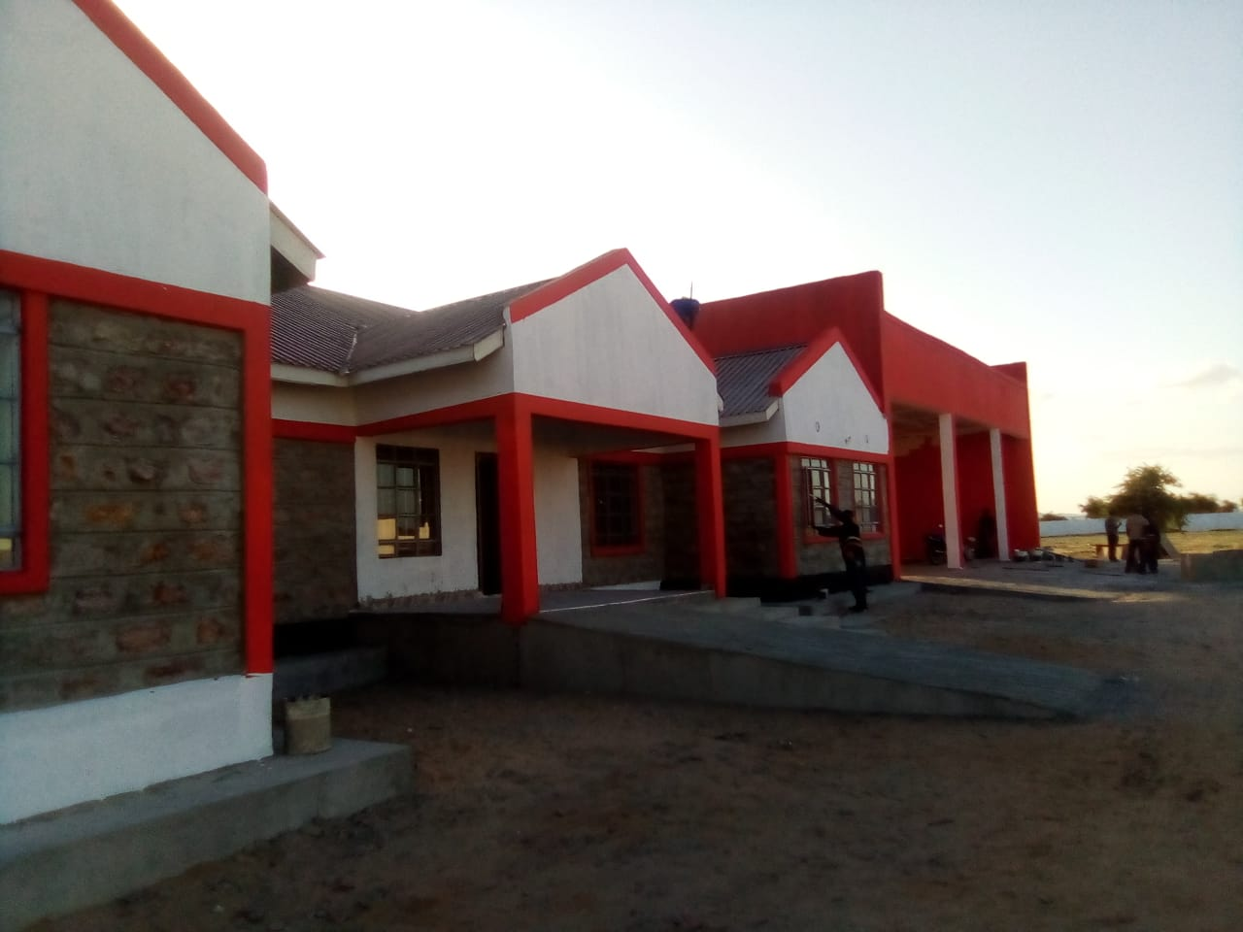
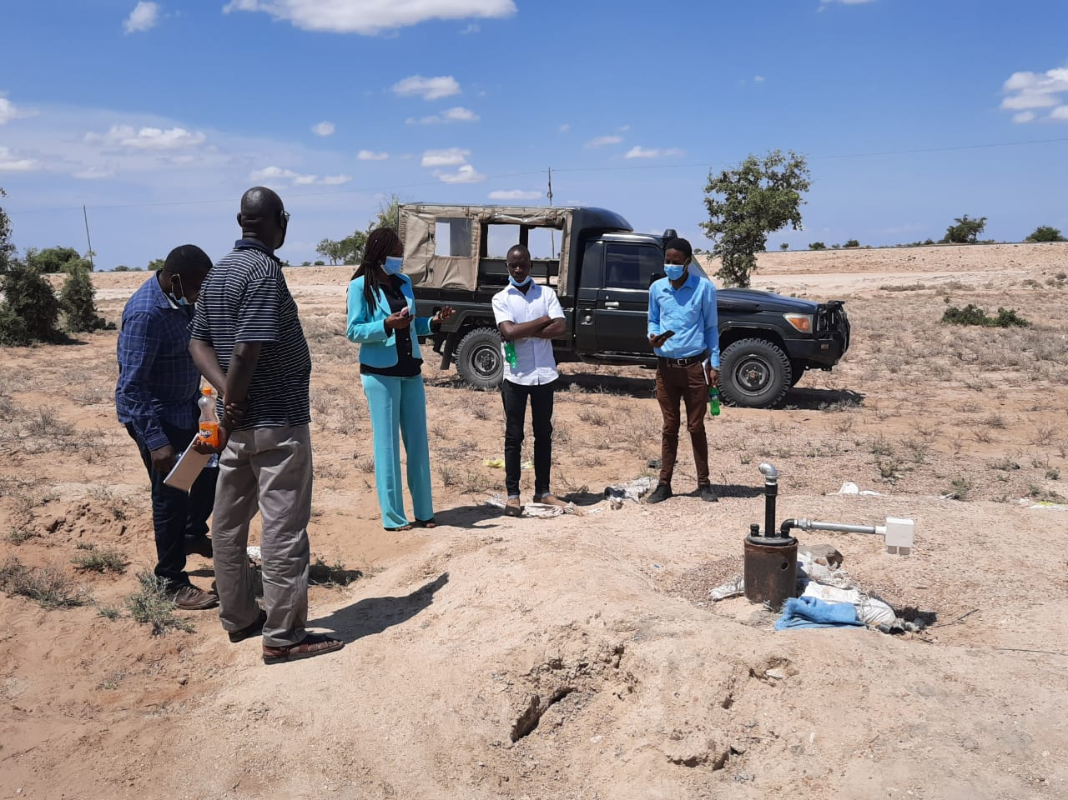

Before the Construction of the fire station During construction of the Fire station

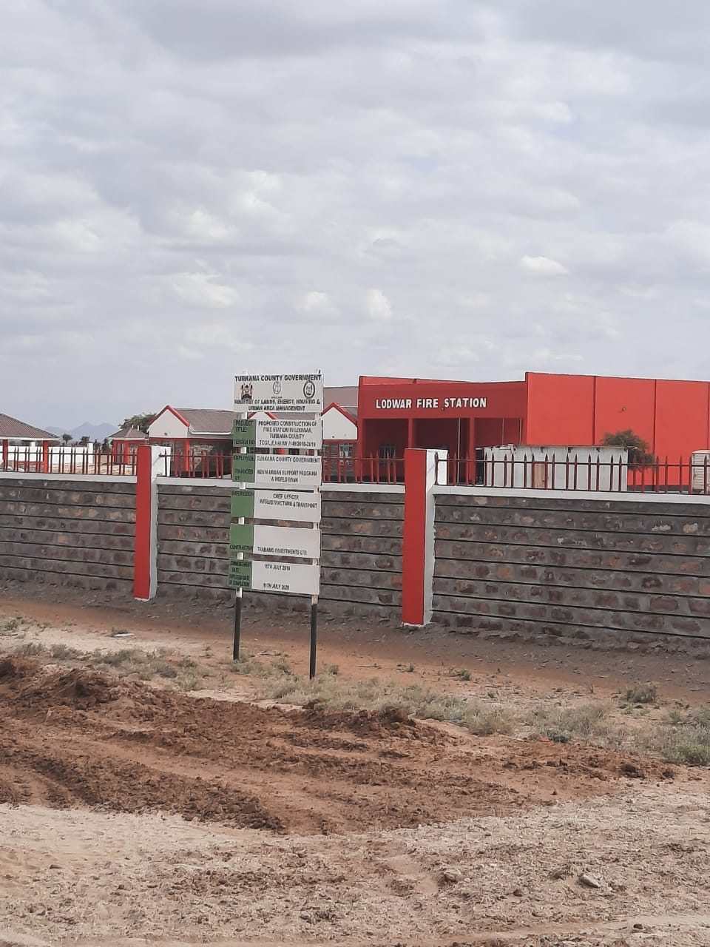
After construction of the fire station

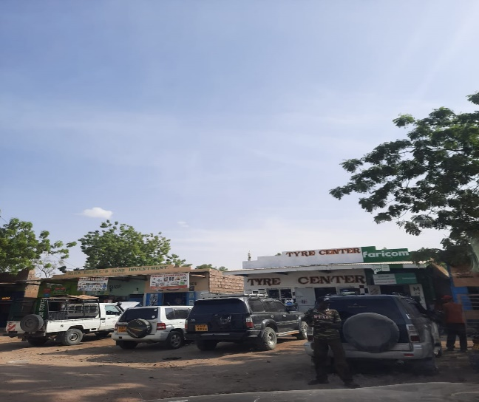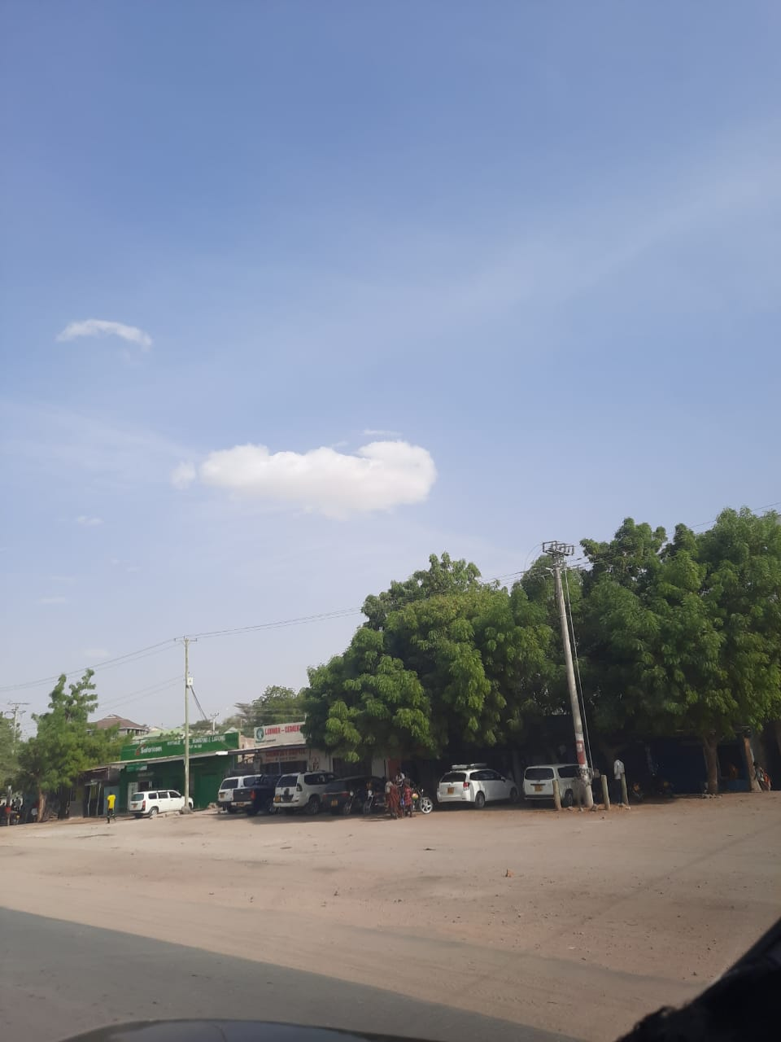
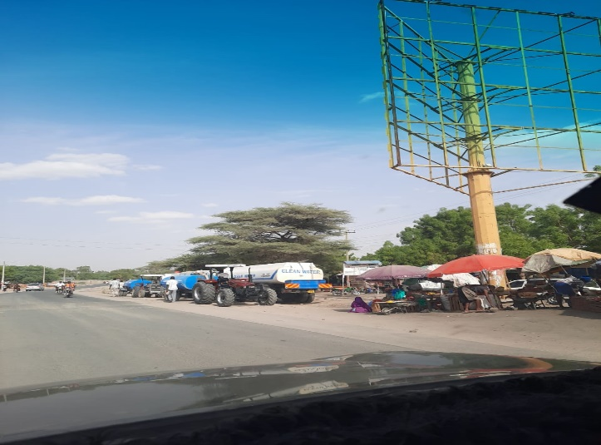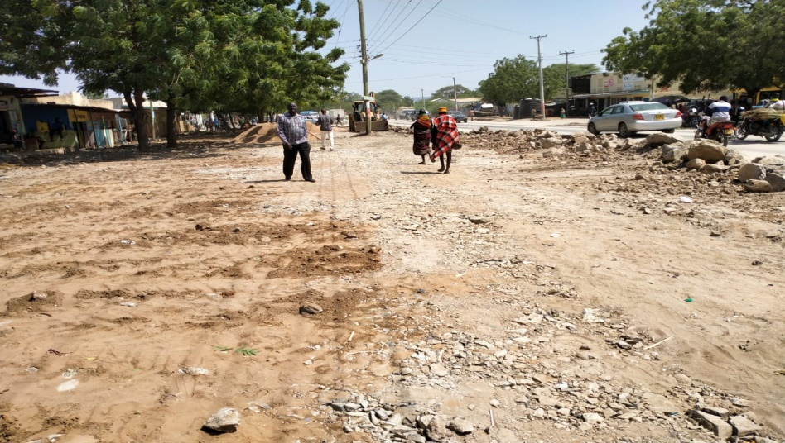
Before the construction of parking lots project During the construction of the parking lots project

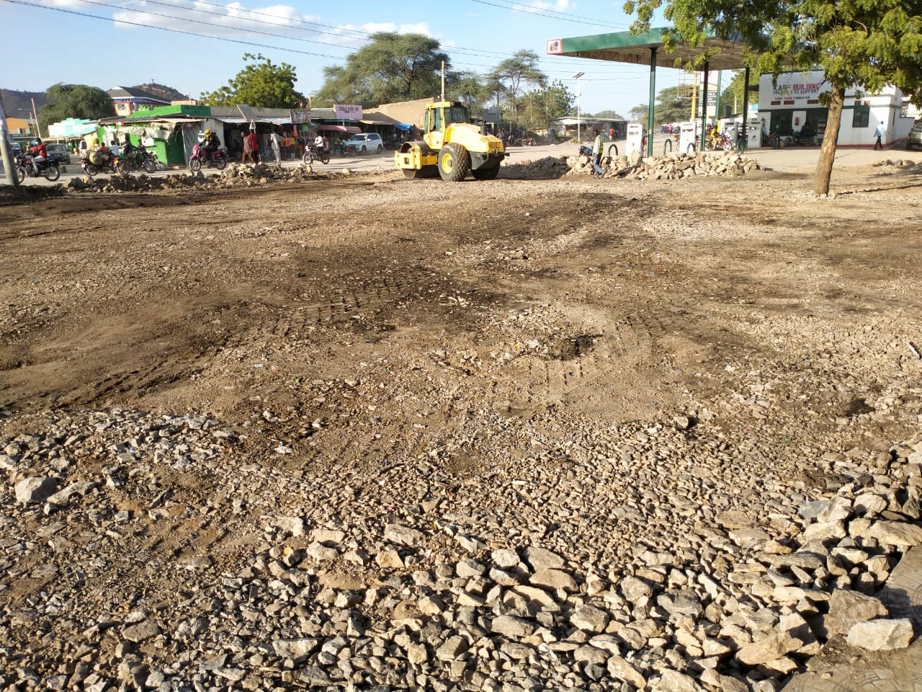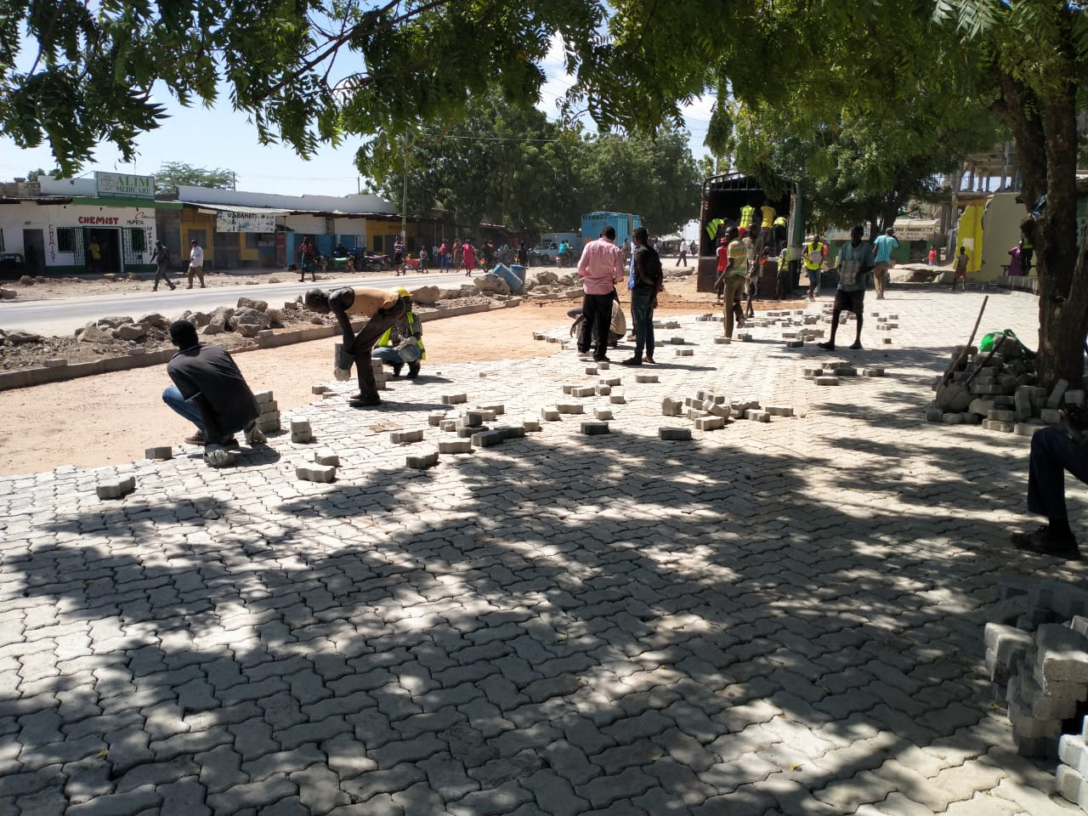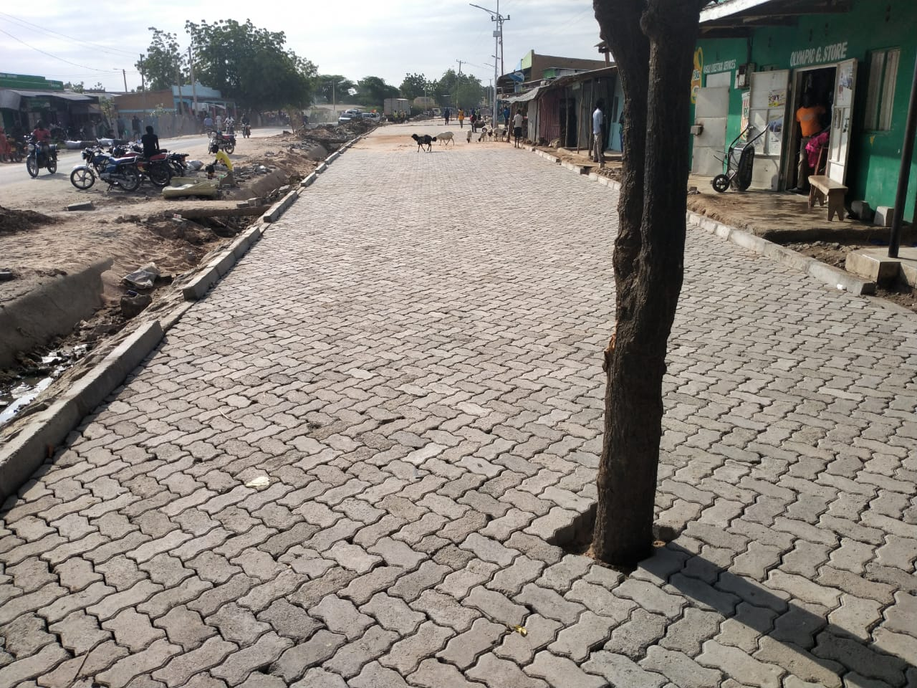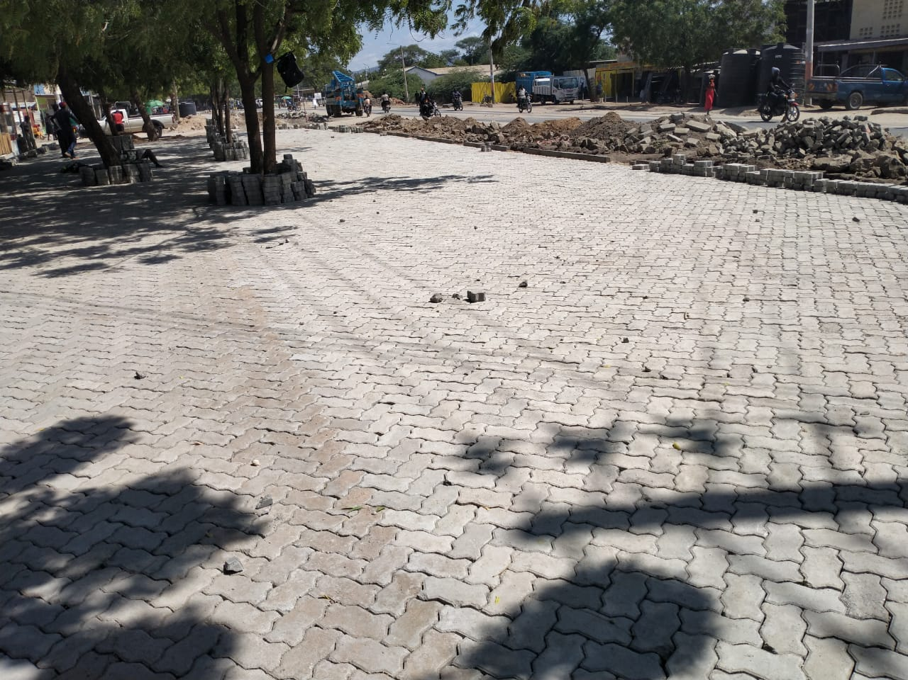
During the construction of the parking lots project
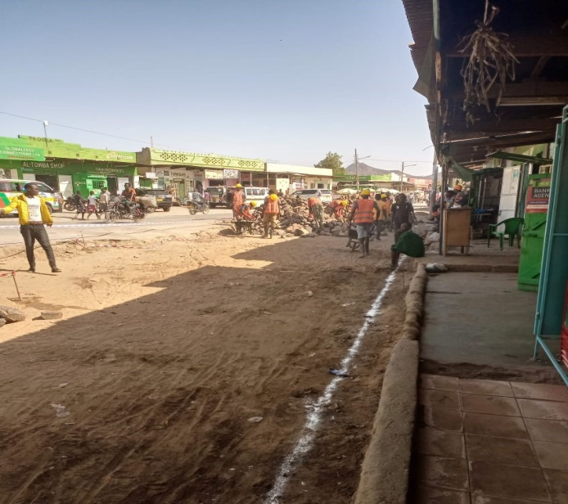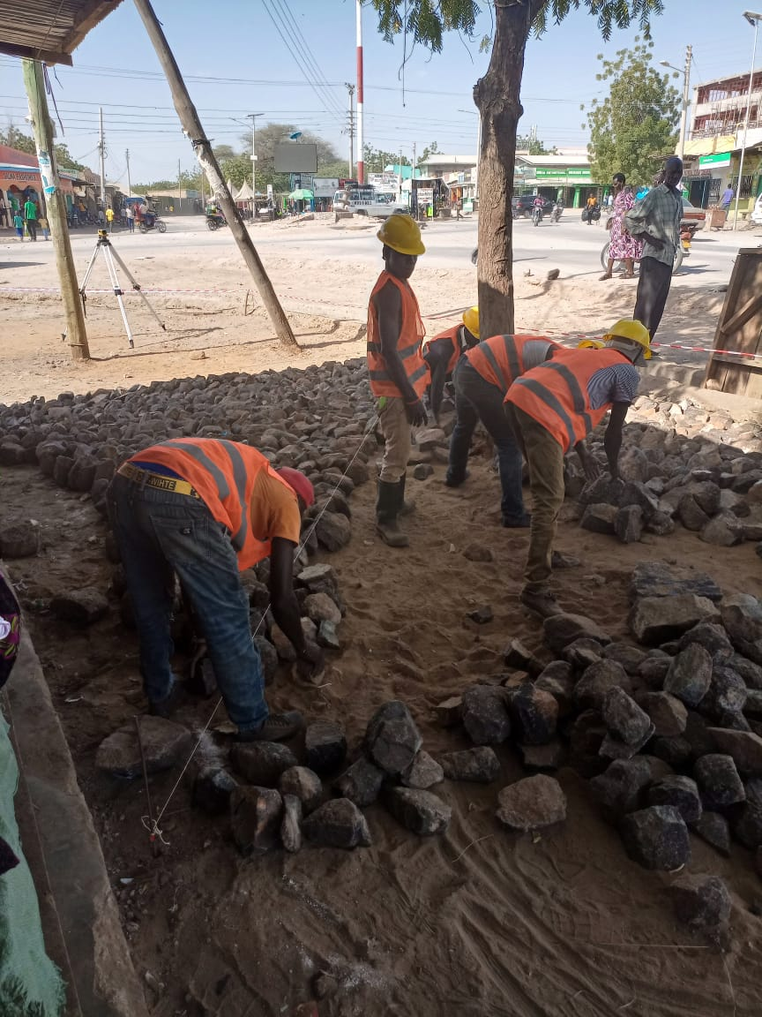
parking lots phase construction ongoing.
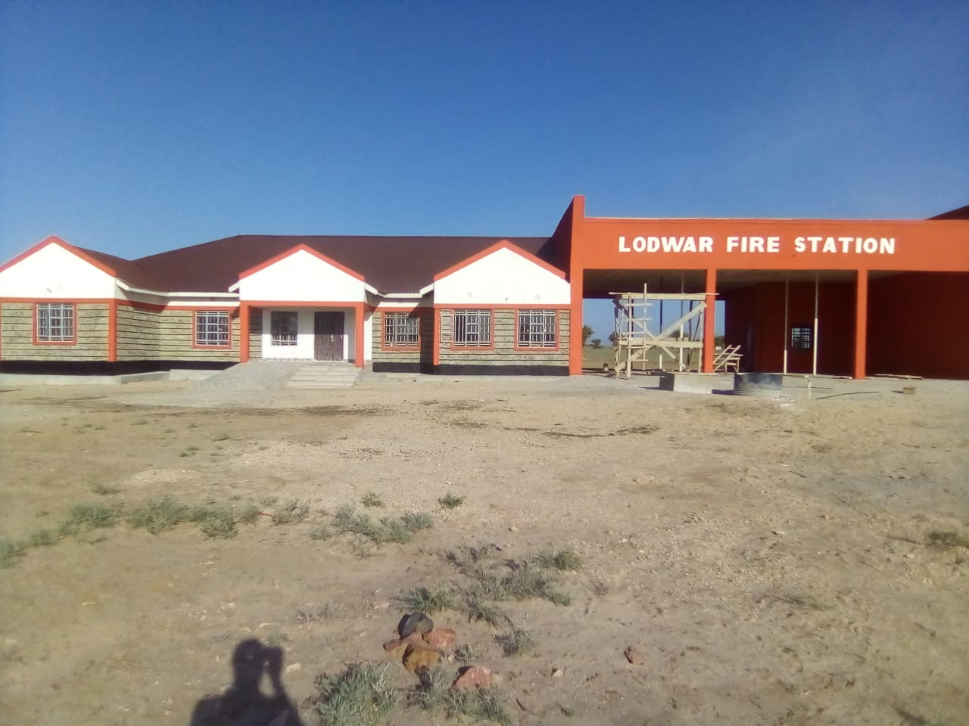
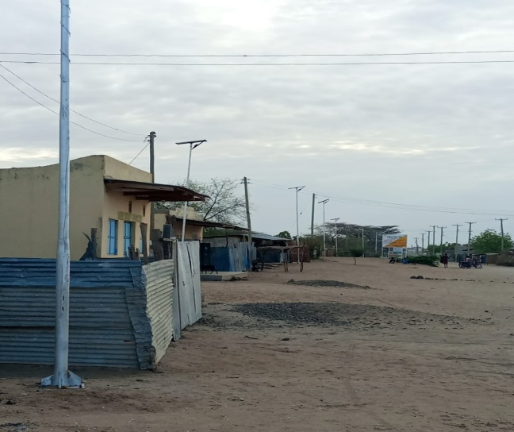
streets lights

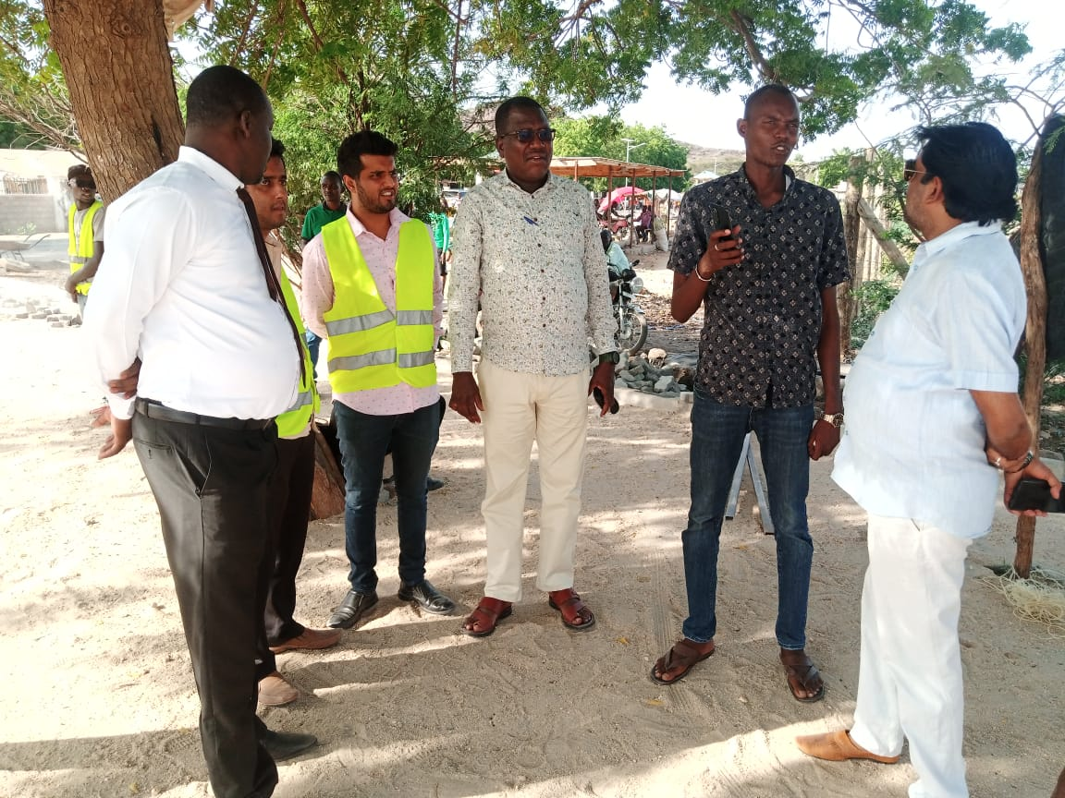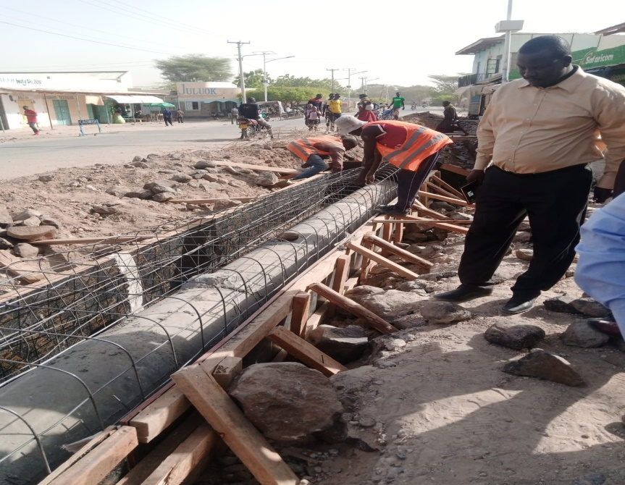
During construction of drainage phase 2

KENYA URBAN SUPPORT PROGRAM (KUSP)

Status of Environmental and Social Safeguards Implementation – as at 31st December, 2022

COUNTY:TURKANA COUNTY
MUNICIPALITY: Lodwar Municipality

Safeguards Personnel Details:
1. Environment Officer: Name: John kirwa Tel:0729386643

2. Social Officer: Name: Francisca Asimit Tel:0717604177

Project Description  [Name of project/contract in full] | Environmental & Social Screening |  |  | Preparation and Approval of Safeguards documents |  |  |  |  | Contract and Safeguards Implementation
Project Description  [Name of project/contract in full] | Screening Checklists Prepared  [as per POM Vol. II Annex 16] | Environmental risk category  (High, Medium or Low)  [as per L.N. no. 31 of 30th April, 2019] | Required Safeguards Documents  (SPR/ESIA, RAP)  [As per nature of works and anticipated negative impacts] | Date of Preparation |  | Public Disclosure |  | NEMA Approval  [Licence number and date of issuance. Or ref number and date of acknowledgement letter where applicable] | Contract Implementation Status  [Physical implementation status of project as a percentage] | RAP Implementation Status  [List specific RAP implementation activities undertaken for period] | Remarks  [Explanatory notes, observations etc.]
 |  |  |  | SPR/ ESIA  [Date of preparation] | RAP  [Date of preparation] | SPR/ESIA  [Date of public disclosure] | RAP  [Date of public disclosure]
FY2018/19
Construction of parking lots and auxiliary infrastructure (walk ways and drainage system) and installation of solar street lights investment | Yes | Low | ESIA | 29th April 2021 | 29th April 2021 | 20th April 2021 | 20th April 2021 | 0066651 | Initial stages | Public participation and relocation of affected persons especially small business enterprises | Project was at initial stages
Construction of fire station facility in Lodwar Municipality | Yes | Low | ESIA | 24th February 2020 | - | 1st February 2020 | - | 0066575 | Initial stages | Public participation activities | Project was at initial stages
FY2019/20
Construction of parking lots and auxiliary infrastructure (walk ways and drainage system) and installation of solar street lights investment | Yes | Low | ESIA | 29th April 2021 | 29th April 2021 | 20th April 2021 | 20th April 2021 | 0066651 | Initial construction work began | Public participation and relocation of affected persons especially small business enterprises | Project was at initial stages
Construction of fire station facility in Lodwar Municipality | Yes | Low | ESIA | 24th February 2020 | - | 1st February 2020 | - | 0066575 | Actual construction was in progress | Public participation activities | Active construction stage
FY2020/21
Construction of parking lots and auxiliary infrastructure (walk ways and drainage system) and installation of solar street lights investment | Yes | Low | ESIA | 29th April 2021 | 29th April 2021 | 20th April 2021 | 20th April 2021 | 0066651 | Midway of the construction | Public participation ongoing | Project was half way done
Construction of fire station facility in Lodwar Municipality | Yes | Low | ESIA | 24th February 2020 | - | 1st February 2020 | - | 0066575 | Actual construction was in progress | Public participation activities | Project was half way done
FY2021/22
Construction of parking lots and auxiliary infrastructure (walk ways and drainage system)and installation of solar street lights investment | Yes | Low | ESIA | 29th April 2021 | 29th April 2021 | 20th April 2021 | 20th April 2021 | 0066651 | Complete | Public participation and relocation of affected persons who have returned back to site | Project is complete awaiting launching
Construction of fire station facility in Lodwar Municipality | Yes | Low | ESIA | 24th February 2020 | - | 1st February 2020 | - | 0066575 | Complete | Public participation activities on the importance of the completed fire station | Project is complete awaiting launching
FY 2022/2023
Phase 2;Construction of parking lots and auxiliary infrastructure (walk ways and drainage system) and installation of solar street lights investment | Yes | Low | ESIA | 29th April 2021 | - | 29th April 2021 | - | 0066651 | The project just started (January 2023) | Public participation on-going | The phase 2 just started

Grievances Redress Matrix – Up to 31st December, 2022

COUNTY: TURKANA COUNTY

Date received | Name & contact of complainant | Investment/Project name | Nature/Details of complaint | Status of complaint (Resolved/  Pending/  Referred) | Date of resolution | Remarks
8/3/21 | Esther Esete:0712042879  (hotel) | Parking lots and street lighting investment | Air pollution caused by dust during excavation works | Resolved | 9/3/21 | The contactor was told to ensure sprinkling of water throughout to prevent dust
14/3/21 | Taamland timber yard  0716865093 | Parking lots and street lighting investment | Road kerbs preventing access to his yard | Resolved | 18/3/21 | 3 road kerbs were removed at the entrance to the yard
10/3/21 | Joshua  0768793989 | Parking lots and street lighting | Employment | Resolved | 11/3/21 | The complainant was engaged to do casual job
12/1/21 | Apa Tuko | Construction of Lodwar fire station | Encroachment into the fire station land | Resolved | 19/1/21 | Resolved through prove of ownership from the ministry of Land
12/1/21 | Lokiru Nakorey | Construction of Lodwar fire station | Encroachment into the fire station land | Resolved | 19/1/21 | Resolved through prove of ownership from the ministry of Land
28/1/23 | Local youths | Parking lots and street lighting investment-Phase 2 | Youths wanted jobs during consrtuction | Resolved | 3/2/23 | Resolved by acceptance to undertake democratic selection of youths to be engaged (Use of Yes/No)
MUNICIPALITY: Lodwar Municipality

Site Accidents/Incidents Matrix – Up to 31st December, 2022

COUNTY: TURKANA COUNTY MUNICIPALITY: Lodwar Municipality

Project Name | Name & contact of victim | Date & Time of Accident/Incident | Nature/Details of Accident/Incident | Action(s) taken | Date of Action
Construction of fire station | James Ekamais | 2/10/20 | Pricking by sharps at site | Treated in the hospital | 2/10/20
Construction of fire station | Eliud ewoton | 23/10/20 | Fall from height | Taken to hospital for treatment | 23/10/20
Construction of fire station | Adipo Ekaran | 25/10/20 | Pricked by sharps | Given first aid and taken to hospital/resolved | 25/10/20
Construction of fire station | James Eyaan | 27/11/20 | Fight | Given first aid and resoved | 27/11/20
Construction of fire station | Samson kegokon | 8/12/20 | Injury by accident | Taken to hospital | 8/12/20

Report by:
Sign : 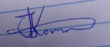

John kirwa;Environmental safeguard

ANNEXURE
Land resolution meeting

