REPUBLIC OF KENYA



TURKANA COUNTY GOVERNMENT

FOR
STANDARD TENDER DOCUMENT

CONSULTANCY SERVICES FOR THE
PLANNING OF KALOBEYEI,LOKIRIAMA AND
KATILU TOWNS.

TENDER NO:TCG/TURLPPUAM/0PEN/116/1188320/2022-2023
ISSUE DATE:3RD MARCH,2023

OPENING DATE-4TH,MARCH,2023

CLOSING -1OTH MARCH,2023

MARCH 2023

TABLE OF CONTENTS

PREFACE v
A) SAMPLE FORMAT FOR A NOTICE FOR REQUEST FOR EXPRESSIONS OF
INTEREST (REOI) - (CONSULTING SERVICES–FIRMS S ELECTION) vi
APPENDIX 1 TOTHE PREFACE viii
GUIDELINES FOR SHORTLISTING CONSULTING FIRMS viii
(B) NOTES TO THE PERSON(S) PREPARING SHORT LISTS viii
APPENDIX 2 TOTHE PREFACE xxi
GUIDELINES FOR PREPARING REQUEST FOR PROPOSALS (RFP) xxi
- GENERAL xxi
- PART 1 - TENDERING PROCEDURES vi
- PART 2 - PROCUREMENT ENTITY'S REQUIREMENTS vii
- PART 3 - CONDITIONS OF CONTRACT AND CONTRACT FORMS vii
SECTION 1. LETTER OF REQUEST FOR PROPOSAL (RFP) 1
SECTION 2 (A). INSTRUCTIONS TO CONSULTANTS(ITC) 2
  - GENERAL PROVISIONS 2
    - Introduction 3
- Conﬂict of Interest 3
- Unfair Competitive Advantage 4
- Corrupt and Fraudulent Practices 4
- Eligibility 4
  - PREPARATION OF PROPOSALS 5
- General Considerations 5
- Cost of Preparation of Proposal 5
- Language 5
- Documents Comprising the Proposal 5
- Only One Proposal 5
- Proposal Validity 6
- Clariﬁcation and Amendment of RFP 6
- Preparation of Proposals – Speciﬁc Considerations 7
- Technical Proposal Format and Content 7
- Financial Proposal 7
  - SUBMISSION, OPENINGANDEVALUATION 8
- Submission, Sealing, and Marking of Proposals 8
- Sealing and Marking of Proposals 8
- Conﬁdentiality 9
- Opening of Technical Proposals 9
- Proposals Evaluation 9
- Evaluation of Technical Proposals 9
- Public Opening of Financial Proposals 10
- Correction of Errors 11
- Taxes 11
- Conversion to Single Currency 11
- Abnormally Low Prices 11
- Abnormally High Prices 11
- Combined Quality and Cost Evaluation 12
- Notiﬁcation of Intention to Award 12
- Stand still Period 12
  - NEGOTIATIONS AND AWARD 12
- Negotiations 12
- Conclusion of Negotiations 14
- Notiﬁcation of Award 14
- Signing of Contract 14
- Contract Award Notice 14
SECTION 2 (B). DATA SHEET 15
- General Notes Provisions 15
- Preparations of Proposals 16
- Submission, Opening and Evaluation 18
SECTION 3. TECHNICAL PROPOSAL –STANDARD FORMS 21
FORM TECH-1: TECHNICAL PROPOSAL SUBMISSION FORM 21
CERTIFICATE OF INDEPENDENT PROPOSAL DETERMINATION 23
FORM TECH-2: CONSULTANT'S ORGANIZATION AND EXPERIENCE 26
FORM TECH-3: COMMENTS AND SUGGESTIONS 27
FORM TECH-5: WORK SCHEDULE AND PLANNING FOR DELIVERABLES 28
FORMTECH-6A: TEAM COMPOSITION, ASSIGNMENT, AND KEY EXPERTS' INPUTS 29
FORM TECH-6B: CURRICULUMVITAE (CV) 30
FORM TECH - 7: MANDATORY SUPPORT DOCUMENTS 31
FORM TECH - 8: SELF-DECLARATION FORMS 33
FORM TECH - 9: TENDER-SECURING DECLARATION FORM {r 46and 155(2)} 36
SECTION 4. FINANCIAL PROPOSAL - STANDARD FORMS 37
SECTION 4. FINANCIAL PROPOSAL -STANDARD FORMS 38
- FORM FIN-1: FINANCIAL PROPOSAL SUBMISSION FORM 38
- FORMF IN-2: SUMMARY OF COSTS 39
- FORMF IN-3A: BREAK DOWN OF REMUNERATION 40
- FORMFIN3B: CONSULTANT’S REPRESENTATIONS REGARDING
COSTS AND CHARGES 41
- Form 3 C: Form for Consultant's Representations Regarding Costs and Charges 42
- Form FIN 3D: Break down of Remuneration Rates [for Time Based Contracts Only] 43
- FORM FIN-4 BREAK DOWN OF REIMBURSABLE 44
SECTION 5. TERMS O FREFERENCE 45
SECTION 6. CONDITIONS OF CONTRACT AND CONTRACT FORMS 46
CONTRACT FOR CONSULTANT'S SERVICES 47
LUMP-SUM CONTRACT 48
FORMOFCONTRACT-LUMP-SUM 48
SECTION 7: GENERAL CONDITIONS OF CONTRACT 49
SECTION 8: SPECIAL CONDITIONS OF CONTRACT 60
SECTION 9: APPENDICES 66
APPENDIX A–TERMS OF REFERENCE 66
APPENDIX B- KEY EXPERTS 66
APPENDIX C – BREAKDOWN OF CONTRACT PRICE.............................................................................................
APPENDIX D-FORM OF ADVANCE PAYMENT GUARANTEE 66
TIME-BASED CONTRACT 68
FORM OF CONTRACT-TIME-BASED 69
SECTION7: GENERAL CONDITIONS OF CONTRACT 70
SECTION8: SPECIAL CONDITIONS OF CONTRACT 82
SECTION 9:APPENDICES 86
APPENDIX A–TERMS OF REFERENCE 86
APPENDIX B-KEY EXPERTS 86
APPENDIX C – REMUNERATION COST ESTIMATES – BREAKDOWN OF AGREED FIXED RATES IN CONSULTANT'S CONTRACT 86
APPENDIXD: REIMBURSABLE EXPENSES COST ESTIMATES 88
APPENDIXE: FORM OF ADVANCE PAYMENTS GUARANTEE 89
SECTION 10. NOTIFICATION FORMS 90
- NOTIFICATION OF INTENTION TO AWARD 90
- NOTIFICATION OF AWARD 94
- BENEFICIAL OWNERSHIP DISCLOSURE FORM 95

- SAMPLE FOR MATFORA NOTICE FOR REQUEST FOR EXPRESSIONS OF INTEREST (REOI)- (CONSULTING SERVICES – FIRMS SELECTION)

[NAMEOFPROCURINGENTITY]MINISTRY OF LANDS,PHYSICAL PLANNING AND URBANA AREAMANGEMENT.
Assignment or Contract Title:CONSULTANCY SERVICE FOR THE PLANNING OF KALOBEYEI,LOKIRIAMA AND KATILU TOWN
Reference No. (as per Procurement Plan):25183.
- The [MINISTRY OF LANDS,PHYSICAL PLANNING AND URBAN AREA MANAGEMENTS] intends to shortlist consultants to provide consulting services (the Services) for [REQUEST FOR CONSULTANCY SERVICE FOR THE PLANNING OF KALOBEYEI,LOKIRIAMA AND KATILU TOWNS) - include brief description, estimated level of effort (professional staff-months), implementation period, expected start date of assignment, etc.] in full consistency with the Terms of Reference (TOR) that: AS ATACHED
  - Are attached or referred to in this request for expressions of interest. or
  - Can be found at the following website:WWW.(WWW.TENDERS.GO.KE). or
  - Can be obtained at the address given below.
Name of Procuring Entity;TURKANA COUNTY,MINISTRY OF LANDS,PHYSICAL PLANNING,AND URBAN AREA MANAGEMENT.
DIRECTOR SUPPLY CHAIN ,MANAGEMENT SERVICES .
TURKANA COUNTY GOVERNMENT.
11-30500
LODWAR.
- The [MINISTRY OF LANDS,PHYSICAL PLANNING,HOUSING AND URBANA AREAS MANAGEMENT] now invites eligible consulting ﬁrms (“Consultants”) to indicate their interest in providing the Services. Interested Consultants should provide information demonstrating that they have the required qualiﬁcations and relevant experience to perform the Services. The shortlisting criteria on required qualiﬁcations and experience of the ﬁrm are:
  - Experience in the assignment, including technical and managerial capability of the ﬁrm.
  - Number of years in business working on the area of the assignment.
  - Reference to at least three assignments of similar nature and size carried out in the last THREE (3 years) (specify three to ﬁve). Include persons or institutions and contact addresses (phone, email) who can be contacted on the same.
Qualiﬁcations and Experience of Key Experts shall not be included in the short listing criteria. Key Experts will not be evaluated at the shortlisting stage.
- The attention of interested Consultants is drawn to the following provisions that will be highlighted in the Request for Proposals to be issued to shortlisted ﬁrms.
  - The Consultant will be expected to have no conﬂict of interest with other assignments or its own corporate interests and acting without any consideration for future work.
  - The consultant has no personal or business relationship with the Procuring Entity's senior management or professional staff.
  - A ﬁrm or an individual in the ﬁrm has not been sanctioned by the Public Procurement Regulatory Authority or are under a suspension or a debarment imposed by any other entity of the Government of Kenya, or any international organization.

Government-owned enterprises or institutions of Kenya Government, ofﬁcials and civil servants and employees of public institutions may not eligible.

- Consultants may associate with other ﬁrms to enhance their qualiﬁcations, but should indicate clearly whether the association is in the form of a joint venture and/or a sub-consultancy. In the case of a joint venture, all the partners in the joint venture shall be jointly and severally liable for the entire contract, if selected.
- A Consultant will be selected in accordance with the [insert approved selection method] method set out in the Act and Regulations.
- Further information can be obtained at the address below during ofﬁce hours hours .0900to1700hours].

Name of Procuring Entity:TURKANA COUNTY GOVERNMENT.

Contact Person/Ofﬁcial .DIRECTOR SUPPLY CHAIN MANAGEMENT SERVICES

Email AddressPostal Address:11-30500

Physical Address .NAWOITORONG OFF LODWAR -KITALE ROAD.

APPENDIX 1 TO THE PREAFACE

GUIDELINES FOR SHORT LISTING CONSULTING FIRMS
- NOTES TO THE PERSON (S) PREPARING SHORTLISTS
- Shortlisting Process
- The Expression of Interest (EOI) below in Item (B) of this Appendix is used as a notice to request interested ﬁrms to apply for being considered in a shortlist of ﬁrms to be invited to submit proposals for large consulting contracts. The EOI is usually used for QCB Sand QBS contracts. For small contracts, the Procuring Entity may directly solicit interest and short list from qualiﬁed ﬁrms based on its own knowledge, from its data base or from other Procuring Entities.
- For the purpose of establishing a shortlist, the nationality of a ﬁrm is that of the country in which it is registered or incorporated, and in the case of Joint Ventures, the nationality of its lead partner. If foreign ﬁrms express interest, they shall be considered.
- The Terms of Reference (TOR) shall be prepared by a person(s) or a ﬁrm specialized in the area of the assignment. The scope of the services described in the TOR shall be compatible with the available budget. The Cost Estimate (Budget) in the Procurement Plan must be carefully prepared as it will be the guidance determining the capacity of the consultants to be shortlisted and for negotiating a contract.
- The Procuring Entity is responsible for preparing shortlists. The Procuring Entity shall give ﬁrst consideration to those ﬁrms expressing interest that possess the relevant qualiﬁcations. Short lists shall be limited to the number allowed in the Act (to comprise of about six ﬁrms). Firms that expressed interest, as well as any other ﬁrm or entity that speciﬁcally requests so, shall be provided with the ﬁnal shortlist of ﬁrms by the Procuring Entity.
- The short list may comprise entirely national consultants (ﬁrms registered or incorporated in Kenya, if the assignment is below the ceiling(s) established in the Procurement Regulations, or where a sufﬁcient number of qualiﬁed national ﬁrms is available or where competition including foreign consultants is prima facie not justiﬁed or where foreign consultants have not expressed interest.
- The short list should comprise consultants of the with similar business objectives, corporate capacity, experience and ﬁeld of expertise, and that have undertaken assignments of a similar nature and complexity. Government-owned enterprises or institutions and not-for-proﬁt organizations (NGOs, Universities, UN Agencies, etc.) should not normally be included in the same shortlist along with private sector ﬁrms, unless they operate as commercial entities. If mixing is used, the selection should normally be made using Quality-Based Selection (QBS) or Selection Based on the Consultants' Qualiﬁcations (CQS) (for small assignments). The shortlist shall not include Individual Consultants. If the same ﬁrm is considered for inclusion in short lists for concurrent assignments, the Procuring Entity shall assess the ﬁrm's overall capacity to perform multiple contracts before including it in more than one shortlist.

Eligibility of Consultants to be shortlisted
Consultants are expected to provide professional, objective, and impartial advice and at all times hold the Procuring Entity's interests as paramount, without any consideration for future work, and that in providing advice they avoid conﬂicts with other assignments and their own corporate interests. Consultants shall not be hired for any assignment that would be in conﬂict with their prior or current obligations to other clients, or that may place them in a position of being unable to carry out the assignment in the best interest of the Procuring Entity. Without limitation on the generality of the foregoing, consulting ﬁrms shall not be shortlisted or hired under the circumstances set forth below:
  - Conﬂict between consulting activities and procurement of goods, works, or non-consulting services for a project (i.e., services other than consulting services);
- A ﬁrm that has been engaged by the Procuring Entity to provide goods, works, or non-consulting services for a project, or
- a ﬁrm that is providing consulting services resulting from or directly related to procurement of those goods, works, or non-consulting services, or
- Any afﬁliate ﬁrm that directly or indirectly controls, is controlled by, or is under common control with a ﬁrm that is categorized under items (i) and (ii) above.

This provision does not apply to the various ﬁrms (consultants, contractors, or suppliers) which together are performing the Contractor's obligations under a turnkey or design and build contract.
  - Consulting ﬁrms that are carrying out for/or are being considered by the Procuring Entity an assignment that by its nature may be in conﬂict with the subject assignment of the Procuring Entity. As an example, consultants assisting a Procuring Entity in preparing a feasibility study or an environmental impact assessment or Terms of Reference (TOR) for the assignment.
  - Consultants (including their experts and other personnel, and sub-consultants) that have a close business or family relationship with a Public Ofﬁcers of the Procuring Entity or the ofﬁcer (s) spouse, child, parent, brothers or sister. child, parent, brother or sister of a spouse, and who are directly or indirectly involved in any part of:
    - The preparation of the TOR for the assignment, or
    - The selection process for the contract, or
    - The supervision of such contract, unless the conﬂict stemming from this relationship has been resolved by the Procuring Entity in a manner acceptable throughout the selection process and the execution of the contract.
  - Consultants (ﬁrms and individuals) from ineligible countries. In this respect, a country is considered ineligible if:
    - As a matter of law or ofﬁcial regulations, Kenya prohibits commercial relations with the consultant's country, or
    - By an act of compliance with a decision of the United Nations Security Council taken under Chapter VII of the Charter of the United Nations, Kenya prohibits any payments to any country, person, or entity.
  - Government-owned enterprises or public institutions of Kenya if they are not or cannot establish that they:
    - Are legally and ﬁfinancially autonomous,
    - Operate under commercial law, and
    - Are not dependent agencies of the Public Sector.
As an exception to (e) above, when the services of government-owned universities or research centers or other institutions in Kenya are of unique and exceptional nature including because of the absence of a suitable private sector alternative, and their participation is critical to project implementation, the Procuring Entity may agree on the hiring of those institutions on a case-by-case basis. On the same basis, university professors or scientists from research institutes can be contracted individually.
  - Government ofﬁcials and civil servants shall not be short listed or hired under consulting contracts either as individuals or as members of the team of experts proposed by a consulting ﬁrm.

As a general Rule

The Procuring Entity shall not deny participation in a short-listing or selection process or award to a consultant for reasons un related to:
    - Its capability and resources to successfully perform the contract; or
    - The conﬂict of interest situations.
    - The Procuring Entity shall not require consultants to form associations with any speciﬁc ﬁrm or group of ﬁrms or include any particular individual in their proposals, but may encourage association with qualiﬁed national ﬁrms.

Advertising
The EOI shall be published in the dedicated government's advertising tender portal, in the PE's website and at least one daily newspaper of country wide circulation as provided in the Act. Applicants shall be given adequate number of days to per use the TOR and make any enquiries to enable them respond to the EOI.Usually14daysis considered adequate, since no proposals are expected. The notice will advise on when the applications will be closed. The Procuring Entity must open the applications at the place and time indicated in the EOI. Late applications may not be necessarily rejected, since these are not proposals or tenders.

Preparation of Applications
The applications shall at least pay particular attention to providing all the information required in the EOI. The Procuring Entity has no control of how much the application will contain but shall determine what information is relevant/not relevant. Applicants have a tendency of including too much information to impress the Procuring Entity; so, it will be responsibility of the PE to remove or separate fat from the meat, assuming what is wanted is meat.

Opening of applications
The Procuring Entity shall publicly open and read out all applications received by the deadline, at the date, time and place speciﬁed in the EOI Notice, in the presence of the applicants, designated representatives who chooses to attend.

TABLE 1 - OPENING OFAPPLICATIONS



- The Evaluation Committee will follow the following steps.
13.1 This document, “SHORTLISTING GUIDELINES AND SCORING SHEETS” for the Assignment will be circulated in advance to each Member of Evaluation Committee for their prior information and comments, if any.
13.2 The Evaluators will start together by completing Table 2 - Examination for eligibility, to establish the list of eligible applicants and putting this list in Table3–Firms that passed the Eligibility Criteria, thus eliminating the inherent risk of waste of timing scanning through applications of non-qualiﬁed applicants. The Procuring Entity will get list of ﬁrms debarred by PPRA and circulate to Evaluators. Note that the tables below are guidelines and the Procuring Entity can devise own guidelines provided they are rational and will lead to selection of qualiﬁed applicants.

xi

TABLE 2 – EXAMINATION FOR ELIGIBILITY
The Applicants will be examined for eligibility on the following basis. Those who do not qualify will not be subjected to more detailed evaluation.



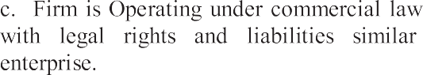
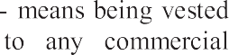
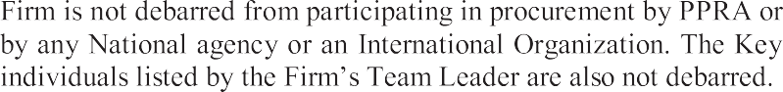
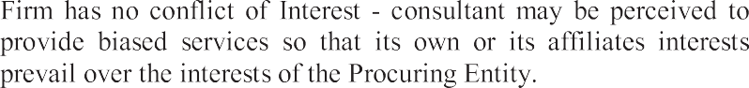


TABLE 3 - FIRMS THAT PASSED THE ELIGIBILITY CRITERIA



- Each Evaluator / member of the Shortlisting Committee must review and check the documents submitted by the Firms and make own assessment in-line with the criteria provided in Table 4 – Notes on the Criteria and sub- criteria and Evaluation Criteria and based on Table 5-Evaluation Scoring Guidelines (sub-criterion).

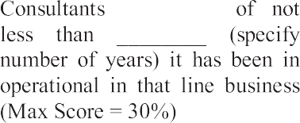
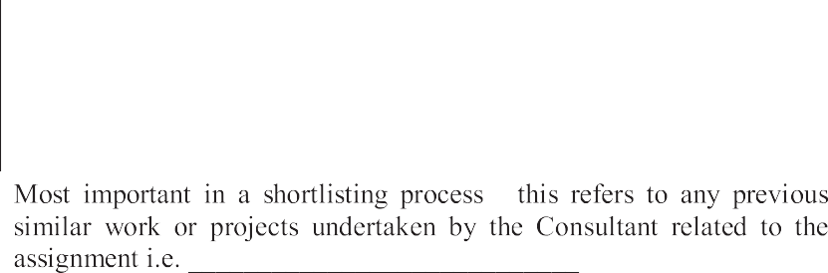
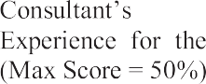

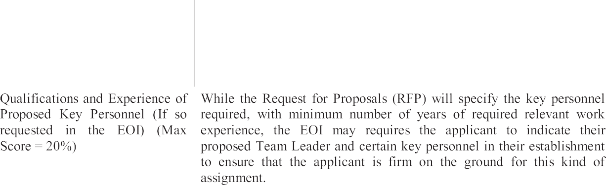
TABLE 4 - NOTES ON EVALUATION CRITERIA

 | 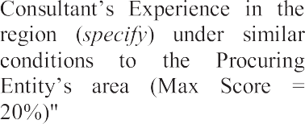 | 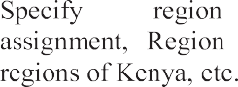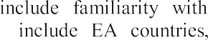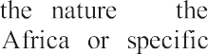

- The assessment will be based on the information that each ﬁrm presented and no additional information on the ﬁrm's capacity and experience that was not provided in the Application and the EoI would be sourced. The Evaluation Committee members will then assemble as a team under its Chairperson, and collectively gave their assessments. Each Evaluator will complete his/her scores as on Table6A and B–Individual Evaluator's Scoring Sheets shown below following the guidelines shown on Table5-Evaluation Scoring Guide lines (sub-criterion). The scores in all the Table 6s from each Evaluator will be moderated by whole Evaluation Committee to ensure there are no “too high or too low scores” by any Evaluator and will be transferred to Table 7- Consolidated scores. The Evaluation Team will agree on a ﬁnal Table 8- and the Applicants will be ranked, from which a shortlist will be made and summarized on Table 11 – Shortlisted ﬁrms, which will be the outcome of the assessment.


TABLE 5 - EVALUATION SCORING GUIDELINES (SUB-CRITERION)


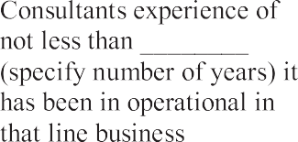

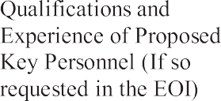
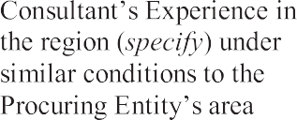


xiii

xiv

TABLE 6 A – INDIVIDUAL EVALUATOR'S SCORING SHEET


Name of Evaluator

xv

Name and Signature of Evaluator

Date

- The Evaluators will in addition complete Table 6B-Weaknesses and Strengths below for each ﬁrm to show the weaknesses and strengths of each applicant. The Committee will consider each of the factors and if in its opinion, the ﬁrm is considered too weak or has literally no strengths to warrant being shortlisted, such a ﬁrm will be dropped.

TABLE 6B - WEAKNESSES AND STRENGTHS



Name and Signature of Evaluator

Date

xvii

TABLE 7 - CONSOLIDATED SCORES (Four Tables one for each Criterion i.e. items 3, 4, 5 and 6 on Table 8)



xviii

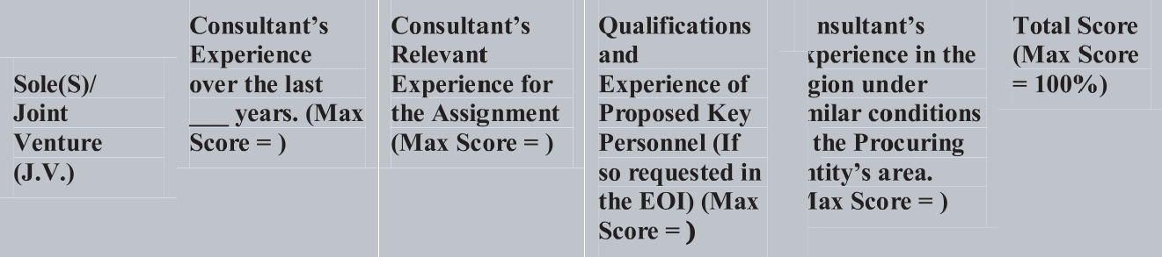
TABLE 8 - CONSOLIDATED SCORES FOR EACH FIRM (for Eligible Applicants)

- The Committee would determine the score mark for being considered a pass applicant (E.g.75 marks and above out of 100). The Firms that scored above the pass mark will be listed in Table 9: Firms that passed all the criteria and would be considered for being on the short list as the ﬁrst priority ﬁrms, while the ﬁrms in Table10 are those who marginally passed all the criteria and would be considered as alternative ﬁrms in case ﬁrms on Table 9 cannot make the required number for the shortlist.

TABLE 9: FIRMS THAT PASSED THE CRITERIA

 |  | 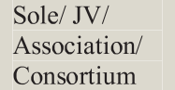

TABLE 10: FIRMS THAT MARGINALLY PASSED ALL THE CRITERIA

 |  | 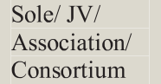

Shortlisting of Firms
- The Evaluation Committee having reviewed the Applications that were received, would then agree on a shortlist of Firms that were determined to have met the qualiﬁcations to be shortlisted. The Committee would give its very considered assessment, the general observation on how the ﬁrms faired. The Committee would then prepare a Table 11 together with a recommendation for presentation to the Committee or Ofﬁcial that approves the Shortlist, in this case an Evaluation Committee or the Head of the Procuring Entity.


TABLE 11: SHORTLISTED FIRMS



- The Shortlisting Committee here by append their signatures on Table 11, conﬁrming their decision for the ﬁrms shortlisted for Consulting Services for the “(name the assignment) of the Project”.

TABLE 12 - SIGNATURES OF SHORTLISTING COMMITTEE MEMBERS
(Conﬁrming they Shortlisted No of Firms)



This Page is the beginning of the Request for Proposals Document to be issued to the Bidders TURKANA COUNTY GOVERNMENT

CONSULTANCY SERVICES PLANNING OF KALOBEYEI,LOKIRIAMA AND KATILU TOWN

SELECTION OF CONSULTING FIRMS
    - Name of Procuring Entity.TURKANA COUNTY GOVERNMENT.
11-30500,LODWAR.
NAWOITORONG OFF
LODWAR-KITALE ROAD
Designation:DIRECTOR SUPPLY CHAIN MANAGEMENT SERVICES.
FOR .COUNTY SECRETARY
TURKANA COUNTY GOVERNMENT.
- Contract Name.
CONSULTANCY SERVICES FOT PLANNING OF KALOBEYEI,LOKIRIAMA AND KATILU TOWNS.

SECTION 1 (A) - REQUEST FOR PROPOSAL (RFP)
Date: Reference No.: Name of Assignment:CONSULTANCY SERVICES FOR PLANNING OF KALOBEYEI,LOKIRIAMA AND KATILU TOWNS.
TO:
[Note to Procuring Entity: Insert Name and Address of Consultant. In case of a Joint Venture (JV), indicate the full name of the JV and the names of each member]
Dear Messrs.
- The [MINISTRY OF LANDS,,PHYSICAL PLANNING AND URBAN AREAS MANAGEMENT] has set aside funds in its budget or has received financing from.EXCHEQUE toward the cost of the subject consulting services.
- The Procuring Entity now invites proposals to provide the following consulting services (here in after called “the
services”): [insert: name of consulting services.
assignment]. More details on the Services are provided in Section 8 Terms of Reference.
- This Request for Proposals (RFP) has been addressed to the following Consulting Firms: i)........................................................................................................................................................ ii)....................................................................................................................................................... iii)...................................................................................................................................................... iv) ..................................................................................................................................................... v)....................................................................................................................................................... vi).................................................................................................................................................etc.
- If a Consultant is a Joint Venture (JV), the full name of the JV shall be used and all members, starting with the name of the lead member. Where sub-consultants have been proposed, they shall be named. The maximum number of JV members shall be speciﬁed in the DS.
- It is not permissible to transfer this RFP to any other ﬁrm.
- A ﬁrm will be selected under [insert: Selection Method] method and in a format as described in this RFP, in accordance with the Public Procurement and Asset Disposal Act 2015, a copy of which is found at the following website: www.ppra.go.ke.
- The: Section 1: Letter of Request for Proposals
Section2: Instructions to Consultants and Data Sheet Section 3: Technical Proposal Standard Forms Section 4: Financial Proposal Standard Forms Section 5: Terms of Reference
Section 6: Standard Forms of Contract ([Select: Time-Based or Lump-Sum])
- Please inform us by [insert date], in writing at the address below or by E-mail [insert e-mail address]:
  - That you have received this Request for Proposals; and
  - whether you intend to submit a proposal alone or intend to enhance your experience by requesting permission to associate with other ﬁrm(s) (if permissible under Section 2, Instructions to Consultants (ITC), Data Sheet14.1.1).
- Details on the proposal's submission date, time and address are provided in the ITC 17.7and ITC 17.9 of the Data Sheet.
Yours sincerely,

SECTION 2. INSTRUCTIONS TO CONSULTANTS AND DATA SHEET
Section 2(a). Instructions to Consultants (ITC)
[Notes to the Procuring Entity: this part of Section2, Instructions to Consultants, shall not be modiﬁed. Any necessary changes, to address speciﬁc issues, to supplement, but not over-write, the provisions of the Instructions to Consultants (ITC), shall be introduced through the Data Sheet only. This “Notes to the Procuring Entity” should be deleted from the ﬁnal RFP issued to the Consultants].
- GENERALPROVISIONS

Meanings/Deﬁnitions
    - “Afﬁliate(s)” means an individual or an entity that directly or indirectly controls, is controlled by, or is under common control with the Consultant.
    - “Applicable Law” means the laws and any other instruments having the force of law in Kenya.
    - “Procuring Entity” means the entity that is carrying out the consultant selection process and signs the Contract for the Services with the selected Consultant.
    - “Consultant” means a legally-established professional consulting ﬁrm or an entity that may provide or provides the Services to the Procuring Entity under the Contract.
    - “Contract” means a legally binding written agreement signed between the Procuring Entity and the Consultant and includes all the attached documents listed in its Clause 1 (the General Conditions of Contract (GCC), the Special Conditions of Contract (SCC), and the Appendices).
    - “Data Sheet” means an integral part of the Instructions to Consultants (ITC) Section2thatisusedtoreﬂect speciﬁc assignment conditions to supplement, but not to over-write, the provisions of the ITC.
    - “Day” means a calendar day unless otherwise speciﬁed as "Business Day". A Business Day is any day that is an ofﬁcial working day in Kenya and excludes ofﬁcial public holidays.
    - “Experts” means, collectively, Key Experts, Non-Key Experts, or any other personnel of the Consultant, Sub-consultant or Joint Venture member(s).
    - “Government” means the Government of the Republic of Kenya.
    - “In writing “means communicated in written form such as by mail, e-mail, fax, including, if speciﬁed in the Data Sheet, distributed or received through the electronic-procurement system used by the Procuring Entity with proof of receipt.
    - “Joint Venture (JV)” means an association with or without a legal personality distinct from that of its members, of more than one Consultant where one member has the authority to conduct all business for and on behalf of any and all the members of the JV, and where the members of the JV are jointly and severally liable to the Procuring Entity for the performance of the Contract.
    - “Key Expert(s)” means an individual professional whose skills, qualiﬁcations, knowledge and experience are critical to the performance of the Services under the Contract and whose CV is considered in the technical evaluation of the Consultant's proposal.
    - “ITC” (this Section2 of the RFP) means the Instructions to Consultants that provides the Consultants with all information needed to prepare their Proposals.
    - “Letter of RFP” means the letter of invitation being sent by the Procuring Entity to the Consultants.
    - “Non-Key Expert(s)” means an individual professional provided by the Consultant or its Sub-consultant andwhoisassignedtoperformtheServicesoranypartthereofundertheContractandwhoseCVsarenot evaluated individually.
    - “Proposal” means the Technical Proposal and the Financial Proposal of the Consultant.
    - “Public Procurement Regulatory Authority (PPRA)” means the statutory authority of the Government of Kenya that mandated with the role of regulating and monitoring compliance with the public procurement law and regulations.
    - “RFP” means the Request for Proposals to be prepared by the Procuring Entity for the selection of Consultants.

    - “Services” means the work to be performed by the Consultant pursuant to the Contract.
    - “Sub-consultant” means an entity to whom the Consultant intends to subcontract any part of the Services while the Consultant remains responsible to the Procuring Entity during the whole performance of the Contract.
v) “Terms of Reference (TORs)” means the Terms of Reference that explains the objectives, scope of work, activities, and tasks to be performed, respective responsibilities of the Procuring Entity and the Consultant, and expected results and deliverables of the assignment.

Introduction
  - The Procuring Entity named in the Data Sheet intends to select a Consultant from those listed in the Request for Proposals (RFP), in accordance with the method of selection speciﬁed in the Data Sheet.
  - The Consultant are invited to submit a Technical Proposal and a Financial Proposal, for consulting services required for the assignment named in the Data Sheet. The Proposal will be the basis for negotiating and ultimately signing the Contract with the selected Consultant.
  - The Consultants should familiarize themselves with the local conditions and take them into account in preparing their Proposals, including attending a pre-proposal conference if one is speciﬁed in the Data Sheet. Attending any such pre-proposal conference is optional and is at the Consultants' expense.
  - The Procuring Entity will timely provide, at no cost to the Consultants, the inputs, relevant project data, and reports required for the preparation of the Consultant's Proposal as speciﬁed in the Data Sheet.

Conﬂict of Interest
  - The Consultant is required to provide professional, objective, and impartial advice, always holding the Procuring Entity's interest's paramount, strictly avoiding conﬂicts with other assignments or its own corporate interests and acting without any consideration for future work.
  - The Consultant has an obligation to disclose to the Procuring Entity any situation of actual or potential conﬂict that impacts its capacity to serve the best interest of the Procuring Entity. Failure to disclose such situations may lead to the disqualiﬁcation of the Consultant or the termination of its Contract.
  - Without limitation on the generality of the foregoing, and unless stated otherwise in the Data Sheet, the Consultants hall not be hired under the circumstances set forth below:
    - Conﬂicting Activities
Conﬂict between consulting activities and procurement of goods, works or non-consulting services: a ﬁrm that has been engaged by the Procuring Entity to provide goods, works, or non-consulting services for a project, or any of its Afﬁliates, shall be disqualiﬁed from providing consulting services resulting from or directly related to those goods, works, or non-consulting services. Conversely, a ﬁrm hired to provide consulting services for the preparation or implementation of a project, or any of its Afﬁliates, shall be disqualiﬁed from subsequently providing goods or works or non-consulting services resulting from or directly related to the consulting services for such preparation or implementation.
    - Conﬂicting Assignments
Conﬂict among consulting assignments: A Consultant (including its Experts and Sub-consultants) or any of its Afﬁliates shall not be hired for any assignment that, by its nature, may conﬂict with another assignment of the Consultant for the same or for another Procuring Entity.
(iii) Conﬂicting Relationships
Relationship with the Procuring Entity's staff: a Consultant (including its Experts and Sub-consultants) that has a close business or personal relationship with senior management or professional staff of the Procuring Entity who has the ability to inﬂuence the bidding process and: (i) are directly or indirectly involved in the preparation of the Terms of Reference for the assignment,(ii) the selection process for the Contract, or (iii) the supervision of the Contract, may not be awarded a Contract, unless the conﬂict stemming from such relationship has been resolved in a manner that determines there is no conﬂict to affect this selection process.
iv) Others
Any other types of conﬂicting relationships as indicated in the Data Sheet.

Unfair Competitive Advantage
  - Fairness and transparency in the selection process require that the Consultants or their Afﬁliates competing for a speciﬁc assignment do not derive a competitive advantage from having provided consulting services related to the assignment in question. To that end, the Procuring Entity shall indicate in the Data Sheet and make available to all Consultants together with this RFP all information that would in that respect give such Consultant any unfair competitive advantage over competing Consultants.

Corrupt and Fraudulent Practices
  - Consultant ﬁrms or any of its members shall not be involved in corrupt, coercive, obstructive, collusive or fraudulent practice. Consultant ﬁrms or any of its members that are proven to have been involved in any of these practices shall be automatically disqualiﬁed and would not be awarded a contract.

5.2 Collusive practices
  - The Procuring Entity requires compliance with the provisions of the Competition Act 2010, regarding collusive practices in contracting. Any Consultant found to have engaged in collusive conduct shall be disqualiﬁed and criminal and/or civil sanctions may be imposed. To this effect, Consultants shall be required to complete and sign the “Certiﬁcate of Independent Proposal Determination” annexed to the Proposal Form.
  - In further pursuance of this policy, Consultants shall permit and shall cause their agents (where declared or not), subcontractors, sub-consultants, service providers, suppliers, and their personnel, to permit the Government and its agencies to inspect all accounts, records and other documents relating to any short-listing process, Proposal submission, and contract performance (in the case of award), and to have them audited by auditors, investigators or compliance ofﬁcers.

Eligibility
  - In selection of Consultants, short-listing shall be composed of ﬁrms or individuals who belong to the same line of professional business and who are almost of the same capability.
  - Unless otherwise speciﬁed in the Data Sheet, the Procuring Entity permits Consultants including proposed experts, joint ventures and individual members from all countries and categories to offer consulting services. The maximum number of members so far JV shall be speciﬁed in the TDS.
  - The Competition Act of Kenya requires that ﬁrms wishing to tender as Joint Venture undertakings which may prevent, distort or lessen competition in provision of services are prohibited unless they are exempt in accordance with the provisions of Section 25 of the Competition Act, 2010. JVs will be required to seek for exemption from the Competition Authority. Exemption shall not be a condition for submission of proposals, but it shall be a condition of contract award and signature. AJV tenderer shall be given opportunity to seek such exemption as a condition of award and signature of contract. Application for exemption from the Competition Authority of Kenya may be accessed from the websitewww.cak.go.ke
  - 3.2Public Ofﬁcers of the Procuring Entity, their Spouses, Child, Parent, Brothers or Sister. Child, Parent, Brother or Sister of a Spouse, their business associates or agents and ﬁrms/organizations in which they have a substantial or controlling interest shall not be eligible to tender or be awarded a contract. Public Ofﬁcers are also not allowed to participate in any procurement proceedings.
  - It is the Consultant's responsibility to ensure that it’s Experts, joint venture members, Sub-consultants, agents (declared or not), sub-contractors, service providers, suppliers and/or their employees meet the eligibility requirements.
  - AsanexceptiontotheforegoingITC6.1and6.2above:
    - Sanctions-Aﬁrmoranindividualthathasbeendebarredfromparticipatinginpublicprocurementshallbe ineligible to be awarded a contract, or to beneﬁt from the contract, ﬁnancially or otherwise, during the debarment period. The list of debarred ﬁrms and individuals is available from the website of PPRA www.ppra.go.ke.
    - Prohibitions-Firms and individuals of a country or goods in a country maybe ineligible if:
      - As a matter of law or ofﬁcial regulations, Kenya prohibits commercial relations with that country; or
      - By an act of compliance with a decision of the United Nations Security Council taken under Chapter

VII of the Charter of the United Nations, Kenya prohibits any import of goods or services from that country or any payments to any country, person, or entity in that country.
    - Restrictions for Government-ownedEnterprises-Government-ownedenterprisesorinstitutionsinKenya shall be eligible only if they can establish that they
      - Are legally and ﬁnancially autonomous,
      - Operate under commercial law, and
      - That they are not dependent agencies of the Procuring Entity.
    - Restrictions for public employees - Government ofﬁcials and civil servants and employees of public institutions shall not be hired for consulting contracts.
  - Margin of Preference and Reservations-no margin of preference shall be allowed in the selection of consultants. Reservations may however be allowed to a speciﬁc group of businesses (these groups are Small and Medium Enterprises, Women Enterprises, Youth Enterprises and Enterprises of persons living with disability, as the case may be), and who are appropriately registered as such by the authority to be speciﬁed in the Data Sheets. A procuring entity shall ensure that the invitation to submit proposals speciﬁcally includes only businesses or ﬁrms belonging to one group.

Preparation of Proposals
- General Considerations
  - In preparing the Proposal, the Consultant is expected to examine the RFP in detail. Material deﬁciencies in providingtheinformationrequestedintheRFPmayresultinrejectionoftheProposal.

Cost of Preparation of Proposal
  - The Consultant shall bear all costs associated with the preparation and submission of its Proposal, and the Procuring Entity shall not be responsible or liable for those costs, regardless of the conduct or outcome of the selection process. The Procuring Entity is not bound to accept any proposal and reserves the right to annul the selection process at any time prior to Contract award, without there by incurring any liability to the Consultant.

Language
  - The Proposal, as well as all correspondence and documents relating to the Proposal exchanged between the Consultant and the Procuring Entity shall be written in the English language.

Documents Comprising the Proposal
  - The Proposal shall comprise the documents and forms listed in the Data Sheet.
  - The Consultant shall declare in the Financial Proposal Submission Form, that in competing for and executing a contract, it shall undertake to observe the laws of Kenya against fraud and corruption including bribery, as well as against anti-competitive practices including bid rigging.
  - The Consultant shall furnish information on commissions, gratuities and fees, if any, paid or to be paid to agents or any other party relating to this Proposal and, if awarded, Contract execution, as requested in the Financial Proposal Submission Form.

Only One Proposal
  - The Consultant (including the individual members of any Joint Venture) shall submit only one Proposal, either in its own name or as part of a Joint Venture in another Proposal. If a Consultant, including any Joint Venture member, submits s or participates in more than one proposal, all such proposals shall be disqualiﬁed and rejected. This does not, however, preclude Sub-consultant, or the Consultant's staff from participating as Key Experts and Non-Key Experts in more than one Proposal when circumstances justify and if stated in the Data Sheet.
  - Members of a joint venture may not also make an individual Proposal, be a subcontractor in a separate proposal or be part of another joint venture for the purposes of the same Contract.

  - Should a Joint Venture subsequently win the Contract, it shall consider whether an application for exemption from the Competition Authority of Kenya is merited pursuant to Section 25 of the Competition Act 2010.

Proposal Validity
a. Proposal Validity Period
  - The Data Sheet indicates the period during which the Consultant's Proposal must remain valid after the Proposal submission deadline.
  - During this period, the Consultant shall maintain its original Proposal without any change, including the availability of the Key Experts, the proposed rates and the total price.
  - If it is established that any Key Expert nominated in the Consultant's Proposal was not available at the time of Proposal submission or was included in the Proposal without his/her conﬁrmation, such Proposal shall be disqualiﬁed and rejected for further evaluation and may be subject to sanctions in accordance with IT C5.

b. Extension of Validity Period
  - The Procuring Entity will make its best effort to complete the negotiations within the proposal's validity period. However, should the need arise, the Procuring Entity may request, in writing, all Consultants who submitted Proposals prior to the submission deadline to extend the Proposals' validity.
  - If the Consultant agrees to extend the validity of its Proposal, it shall be done without any change in the original Proposal and with the conﬁrmation of the availability of the Key Experts, except asprovidedinITC12.7.
  - The Consultant has the right to refuse to extend the validity of its Proposal in which case such Proposal will not be further evaluated.

b. Substitution of Key Experts at Validity Extension
  - If any of the Key Experts become unavailable for the extended validity period, the Consultant shall provide a written adequate justiﬁcation and evidence satisfactory to the Procuring Entity together with the substitution request. In such case, a replacement Key Expert shall have equal or better qualiﬁcations and experience than those of the originally proposed Key Expert. The technical evaluations core, however, will remain to be based on the evaluation of the CV of the original Key Expert.
  - If the Consultant fails to provide a substitute Key Expert with equal or better qualiﬁcations, or if the provided reasons for the replacement or justiﬁcation are unacceptable to the Procuring Entity, such Proposal will be rejected.

c. Sub-Contracting
  - The Consultant shall not subcontract the whole or part of the Services without reasonable justiﬁcation and written approval of the Procuring Entity.

Clariﬁcation and Amendment of RFP
  - The Consultant may request a clariﬁcation of any part of the RFP during the period indicated in the Data Sheet before the Proposals' submission deadline. Any request for clariﬁcation must be sent in writing, or by standard electronic means, to the Procuring Entity's address indicated in the Data Sheet. The Procuring Entity will respond in writing, or by standard electronic means, and will send written copies of the response (including an explanation of the query but without identifying its source) to all Consultants. Should the Procuring Entity deem it necessary to amend the RFP as a result of a clariﬁcation, it shall do so following the procedure described below:
  - At any time before the proposal submission deadline, the Procuring Entity may amend the RFP by issuing an amendment in writing or by standard electronic means. The amendment shall be sent to all invited Consultants and will be binding on them. The Consultants shall acknowledge receipt fall amendments in writing.
  - If the amendment is substantial, the Procuring Entity may extend the proposal submission deadline to give the Consultants reasonable time to take an amendment in to account in their Proposals.

  - The Consultant may submit a modiﬁed Proposal or a modiﬁcation to any part of it at any time prior to the proposal submission deadline. No modiﬁcations to the Technical or Financial Proposal shall be accepted after the deadline.
- Preparation of Proposals–Speciﬁc Considerations
  - While preparing the Proposal, the Consultant must give particular attention to the following:
    - If a Consultant considers that it may enhance its expertise for the assignment by associating with other consultants in the form of a Joint Venture or as Sub-consultants, it may do solon gas only one Proposal is submitted, in accordance with ITC 11. Above. A Consultant cannot associate with shortlisted Consultant(s). When associating with non-shortlisted/non-invited ﬁrms in the form of a joint venture or a sub-consultancy, the shortlisted/invited Consultant shall be a lead member. If shortlisted/invited Consultant associates with each other, any of them can be a lead member.
    - The Procuring Entity may indicate in the Data Sheet the estimated amount or Key Experts' time input (expressed in person-month), or the Procuring Entity's estimated total cost of the assignment, but not both. This estimate is indicative and the Proposal shall be based on the Consultant's own estimates for the same. This clause shall not apply when using Fixed Budget selection method.
    - For assignments under the Fixed-Budget selection method, the estimated Key Experts' time input shall not be disclosed. Total available budget, with an indication whether it is inclusive or exclusive of taxes, is given in the Data Sheet, and the Financial Proposal shall not exceed this budget.
d) Key Experts shall not appear in more than one proposal unless so allowed in the Data Sheet. Invited ﬁrms must conﬁrm and ensure their Key experts do not appear in proposal of other invited ﬁrms, otherwise proposals with Key experts appearing in other proposals will be rejected.

Technical Proposal Format and Content
  - The Technical Proposal shall be prepared using the Standard Forms provided in Section 3 of the RFP and shall comprise the documents listed in the Data Sheet under ITC 10.1. The Technical Proposal shall not include any ﬁnancial information. A Technical Proposal containing material ﬁnancial information shall be declared non- responsive.
  - Consultant shall not propose alternative Key Experts. Only one CV shall be submitted for each Key Expert position. Failure to comply with this requirement will make the Proposal non-responsive.

Financial Proposal
  - The Financial Proposal shall be prepared using the Standard Forms provided in Section 4 of the RFP. It shall list all costs associated with the assignment, including (a) remuneration for Key Experts and Non-Key Experts, (b) reimbursable expenses indicated in the Data Sheet. Irrespective of the consultant selection method, any Consultant that does not submit itemized and priced ﬁnancial proposal, or merely refers the Procuring Entity to other legal instruments for the applicable minimum remuneration fees shall be considered non-responsive.

Price Adjustment
  - For assignments with a duration exceeding 18 months, a price adjustment provision for foreign and/or local inﬂation for remuneration rates apply if so, stated in the Data Sheet.

b. Taxes
  - TheConsultantanditsSub-consultantsandExpertsareresponsibleformeetingalltaxliabilitiesarisingoutof the Contract unless stated otherwise in the Data Sheet. Information on taxes in Kenya is provided in the Data Sheet.

c. Currency of Proposal
  - The Consultant may express the price for its Services in the currency or currencies as stated in the Data Sheet. If indicated in the Data Sheet, the portion of the price representing local cost shall be stated in Kenya Shillings.

d. Currency of Payment
  - Payment under the Contract shall be made in the currency or currencies in which the payment is requested in the Proposal.

C. SUBMISSION, OPENINGANDEVALUATION
- Submission, Sealing, and Marking of Proposals
  - The Consultant shall submit a signed and complete Proposal comprising the documents and forms in accordance with ITC 10 (Documents Comprising Proposal). Consultants shall mark as “CONFIDENTIAL” information in their Proposals which is conﬁdential to their business. This may include proprietary information, trade secrets or commercial or ﬁnancially sensitive information. The submission can be done by mail or by hand. If speciﬁed in the Data Sheet, the Consultant has the option of submitting its Proposals electronically.
  - An authorized representative of the Consultant shall sign the original submission letters in the required format for both the Technical Proposal and the Financial Proposals and shall initial all pages of both. The authorization shall be in the form of a written power of attorney attached to the Technical Proposal.
  - A Proposal submitted by a Joint Venture shall be signed by all members so as to be legally binding on all members, or by an authorized representative who has a written power of attorney signed by each member's authorized representative.
  - Any modiﬁcations, revisions, interlineations, erasures, or overwriting shall be valid only if they are signed or initialed by the person signing the Proposal.
  - The signed Proposal shall be marked “ORIGINAL”, and its copies marked “COPY” as appropriate. The number of copies is indicated in the Data Sheet. All copies shall be made from the signed original. If there are discrepancies between the original and the copies, the original shall prevail.

Sealing and Marking of Proposals
  - The ﬁrm shall deliver the Proposals in a single sealed envelope, or in a single sealed package, or in a single sealed container bearing the name and Reference number of the assignment, addressed to the Procuring Entity and a warning “DO NOT OPEN BEFORE…………. (The time and date for proposal opening date”. Within the single envelope, package or container, the Firm shall place the following separate, sealed envelopes:
  - In the single sealed envelope, or in a single sealed package, or in a single sealed container the following documents shall been closed and shall be addressed as follows:
- in an envelope or package or container marked “ORIGINAL”, all documents comprising the Technical Proposal, as described in ITC11;
- in an envelope or package or container marked “COPIES”, all required copies of the Technical Proposal;
- in an envelope or package or container marked “ORIGINAL”, all required copies of the Financial Proposal; and
  - The inner envelopes or packages or containers shall:
- Bear the name and address of the Procuring Entity.
- Bear the name and address of the Firm; and
- Bear the name and Reference number of the Assignment.
  - If an envelope or package or container is not sealed and marked as required, the Procuring Entity will assume no responsibility for the misplacement or premature opening of the proposal. Proposals that are misplaced or opened prematurely will not be accepted.
  - The Proposal or its modiﬁcations must be sent to the address indicated in the Data Sheet and received by the Procuring Entity no later than the deadline indicated in the Data Sheet, or any extension to this deadline. Any Proposal or its modiﬁcation received by the Procuring Entity after the deadline shall be declared late and rejected, and promptly returned unopened.

Conﬁdentiality/Canvassing
  - From the time the Proposals are opened to the time the Contract is awarded, the Consultant should not contact the Procuring Entity on any matter related to its Technical and/or Financial Proposal. Information relating to the evaluation of Proposals and award recommendations shall not be disclosed to the Consultants who submitted the Proposals or to any other party not ofﬁcially concerned with the process, until the publication of the Contract award information.

  - Any attempt by Consultants or any one on behalf of the Consultant to inﬂuence improperly the Procuring Entity in the evaluation of the Proposals or Contract award decisions may result in the rejection of its Proposal and may be subject to the application of prevailing PPRA's debarment procedures.
  - Notwithstanding the above provisions, from the time of the Proposals' opening to the time of Contract award publication, if a Consultant wishes to contact the Procuring Entity on any matter related to the selection process, it should do so only in writing.

Opening of Technical Proposals
  - The Procuring Entity's opening committee shall conduct the opening of the Technical Proposals in the presence of the Consultants' authorized representatives who choose to attend (in person, or online if this option is offered in the Data Sheet). The opening date, time and the address are stated in the Data Sheet. The envelopes with the Financial Proposal shall remain sealed and shall be securely stored by the Procuring Entity or with a reputable public auditor or independent authority until they are opened in accordance with ITC 22.
  - At the opening of the Technical Proposals the following shall be read out: (i) the name and the country of the Consultant or, in case of a Joint Venture, the name of the Joint Venture, the name of the lead member and the names and the countries of all members; (ii) the presence or absence of a duly sealed envelope with the Financial Proposal; (iii) any modiﬁcations to the Proposal submitted prior to proposal submission deadline; and (iv) any other information deemed appropriate or as indicated in the Data Sheet.

Proposals Evaluation
  - Subject to provision of ITC 15.1, the valuators of the Technical Proposals shall have no access to the Financial Proposals until the technical evaluation is concluded and after the Procuring Entity notiﬁes all the Consultants in accordance with ITC 22.1.
  - The Consultant is not permitted to alter or modify its Proposal in anyway after the proposal submission deadline except as permitted under ITC12.7. While evaluating the Proposals, the Evaluation Committee will conduct the evaluation solely on the basis of the submitted Technical and Financial Proposals.
- Evaluation of Technical Proposals
  - The Procuring Entity's evaluation committee shall evaluate the Technical Proposals that have passed the eligibility and mandatory criteria, on the basis of their responsiveness to the Terms of Reference and the RFP. The eligibility and mandatory criteria shall include the following and any other that may include in the Data sheet.
- Firm has submitted the required number of copies of the Technical Proposals.
- Firm has submitted a sealed ﬁnancial proposal.
- The Proposal is valid for the required number of days.
- The Technical Proposal is signed by the person with power of attorney, without material deviation, reservation, or omission.
- The Technical Proposal is complete with all the forms and required documentary evidence submitted.
- A valid tax compliance certiﬁcate or tax exemption certiﬁcate issued by the Kenya Revenue Authority in accordance with ITT 3.14 for Kenyan ﬁrms.
- Key Experts are from eligible countries.
- Key Experts do not appear in more than one proposal, if so required.
- A short-listed ﬁrm has not participated in more than one proposal, if so required.
- The Consultant is not insolvent, in receivership, bankrupt or in the process of being wound up.
- The Consultant, its sub-consultants and experts have not engaged in or been convicted of corrupt or fraudulent practices.
- The Consultant is neither precluded from entering into a Contract nor debarred by PPRA.
- The ﬁrm has not proposed employing public ofﬁcials, civil servants and employees of public institutions.

- The Consultant, its sub-consultants and experts have no conﬂicts of interest.
  - Each responsive Proposal will be given a technical score. A Proposal shall be rejected at this stage if it does not respond to important aspects of the RFP or if it fails to achieve the minimum technical score indicated in the Data Sheet.

Public Opening of Financial Proposals
  - Unsuccessful Proposals
After the technical evaluation is completed, the Procuring Entity shall notify those Consultants whose Proposals were considered non-responsive to the RFP and TOR or did not meet the minimum qualifying technical score, advising them the following: (i) their Proposal was not responsive to the RFP and TOR or did not meet the minimum qualifying technical score;(ii)provide information relating to the Consultant's overall technical score, as well as scores obtained for each criterion and sub-criterion; (iii) their Financial Proposals will be returned unopened after completing the selection process and Contract signing; and (iv ) notify them of the date, time and location of the public opening of the Financial Proposals and invite them to attend.
  - Financial Proposals for QBS, CQS and SSS
Following the ranking of the Technical Proposals, when the selection is based on QBS or CQS, the top-ranked Consultant is invited to negotiate the Contract. Only the Financial Proposal of the technically top-ranked Consultant is opened by the opening committee. All other Financial Proposals shall be returned unopened after the Contract negotiations are successfully concluded and the Contract is signed with the successful Consultant.
When the selection is based on the SSS method and if the invited Consultant meets the minimum technical score required passing, the ﬁnancial proposal shall be opened and the Consultant invited to negotiate the contract.
  - Financial Proposals for QCBS, FBS, LCS
Following the ranking of the Technical Proposals, and after internal approvals, the Procuring Entity shall simultaneously notify in writing those Consultants whose Proposals were considered responsive to the RFP and TOR, and that have achieved the minimum qualifying technical score, advising them the following: (i) their Proposal was responsive to the RFP and TOR and met the minimum qualifying technical score; (ii) provide information relating to the Consultant's overall technical score, as well as scores obtained for each criterion and sub-criterion;(iii) their Financial Proposal will be opened at the public opening of Financial Proposals; and (iv) notify them of the date, time and location of the public opening and invite them for the opening of the Financial Proposals.
  - Opening of Financial Proposals
The opening date should allow the Consultants sufﬁcient time to decide for attending the opening and shall be no less than ﬁve (5) Business Days from the date of notiﬁcation of the result s of the technical evaluation, described in ITC 22.1 and 22.2.
The Consultant's attendance at the opening of the Financial Proposals (in person, or online if such option is indicated in the Data Sheet) is optional and is at the Consultant's choice.
The Financial Proposals shall be opened publicly by the Procuring Entity's opening committee in the presence of the representatives of the Consultants and anyone else who chooses to attend. Any interested party who wishes to attend this public opening should contact the Procuring Entity as indicated in the Data Sheet. At the opening, the names of the Consultants, and the overall technical scores, including the break-down by criterion, shall be read aloud. The Financial Proposals will then be inspected to conﬁrm that they have remained sealed and unopened. These Financial Proposals shall be then opened, and the total prices read aloud and recorded. Copies of the record shall be sent to all Consultants who submitted Proposals.

Correction of Errors
  - Activities and items described in the Technical Proposal but not priced in the Financial Proposal, shall be assumed to be included in the prices of other activities or items, and no corrections are made to the Financial Proposal.

  - Time-Based Contracts-If a Time-Based contract form is included in the RFP, in case of discrepancy between (i) a partial amount(sub-total) and the total amount, or (ii)between the amount derived by multiplication of unit price with quantity and the total price, or (iii) between ﬁgures and words, the later will prevail. In case of discrepancy between the Technical and Financial Proposals in indicating quantities of input, the Technical Proposal prevails and the Procuring Entity's evaluation committee shall correct the quantiﬁcation indicated in the Financial Proposal so as to make it consistent with that indicated in the Technical Proposal, apply the relevant unit price included in the Financial Proposal to the corrected quantity, and correct the total Proposal cost.
  - Lump-Sum Contracts - If a Lump-Sum contract form is included in the RFP, the Consultant is deemed to have included all prices in the Financial Proposal, so neither arithmetical correction nor price adjustments shall be made. The total price, net of taxes understood as per ITC 24 below, speciﬁed in the Financial Proposal (Form FIN-1) shall be considered as the offered price.

Taxes
  - Subject to ITC 24.2, all taxes are deemed to be included in the Consultant's financial proposal as separate items, and, therefore, considered in the evaluation.
  - All local identiﬁable taxes levied on the contract in voices (such as sales tax, VAT, excise tax, or any similar taxes or levies) and in come and withholding tax payable to Kenya on the remuneration of non-resident Experts for the services rendered in Kenya are dealt with in accordance with the instructions in the Data Sheet.

Conversion to Single Currency
  - For the evaluation purposes, prices shall be converted to a single currency using the selling rates of exchange, source and date indicated in the Data Sheet.

Abnormally Low Prices
  - An Abnormally Low Price is one where the ﬁnancial price, in combination with other constituent elements of the proposal, appears unreasonably low to the extent that the price raises material concerns with the Procuring Entity as to the capability of the Consulting ﬁrm to perform the Contract for the offered price.
  - In the event of identiﬁcation of a potentially Abnormally Low Price by the evaluation committee, the Procuring Entity shall seek written clariﬁcation from the ﬁrm, including a detailed price analyses of its price in relation to the subject matter of the contract, scope, delivery schedule, allocation of risk sand responsibilities and any other requirements of the RFP document.
  - After evaluation of the price analyses, if the Procuring Entity determines that the ﬁrm has failed to demonstrate its capability to perform the contract for the offered price, the Procuring Entity shall reject the ﬁrm's proposal.

Abnormally High Prices
  - An abnormally high price is one where the proposal price, in combination with other constituent elements of the proposal, appears unreasonably too high to the extent that the Procuring Entity is concerned that it (the Procuring Entity) may not be getting value for money or it may be paying too high a price for the contract compared with market prices or that genuine competition between Consultants is compromised.
  - In case of an abnormally high tender price, the Procuring Entity shall make a survey of the market prices, check if the estimated cost of the contract is correct, and review the RFP to check if the speciﬁcations, TOR, scope of work and conditions of contract are contributory to the abnormally high proposals. The Procuring Entity may also seek written clariﬁcation from the Consultants on the reason or the high proposal price. The Procuring Entity shall proceed as follows:
- If the proposal price is abnormally high based on wrong estimated cost of the contract, the Procuring Entity may accept or not accept the proposal depending on the Procuring Entity's budget considerations.
- If speciﬁcations, TOR, scope of work and/or conditions of contract are contributory to the abnormally high proposal prices, the Procuring Entity shall reject all proposals and may re-invite for proposals for the contract based on revised estimates, speciﬁcations, TOR, scope of work and conditions of contract.
  - If the Procuring Entity determines that the Proposal Price is abnormally too high because genuine competition between Consultants is compromised (often due to collusion, corruption or other manipulations), the Procuring Entity shall reject all Proposals and shall institute or cause competent Government Agencies to institute an investigation on the cause of the compromise, before re-inviting for proposals.

Combined Quality and Cost Evaluation
a. Quality and Cost Based Selection (QCBS) Method
  - In the case of Quality and Cost Based Selection (QCBS), the total score is calculated by weighting the technical and ﬁnancial scores and adding them as per the formula and instructions in the Data Sheet. The Consultant that achieves the highest combined technical and ﬁnancial score will be notiﬁed and invited for negotiations.

b. Fixed Budget Selection (FBS) Method
  - In the case of FBS, those Proposals that exceed the budget indicated in ITC 14.1.4 of the Data Sheet shall be rejected. The Procuring Entity's evaluation committee will select the Consultant with the highest-ranked Technical Proposal that does not exceed the budget indicated in the RFP, notify and invite such Consultant to negotiate the Contract.

c. Least Cost Selection (LCS) Method
  - In the case of Least-Cost Selection (LCS), the Procuring Entity's evaluation committee will select the Consultant whose Proposal is the lowest evaluated total price among those Proposals that achieve the minimum technical score required to pass, notify the Consultant and invite the Consultant to negotiate the Contract.

d. Combined Technical and Evaluation Report
  - The evaluation committee shall prepare a combined technical and ﬁnancial evaluation report, with speciﬁc recommendations for award or otherwise and subject to the required approvals within the Procuring Entity prior to notiﬁcations and invitation of Consultant for negotiations.

Notiﬁcation of Intention to enter into a Contract/Notiﬁcation of Award
  - The Procuring Entity shall send to each Consultant (that has not already been notiﬁed that it has been unsuccessful) the Notiﬁcation of Intention to Award the Contract to the successful Consultant. The Notiﬁcation of Intention to enter into a Contract / Notiﬁcation of Award shall contain, at a minimum, the following information:
- The name and address of the Consultant with whom the Procuring Entity successfully negotiated a contract;
- the contract price of the successful Proposal;
- a statement of the reasons why the recipient's Proposal was unsuccessful
- the expiry date of the Standstill Period, and
- instructions on how to request a debrieﬁng and/or submit a complaint during the standstill period;

Standstill Period
  - The Standstill Period shall be the number of days stated in the Data Sheet. The Standstill Period commences the day after the date the Procuring Entity has transmitted to each Consultant (that has not already been notiﬁed that it has been unsuccessful) the Notiﬁcation of Intention to Award the Contract. The Contract shall not be signed earlier than the expiry of the Standstill Period. This period shall be allowed for aggrieved Consultants to lodge an appeal. The procedure for appeal and the authority to determine the appeal or complaint is as indicated in the Data Sheet.

D. NEGOTIATIONS AND AWARD
- Negotiations
  - The negotiations will be held at the date and address indicated in the Data Sheet with the Consultant's representative(s) who must have written power of attorney to negotiate and sign a Contract on behalf of the Consultant.
  - The evaluation committee shall prepare minutes of negotiations that are signed by the Accounting Ofﬁcer and the Consultant's authorized representative.

  - Availability of Key Experts
The invited Consultant shall conﬁrm theavailabilityofallKeyExpertsincludedintheProposalasapre-requisite to the negotiations, or, if applicable, a replacement in accordance with ITC 12. Failure to conﬁrm the Key Experts' availability may result in the rejection of the Consultant's Proposal and the Procuring Entity proceeding to negotiate the Contract with the next-ranked Consultant.
  - Notwithstanding the above, the substitution Key Experts at the negotiations may be considered if due solely to circumstances outside the reasonable control of and not foreseeable by the Consultant, including but not limited to death or medical in capacity. In such case, the Consultant shall offer a substitute Key Expert within the period of time speciﬁed in the letter of invitation to negotiate the Contract, who shall have equivalent or better qualiﬁcations and experience than the original candidate.
  - Technical negotiations
The technical negotiations include discussions of the Terms of Reference (TORs), the proposed methodology, the Procuring Entity's inputs, the special conditions of the Contract, and ﬁnalizing the “Description of Services” part of the Contract. These discussions shall not substantially alter the original scope of services under the TOR or the terms of the contract, lest the quality of the ﬁnal product, its price, or the relevance of the initial evaluation be affected.
32.6 Financial negotiations
The ﬁnancial negotiations include the clariﬁcation of the Consultant's tax liability in Kenya and how it should be reﬂected in the Contract. All applicable taxes shall be itemized separately and included in the contract price.
  - If the selection method included cost as a factor in the evaluation (that is QCBS, FBS, LCS), the unit rates and the total price stated in the Financial Proposal for a Lump-Sum contract shall not be negotiated.
  - Where QBS or CQS methods was used for a Lump-sum Contract as indicated in the RFP, the unit rates negotiations shall not take place, except when the offered Key Experts and Non-Key Experts' remuneration rates aremuchhigherthanthetypicallychargedratesbyconsultantsinsimilarcontractsortheprofessionalpractice. In such case, the Procuring Entity may ask for clariﬁcations and, if the fees are very high, ask to change the rates. The format for (i) providing information on remuneration rates in the case of QB Sand CQS; and (ii) clarifying remuneration rates' structure under this Clause, is provided in Appendix A to the Financial Form FIN-3: Financial Negotiations – Breakdown of Remuneration Rates. If after the clariﬁcations, the price is still considered too high, the Procuring Entity may terminate the negotiation and invite the next ranked Consultant to open its ﬁnancial proposal and negotiate the contract.
  - In the case of a Time- Based contract, negotiation of unit rates shall not take place, except when the offered Key Experts and Non-Key Experts' remuneration rates are much higher than the typically charged rates by consultants in similar contracts. In such case, the Procuring Entity may ask for clariﬁcations and, if the fees are very high, ask to change the rates. The format for (i) providing information on remuneration rates in the case of QBS and CQS; and (ii) clarifying remuneration rates 'structure under this Clause, is provided in Appendix A to the Financial Form FIN-3: Financial Negotiations-Breakdown of Remuneration Rates. If after the clariﬁcations, the price is still considered too high, the Procuring Entity may terminate the negotiation and invite the next ranked Consultant for negotiations.
  - Where SSS method was used as indicated in the RFP, both the unit rates and total price shall be negotiated. If the negotiations fail, the Procuring Entity shall terminate the Consultant selection process. In that event, the Procuring Entity shall review the consultancy requirements and market conditions prior to deciding to use an appropriate selection method to again procure the consulting services.

Conclusion of Negotiations
  - The negotiations are concluded with a review of the ﬁnalized draft Contract, which then shall be initialed by the Accounting Ofﬁcer and the Consultant's authorized representative and minutes prepared to record the outcome of the negotiations.
  - If the negotiations fail, the Procuring Entity shall inform the Consultant in writing of all pending issues and disagreements and provide a ﬁnal opportunity to the Consultant to respond. If disagreement persists, the Procuring Entity shall terminate the negotiations informing the Consultant of the reasons for doing so. The Procuring Entity will invite the next-ranked Consultant to negotiate a Contract. Once the Procuring Entity commences negotiations with the next-ranked Consultant, the Procuring Entity shall not reopen the earlier negotiations.

Letter of Award
  - Upon expiry of the Standstill Period, speciﬁed in ITC 28.1, after satisfactorily addressing any appeal that has been ﬁled within the Standstill Period, and upon successful negotiations, the Procuring Entity shall send a Letter of Award to the successful Consultant. The letter shall conﬁrm the Procuring Entity's award of Contract to the successful Consultant and requesting the Consultant to sign and return the draft negotiated Contract within Twenty-One (21) Days from the date of the Letter of Award.

Signing of Contract
  - The Contract shall be signed prior to the expiration of the Proposal Validity Period and promptly after expiry of the Standstill Period, speciﬁed in ITC 28.1 and upon satisfactorily addressing any complaint that has been ﬁled within the Standstill Period.
  - The Consultant is expected to commence the assignment on the date and at the location speciﬁed in the Data Sheet.

Publication of Procurement Contract
  - Within the period speciﬁed in the Data Sheet, the Procuring Entity shall publish the awarded Contract which shall contain, at a minimum, the following information: (a) name and address of the Procuring Entity; (b) name and reference number of the contract being awarded, (c) the selection method used; (d) names of the consultants that submitted proposals; (e) names of all Consultants whose Proposals were rejected or were not evaluated; (f) the name of the successful consultant, the ﬁnal total contract price, the contract duration and a summary of its scope.
  - Consider carefully the information on Consultants to be published, particularly evaluation by the Procuring Entity, to avoid disclosing information which can facilitate bid-rigging formation going forward. Suggest amendment as follows:
  - The awarded Contract shall be published on the Procuring Entity's website with free access if available and in the ofﬁcial procurement tender portal.

SECTION 2 (B). DATA SHEET
[“Notes to Procuring Entity” shown in brackets throughout the text are provided for guidance to prepare the Data Sheet; they should be deleted from the ﬁnal RFP to be sent to the Consultants. Where an e-procurement system is used, modify the relevant parts of the Data Sheet to reﬂect thee-procurement process to be used in the consultant selection]
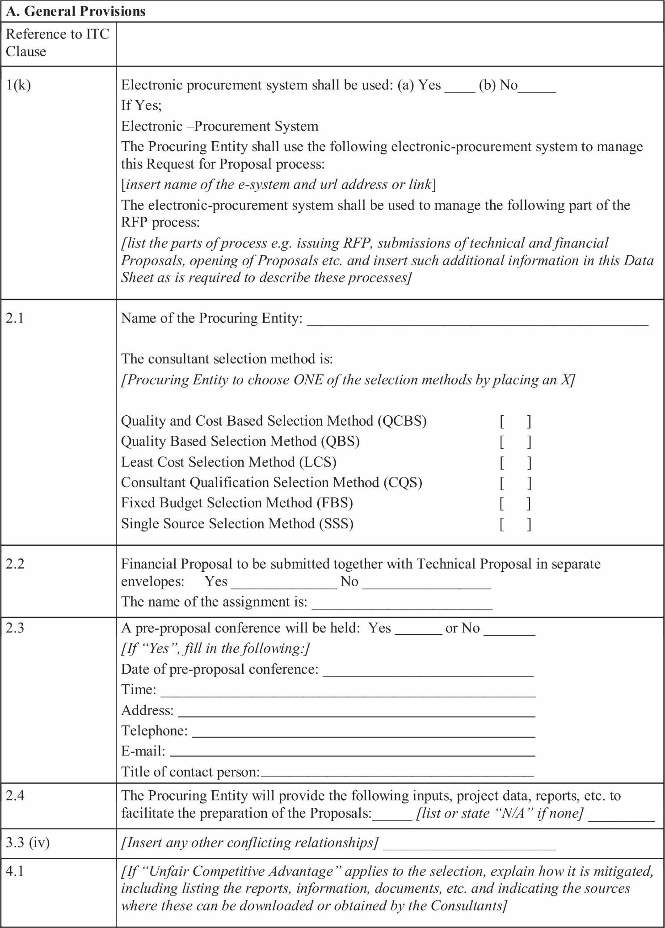

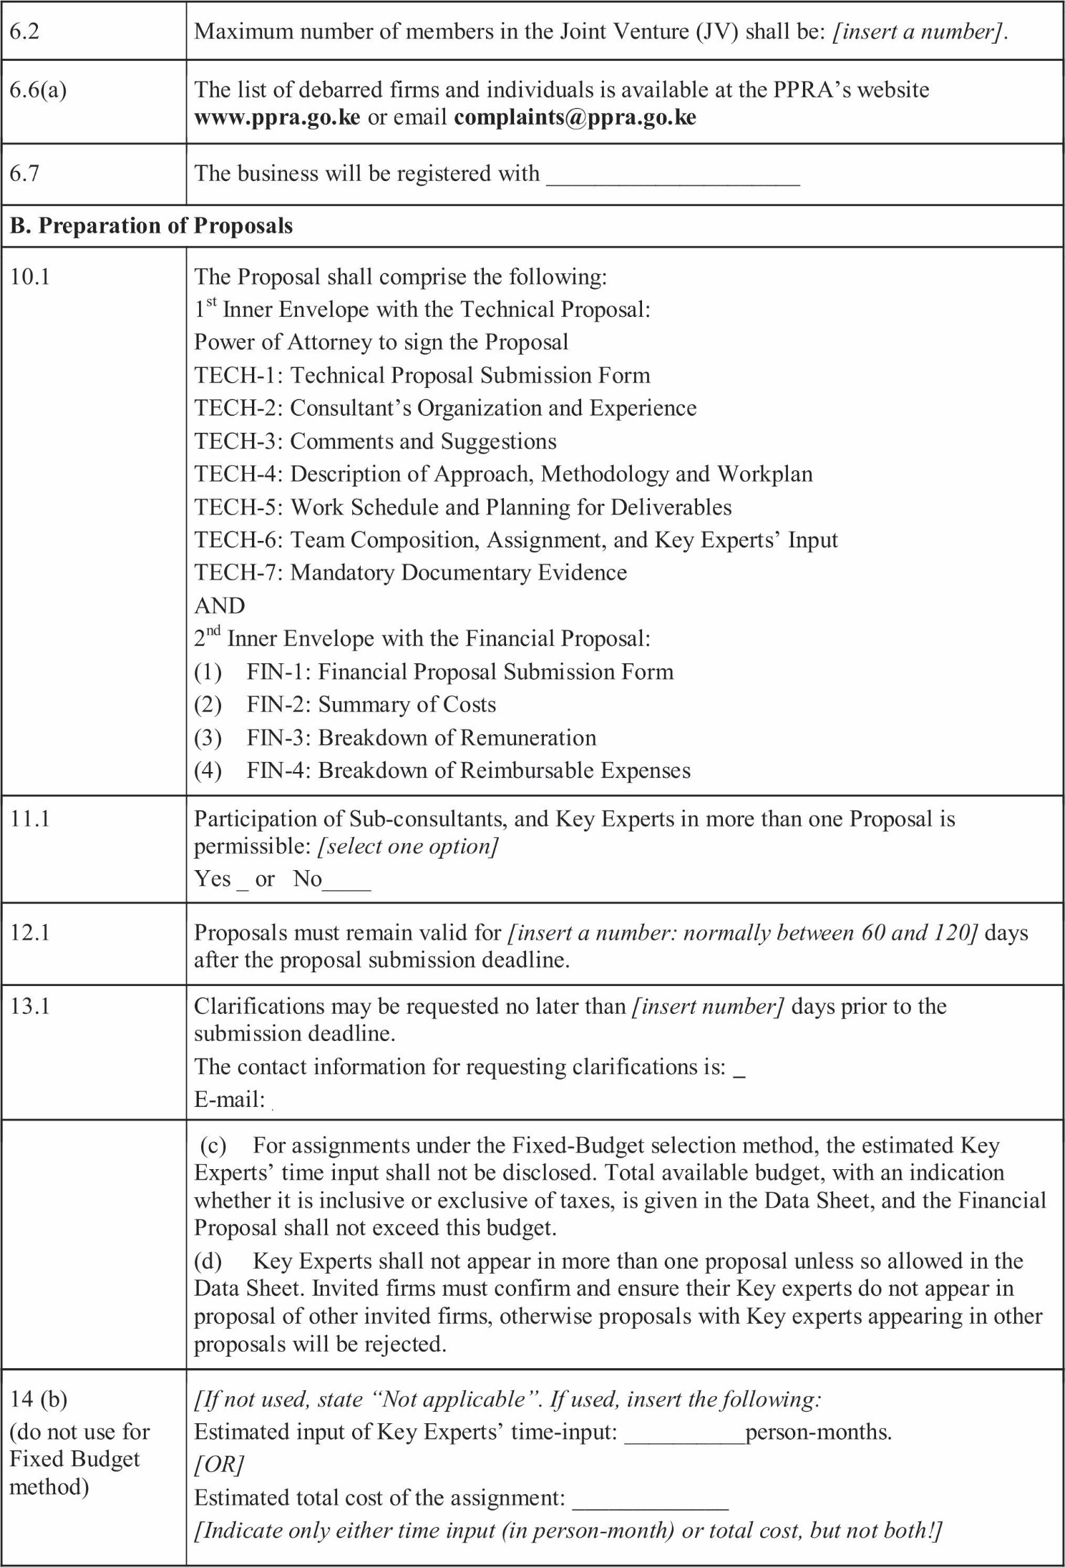

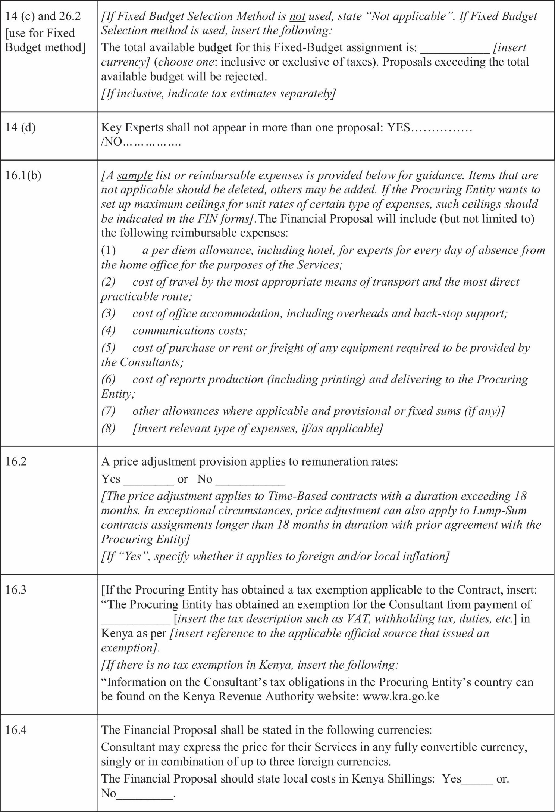

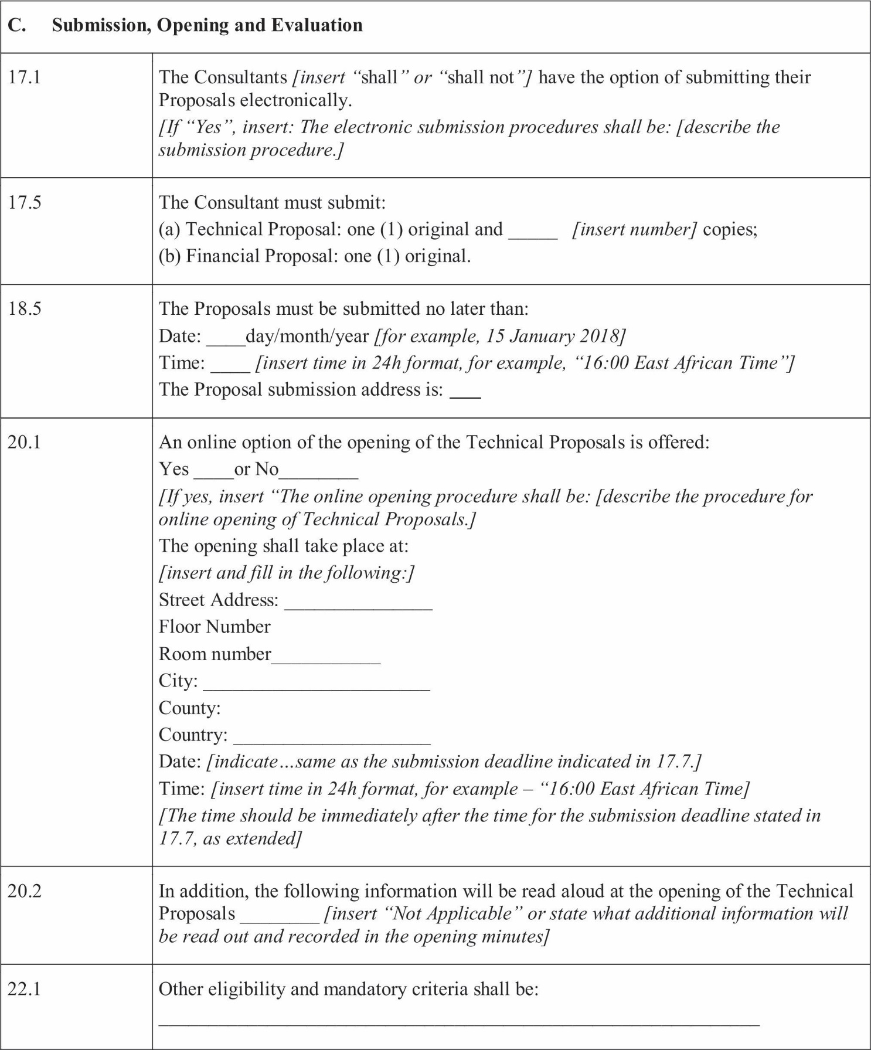

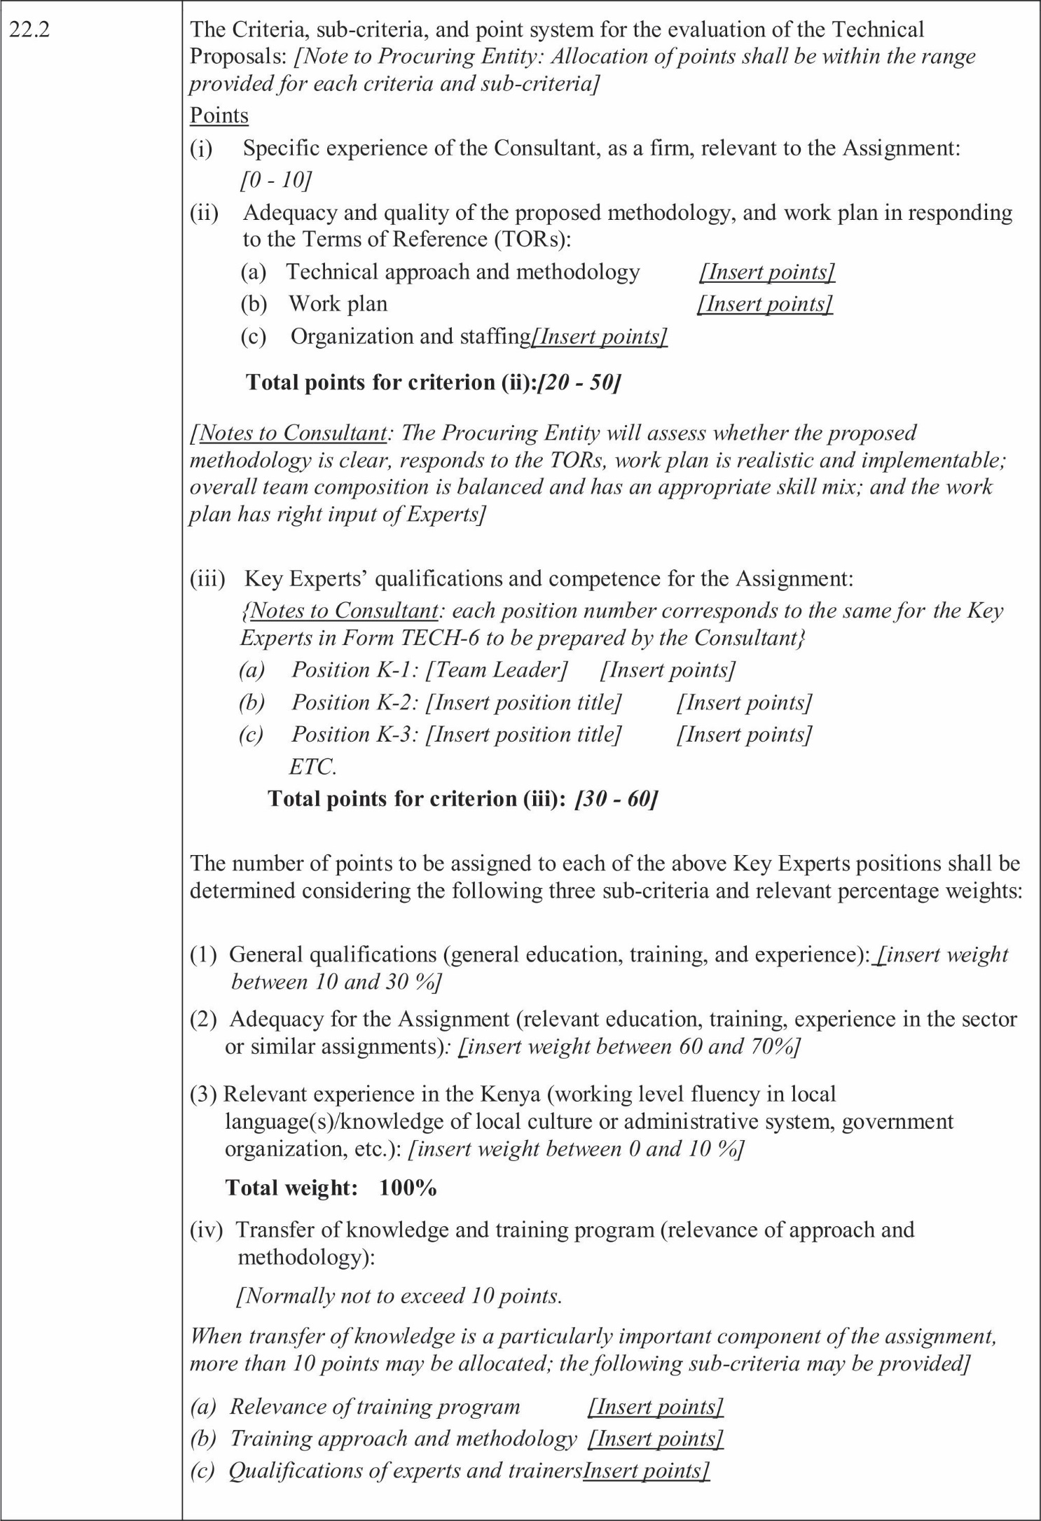

-

SECTION 3. TECHNICAL PROPOSAL – STANDARD FORMS
{Notes to Consultant shown in brackets {} throughout Section 3 provide guidance to the Consultant to prepare the Technical Proposal; they should not appear on the Proposals to be submitted.}

FORMTECH-1: TECHNICAL PROPOSAL SUBMISSION FORM
{Location, Date}
To: [Name and address of Procuring Entity]
Dear Sirs:
We, the undersigned, offer to provide the consulting services for [Insert title of assignment] in accordance with your RFP dated [Insert Date] and our Proposal. We are hereby submitting our Proposal, which includes this Technical Proposal and a Financial Proposal sealed in a separate envelope.
{If the Consultant is a joint venture, insert the following: We are submitting our Proposal in association/as a consortium/as a joint venture with: {Insert a list with full name and the legal address of each member, and indicate the lead member}. We have attached a copy {insert: “of our letter of intent to form a joint venture” or, if a JV is already formed, “of the JV agreement”} signed by every participating member, which details the likely legal structure of and the conﬁrmation of joint and severable liability of the members of the said joint venture.
OR
{If the Consultant's Proposal includes Sub-consultants, insert the following:} We are submitting our Proposal with the following ﬁrms as Sub-consultants: {insert a list with full name and address of each Sub-consultant.}
We hereby declare that:
- All the information and statements made in this Proposal are true and we accept that any misinterpretation or misrepresentation contained in this Proposal may lead to our disqualiﬁcation by the Procuring Entity or maybe sanctioned by the PPRA.
- Our Proposal shall be valid and remain binding upon us for the period of time speciﬁed in the Data Sheet, Clause 12.1.
- We have no conﬂict of interest in accordance with ITC3.
- We meet the eligibility requirements as stated in ITC6, and we conﬁrm our understanding of our obligation to abide by the Government's policy in regard to corrupt, fraudulent and prohibited practices as per ITC5.
- In competing for (and, if the award is made to us, in executing) the Contract, we undertake to observe the laws against fraud and corruption, including bribery, as well as laws against anti-competitive practices, including bid rigging in force in Kenya; we hereby certify that we have taken steps to ensure that no person acting for us or on our behalf engages in any type of Fraud and Corruption or anti-competitive practices.
- We conﬁrm that we are not insolvent, in receivership, bankrupt or on the process of being of being wound up.
- The Consultant shall declare in the Technical Proposal Submission Form, that in competing for and executing a contract, it shall undertake to observe the laws of Kenya against fraud and corruption including bribery, as well as against anti-competitive practices including bid-rigging.
- We are not guilty of any serious violation of fair employment laws and practices. We undertake to observe the laws of Kenya against fraud and corruption including bribery, as well as against collusive and anti-competitive practices, including bid rigging. To this effect we have signed the “Certiﬁcate of Independent Proposal Determination” attached below. We also undertake to adhere by the Code of Ethics for persons participating in Public Procurement and Asset Disposal Activities in Kenya, copy available from (specify website) during the procurement process and the execution of any resulting contract.

  - We, along with any of our sub-consultants are not subject to, and not controlled by any entity or individual that is subject to, a temporary suspension or a debarment imposed by the PPRA.
(e) Except as stated in the ITC12 and Data Sheet, we undertake to negotiate a Contract on the basis of the proposed Key Experts. We accept that the substitution of Key Experts for reasons other than those stated in ITC Clause12 andITCClause29.3 and 29.4 may lead to the termination of Contract negotiations.
- Our Proposal is binding upon us and subject to any modiﬁcations resulting from the Contract negotiations.
- We understand that the Procuring Entity is not bound to accept any Proposal that it receives.
We undertake, if our Proposal is accepted and the Contract is signed, to initiate the Services related to the assignment no later than the date indicated in Clause 32.2 of the Data Sheet.
We remain, Yours sincerely,

Authorized Signature {In full and initials}: Name and Title of Signatory:
Name of Consultant (company’s name or JV's name):
Contact information (phone and e-mail):

{For a joint venture, either all members shall sign or only the lead member, in which case the power of attorney to sign on behalf of all members shall be attached}

CERTIFICATE OF INDEPENDENTPROPOSALDETERMINATION
I, the undersigned, in submitting the accompanying TECHNICAL PROPOSAL SUBMISSION FORM to the
[LANDS,HOUSING,PHYSICAL PLANNING AND URBANA AREAS MANAGEMENT]
for: [Name and number of tender] in response to the request for tenders made by: [Name of Tenderer] do hereby make the followingstatementsthatIcertifytobetrueandcompleteineveryrespect:
I certify, on behalf of [Name of Tenderer] that:

  - I have read and I understand the contents of this Certificate;

2. I understand that the Tender will be disqualified if this Certificate is found not to be true and complete in every
respect;
- I am the authorized representative of the Tenderer with authority to sign this Certificate, and to submit the Tender on behalf of the Tenderer;
- For the purposes of this Certiﬁcate and the Tender, I understand that the word “competitor” shall include any individual or organization, other than the Tenderer, whether or not afﬁliated with the Tenderer, who:
  - Has been requested to submit a Tender in response to this request for tenders;
  - could potentially submit a tender in response to this request for tenders, based on their qualiﬁcations, abilities or experience;
- The Tenderer discloses that [check one of the following, as applicable]:
  - The Tenderer has arrived at the Tender independently from, and without consultation, communication, agreement or arrangement with, any competitor;
  - The Tenderer has entered into consultations, communications, agreements or arrangements with one or more competitors regarding this request for tenders, and the Tenderer discloses, in the attached document(s), complete details thereof, including the names of the competitors and the nature of, and reasons for, such consultations, communications, agreements or arrangements;
- In particular, without limiting the generality of paragraphs(5)(a) or (5) (b)above, there has been no consultation, communication, agreement or arrangement with any competitor regarding:
  - prices;
  - methods, factors or formulas used to calculate prices;
  - the intention or decision to submit, or not to submit, a proposal; or
  - the submission of a proposal which does not meet the speciﬁcations of the request for proposals; except as speciﬁcally disclosed pursuant to paragraph(5)(b) above;
- In addition, there has been no consultation, communication, agreement or arrangement with any competitor regarding the quality, quantity, speciﬁcations or delivery particulars of the works or services to which this RFP relates, except as speciﬁcally authorized by the procuring authority or as speciﬁcally disclosed pursuant to paragraph(5)(b) above;
- The terms of the RFP have not been, and will not be, knowingly disclosed by the Consultant, directly or indirectly, to any competitor, prior to the date and time of the ofﬁcial proposed opening, or of the awarding of the Contract, which ever comes ﬁrst, unless otherwise required by law or as speciﬁcally disclosed pursuant to paragraph(5)(b) above.

Name Title Date
[Name, title and signature of authorized agent of Consultant and Date]

3. APPENDIX TO FORM OF PROPOSAL ON FRAUD AND CORRUPTION CLAUSE (for information)
(Appendix shall not be modiﬁed)

Purpose
the government of Kenya's Anti-Corruption and Economic Crime laws and their sanction's policies and procedures, Public Procurement and Asset Disposal Act (no. 33 of 2015) and its Regulation, and any other Kenya's Acts or Regulations related to Fraud and Corruption, and similar offences, shall apply with respect to Public Procurement Processes and Contracts that are governed by the laws of Kenya.

Requirements
The Government of Kenya requires that all parties including Procuring Entities, Tenderers, (applicants/proposers), Consultants, Contractors and Suppliers; any Sub-contractors, Sub-consultants, Service providers or Suppliers; any Agents (whether declared or not); and any of their Personnel, involved and engaged in procurement under Kenya's Laws and Regulation, observe the highest standard of ethics during the procurement process, selection and contract execution of all contracts ,and refrain from Fraud and Corruption and fully comply with Kenya's laws and Regulations as per paragraphs 1.1 above.
Kenya's public procurement and asset disposal act (no.33 of 2015) under Section 66 describes rules to be followed and actions to be taken in dealing with Corrupt, Coercive, Obstructive, Collusive or Fraudulent practices, and Conﬂicts of Interest in procurement including consequences for offences committed. A few of the provisions noted below highlight Kenya's policy of no tolerance for such practices and behavior:
- a person to whom this Act applies shall not be involved in any corrupt, coercive, obstructive, collusive or fraudulent practice; or conﬂicts of interest in any procurement or asset disposal proceeding;
- A person referred to under sub section (1) who contravenes the provisions of that sub-section commits an offence;
- Without limiting the generality of the subsection (1) and (2), the person shall be: -
  - disqualiﬁed from entering into a contract for a procurement or asset disposal proceeding; or
  - if a contract has already been entered into with the person, the contract shall be avoidable;
- The voiding of a contract by the procuring entity under subsection (7) does not limit any legal remedy the procuring entity may have;
- An employee or agent of the procuring entity or a member of the Board or committee of the procuring entity who has a conﬂict of interest with respect to a procurement—
- Shall not take part in the procurement proceedings;
- shall not, after a procurement contract has been entered into, take part in any decision relating to the procurement or contract; and
- Shall not be a sub-contractor for the tender to whom was awarded contract, or a member of the group of tenderers to whom the contract was awarded, but the sub-contractor appointed shall meet all the requirements of this Act.
- An employee, agent or member described in subsection (1) who refrains from doing anything prohibited under that subsection, but for that subsection, would have been within his or her duties shall disclose the conﬂict of interest to the procuring entity;
- If a person contravenes sub section (1) with respect to a conﬂict of interest described in subsection (5)(a) and the contract is awarded to the person or his relative or to another person in whom one of them had a direct or indirect pecuniary interest, the contract shall be terminated and all costs incurred by the public entity shall be made good by the awarding ofﬁcer.
- Incompliance with Kenya's laws, regulations and policies mentioned above, the Procuring Entity:
  - Deﬁnes broadly, for the purposes of the above provisions, the terms set forth below as follows:
    - “corrupt practice” is the offering, giving, receiving, or soliciting, directly or indirectly, of anything of value to inﬂuence improperly the actions of another party;
    - “fraudulent practice” is any act or omission, including misrepresentation, that knowingly or

recklessly misleads, or attempts to mislead, a party to obtain ﬁnancial or other beneﬁt or to avoid an obligation;
    - “collusive practice “is an arrangement between two or more parties designed to achieve an improper purpose, including to inﬂuence improperly the actions of another party;
    - “coercive practice” is impairing or harming, or threatening to impair or harm, directly or indirectly, any party or the property of the party to inﬂuence improperly the actions of a party;
    - “obstructive practice” is:
      - deliberately destroying, falsifying, altering, or concealing of evidence material to the investigation or making false statements to investigators in order to materially impede investigation by Public Procurement Regulatory Authority (PPRA) or any other appropriate authority appointed by Government of Kenya into allegations of a corrupt, fraudulent, coercive, or collusive practice; and/or threatening, harassing, or intimidating any party to prevent it from disclosing its knowledge of matters relevant to the investigation or from pursuing the investigation; or
      - Acts intended to materially impede the exercise of the PPRA's or the appointed authority's inspection and audit rights provided for under paragraph 2.3e. below.
  - Deﬁnes more speciﬁcally, in accordance with the above procurement Act provisions set forth for fraudulent and collusive practices as follows:
"fraudulent practice" includes a misrepresentation of fact in order to inﬂuence a procurement or disposal processortheexerciseofacontracttothedetrimentoftheprocuringentityorthetendererorthecontractor, andincludescollusivepracticesamongsttendererspriortooraftertendersubmissiondesignedtoestablish tender prices at artiﬁcial non-competitive levels and to deprive the procuring entity of the beneﬁts of free and open competition.
  - Rejects a proposal or award1of a contract if PPRA determines that the ﬁrm or individual recommended for award, any of its personnel, or its agents, or its sub-consultants, sub-contractors, service providers, suppliers and/ or their employees, has, directly or indirectly, engaged in corrupt, fraudulent, collusive, coercive, or obstructive practices in competing for the contract in question;
  - Pursuant to the Kenya's above stated Acts and Regulations, may sanction or debar or recommend to appropriate authority (ies) for sanctioning and debarment of a ﬁrm or individual, as applicable under the Acts and Regulations;
  - Requires that a clause be included in Tender documents and Request for Proposal documents requiring (i) Tenderers (applicants/proposers),Consultants, Contractors, and Suppliers and their Sub-contractors, Sub- consultants, Service providers, Suppliers, Agents personnel, permit the PPRA or any other appropriate authority appointed by Government of Kenya to inspect2all accounts, records and other documents relating to the procurement process, selection and/or contract execution, and to have them audited by auditors appointed by the PPRA or any other appropriate authority appointed by Government of Kenya; and
  - Pursuant to Section 62 of the above Act, requires Applicants/Tenderers to submit along with their Applications/Tenders/Proposals a “Self-Declaration Form” as included in the procurement document declaring that they and all parties involved in the procurement process and contract execution have not engaged/will not engage in any corrupt or fraudulent practices.

1For the avoidance of doubt, a party's ineligibility to be awarded a contract shall include, without limitation, (i) applying for pre-qualiﬁcation, expressing interest in
A consultancy, and tendering, either directly or as a nominated sub-contractor, nominated consultant, nominated manufacturer or supplier, or nominated service provider, in respect of such contract, and(ii) entering into an addendum or amendment introducing a material modiﬁcation to any existing contract.
2 Inspections in this context usually are investigative (i.e., forensic) in nature. They involve fact-ﬁnding activities undertaken by the Investigating Authority or persons appointed by the Procuring Entity to address speciﬁc matters related to investigations/audits, such as evaluating the veracity of an allegation of possible Fraud and Corruption, through the appropriate mechanisms. Such activity includes but is not limited to: accessing and examining a ﬁrm's or individual's ﬁnancial records and information, and making copies thereof as relevant; accessing and examining any other documents, data and information (whether in hard copy or electronic format) deemed relevant for the investigation/audit, and making copies there of as relevant; interviewing staff and other relevant individuals; performing physical inspections and site visits; and obtaining third party veriﬁ

REQUEST FOR CONSULTANCY SERVICES FOR THE PLANNING OF THREE URBAN CENTRES WITHIN TURKANA COUNTY.
County Government of Turkana is seeking to recruit a spatial planning consultant to prepare local spatial development plans for Katilu, Kalobeyei and Lokiriama.
The aim of the project is to prepare local Spatial Development Plans for the mentioned Centres that will guide development of the same for a period of 10years.
The plans will be prepared as per the requirements of the Physical and Land Use Planning Act of 2019.

Deliverable s.
The specific objectives include;

-Preparation of plans that will guide spatial development of the Urban Centers based on the existing situational analysis.
-Ensure that all cross cutting issues such as Climate change, Gender, Disaster Risk reduction, Persons with disabilities and Age are mainstreamed in the plans.
-Interpret and localize strategic national, regional and county policies and strategies.
-To produce Digital maps for planning, infrastructure development and maintenance programmes for the towns.
-To identify the vital natural resources within the towns, analyze level of utilization and propose innovative strategies to enhance their utilization and sustainable management.
-Provide a framework for revitalizing industries, trade and commerce within the towns to spur economic development.
-Formulate strategies for improving transport and communication networks and linkages within the Urban Centres.
-Develop strategies to realize a system of land use for sustainable urban development.
-Identify the region’s environmental concerns and propose protection and conservation Measures.
-Produce Local Development Spatial Plans (whereby the format of the final plan shall be a GIS based digital map and hard copy maps).
-Provide capital investment framework for all development programs proposed within the Urban Centres.
-Provide for Plan Implementation Strategy/framework.

Planning area for specific towns
- Katilu………………….….5km2
- Lokiriama …………….….5km2
- Kalobeyei …….…………..5km2
Qualifications of the Successful Individual firm:
-A minimum Master’s Degree in the field of Urban and Regional Planning, Environmental Planning, Land-use Planning, or similar field for the lead consultant
-Evidence of the ability to develop GIS based spatial plans.
-Familiarity with the area is desirable.
-The consultant shall have excellent spatial planning, analytical, report writing and communication skills, and excellent knowledge of English.
-Youth, women and persons with disabilities are encouraged to apply
Competency for Successful Firm
-The Consultant shall have minimum 5 years of professional experience in the field of Physical/Spatial/Land-use planning and a sound track record of at least 5 successfully completed relevant assignments, such as development of Local Development Spatial Plans and other Physical Development Plans or Spatial/Land-use Plans, out of which s/he shall have been the lead consultant or lead expert (to be clearly stated in the CV and provide evidence of such).
-The lead Consultant should be registered with the Physical Planners Registration Board and should demonstrate capacity to develop GIS based Spatial and Land Use Plans by attaching copies of previous GIS work done in preparing the spatial Plans or other Physical Development Plans.
-Previous experience/knowledge in incorporation/mainstreaming of development control and community land issues in Turkana in the development of Spatial Plans or other Physical Development Plans shall be considered an advantage.

PRELIMINARY EVALUATION
MANDATORY REQUIREMENTS
Mandatory requirements are as shown below
No. | Requirements | Bidders Response  (Yes/No)
1. | Must Submit a copy of certificate of Registration/Incorporation
2. | Must Submit a copy of Valid Tax Compliance certificate/Exemption Certificate
3. | Must submit a copy of PIN/VAT certificate
4. | Must attach CR12 form from the Registrar of Companies
5. | Valid business license permit from any county Government
6. | Original Tender Security of Kshs. 200,000/- from a bank Registered in Kenya or from an Insurance Company Approved by PPRA or equivalent in foreign currency. Valid for 210 days from the date of tender opening.
7. | Must provide the letter professional indemnity.
8. | Dully filled, signed and stamped Self Declaration that the person/tender not to engage in any corrupt or fraudulent practice.
9. | Must fill up, signed and stamped declaration that the bidder or his or her sub-contractors are not debarred from participating in Public Procurement.
10. | Dully filled and signed confidential Business Questionnaire
11. | Must attached the letter of authorization/dealership from the manufacturer.
12. | Must Fill the Price Schedule in the format provided
13. | Bidders must paginate and initial each page of the document.
14 | Proffesional indemnity

TECHNICAL EVALUATION
TECHNICAL EXPERIENCE AND QUALIFICATION
S/NO | REQUIREMENT | MARKS
1 | LEAD CONSULTANT(masters degree in Urban and regional planning, Registered corporate member with a professional body and at least 5years experience.  -Masters-10mkrs  -Registration -10marks  -Experience -10mrks
2 | Technical support and proof of relevant working tools. team(surveyors,planners,environmentalist ,economist GIS expert and sociologist, must have at-least a degree in Relevant field.  Physical planner-4mrks  Surveyors-4mrks  Enviromentalist-3mrks  Economist-3mrks  GIS expert-3mrks  Sociologist-3mrks  N/B;All should be registered with relevant proffesional bodies.
3 | General experience -experience of similar jobs done in another counties with prove of 3 (THREE)LSOs,certificate of completion and notice of completion  -Experience of similar jobs in ASAL counties is an added advantage-3Mrks  -Lso -5mrks  -certificate of completion-5mrks  -notice of completion-5mrks
4 | Recommendations from the previous clients(2mrks)
cation of information.

NB/.THE CONSULTANTS WHO WILL SCORE 60MARKS AND ABOVE WILL BE INVITED FOR PRESENTATION AND FURTHER PROCEED FOR FINANCIAL STATE.

3. FORM TECH-2: CONSULTANT'S ORGANIZATION AND EXPERIENCE
Form TECH-2: a brief description of the Consultant's organization and an outline of the recent experience of the Consultant that is most relevant to the assignment. In the case of a joint venture, information on similar assignments shall be provided for each partner. For each assignment, the outline should indicate the names of the Consultant's Key Experts and Sub-consultants who participated, the duration of the assignment, the contract amount (total and, if it was done in a form of a joint venture or a sub-consultancy, the amount paid to the Consultant), and the Consultant's role/involvement.

A - Consultant's Organization
Provide here a brief description of the background and organization of your company, and-in case of a joint venture-of each member for this assignment.
B - Consultant's Experience
- List only previous similar assignments successfully completed in the last [....................................] years.
- List only those assignments for which the Consultant was legally contracted by the Procuring Entity as a company or was one of the joint venture partners. Assignments completed by the Consultant's individual experts working privately or through other consulting ﬁrms cannot be claimed as the relevant experience of the Consultant, or that of the Consultant's partners or sub-consultants, but can be claimed by the Experts themselves in their Curriculum Vitae (CV).
- The Consultant shall substantiate their claimed experience by presenting copies of relevant documents such as the form of contract (not the whole contract), purchase order, service order, performance certiﬁcate, etc.; which shall be included in the proposal as part of Form Tech 7 Mandatory Documentary Evidence.

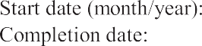
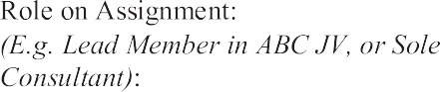

FORMTECH-3: COMMENT SAND SUGGESTIONS
Form TECH-3: The Consultant to provide comments and suggestions on the Terms of Reference, counterpart staff and facilities to be provided by the Procuring Entity that could improve the quality/effectiveness of the assignment; and on requirements for counterpart staff and facilities, which are provided by the Procuring Entity, including: administrative support, ofﬁce space, local transportation, equipment, data, etc.

A - On the Terms of Reference
{Improvements to the Terms of Reference, if any}
B - On Counterpart Staff and Facilities
{Include comments on counterpart staff and facilities to be provided by the Procuring Entity. For example, administrative support, ofﬁce space, local transportation, equipment, data, background reports, etc., if any}
- FORMTECH-4: DESCRIPTION OF APPROACH, METHODOLOGY, AND WORK PLAN
Form TECH-4: a description of the approach, methodology and work plan in responding to the terms of reference for performing the assignment, including a detailed description of the proposed methodology and stafﬁng for training, if the Terms of Reference specify training as a speciﬁc component of the assignment.
{The structure of your Technical Proposal:
  - Technical Approach and Methodology
  - Work Plan
  - Organization and Stafﬁng}
    - Technical Approach and Methodology. {Please explain your understanding of the objectives of the assignment as outlined in the Terms of Reference (TORs), the technical approach, and the methodology you would adopt for implementing the tasks to deliver the expected output(s), and the degree of detail of such output. Please do not repeat/copy the TOR sin here.}
    - Work Plan. {Please outline the plan for the implementation of the main activities/tasks of the assignment, their content and duration, phasing and interrelations, milestones (including interim approvals by the Procuring Entity), and tentative delivery dates of their ports. The proposed work plan should be consistent with the technical approach and methodology, showing your understanding of the TOR and ability to translate them into a feasible working plan. A list of the ﬁnal documents (including reports) to be delivered as ﬁnal output(s)should be included here. The work plan should be consistent with the Work Schedule Form.}
    - Organization and Stafﬁng. {Please describe the structure and composition of your team, including the list of the Key Experts, Non-Key Experts and relevant technical and administrative support staff.}

28

FORM TECH-5: WORK SCHEDULE AND PLANNING FOR DELIVERABLES

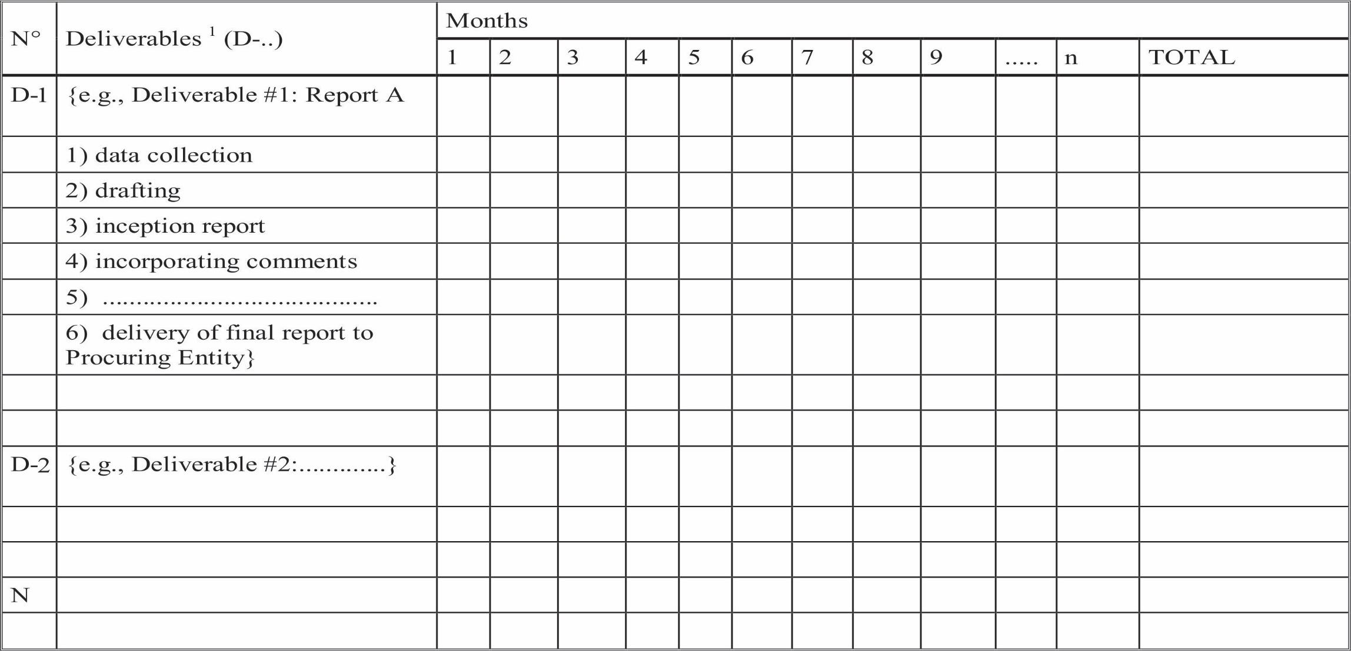

- List the deliverables with the breakdown for activities required to produce them and other benchmarks such as the Procuring Entity's approvals. For phased assignments, indicate the activities, delivery of reports, and benchmarks separately for each phase.
- Duration of activities shall be indicated in a form of a bar chart.
3. Include a legend, if necessary, to help read the chart.

29

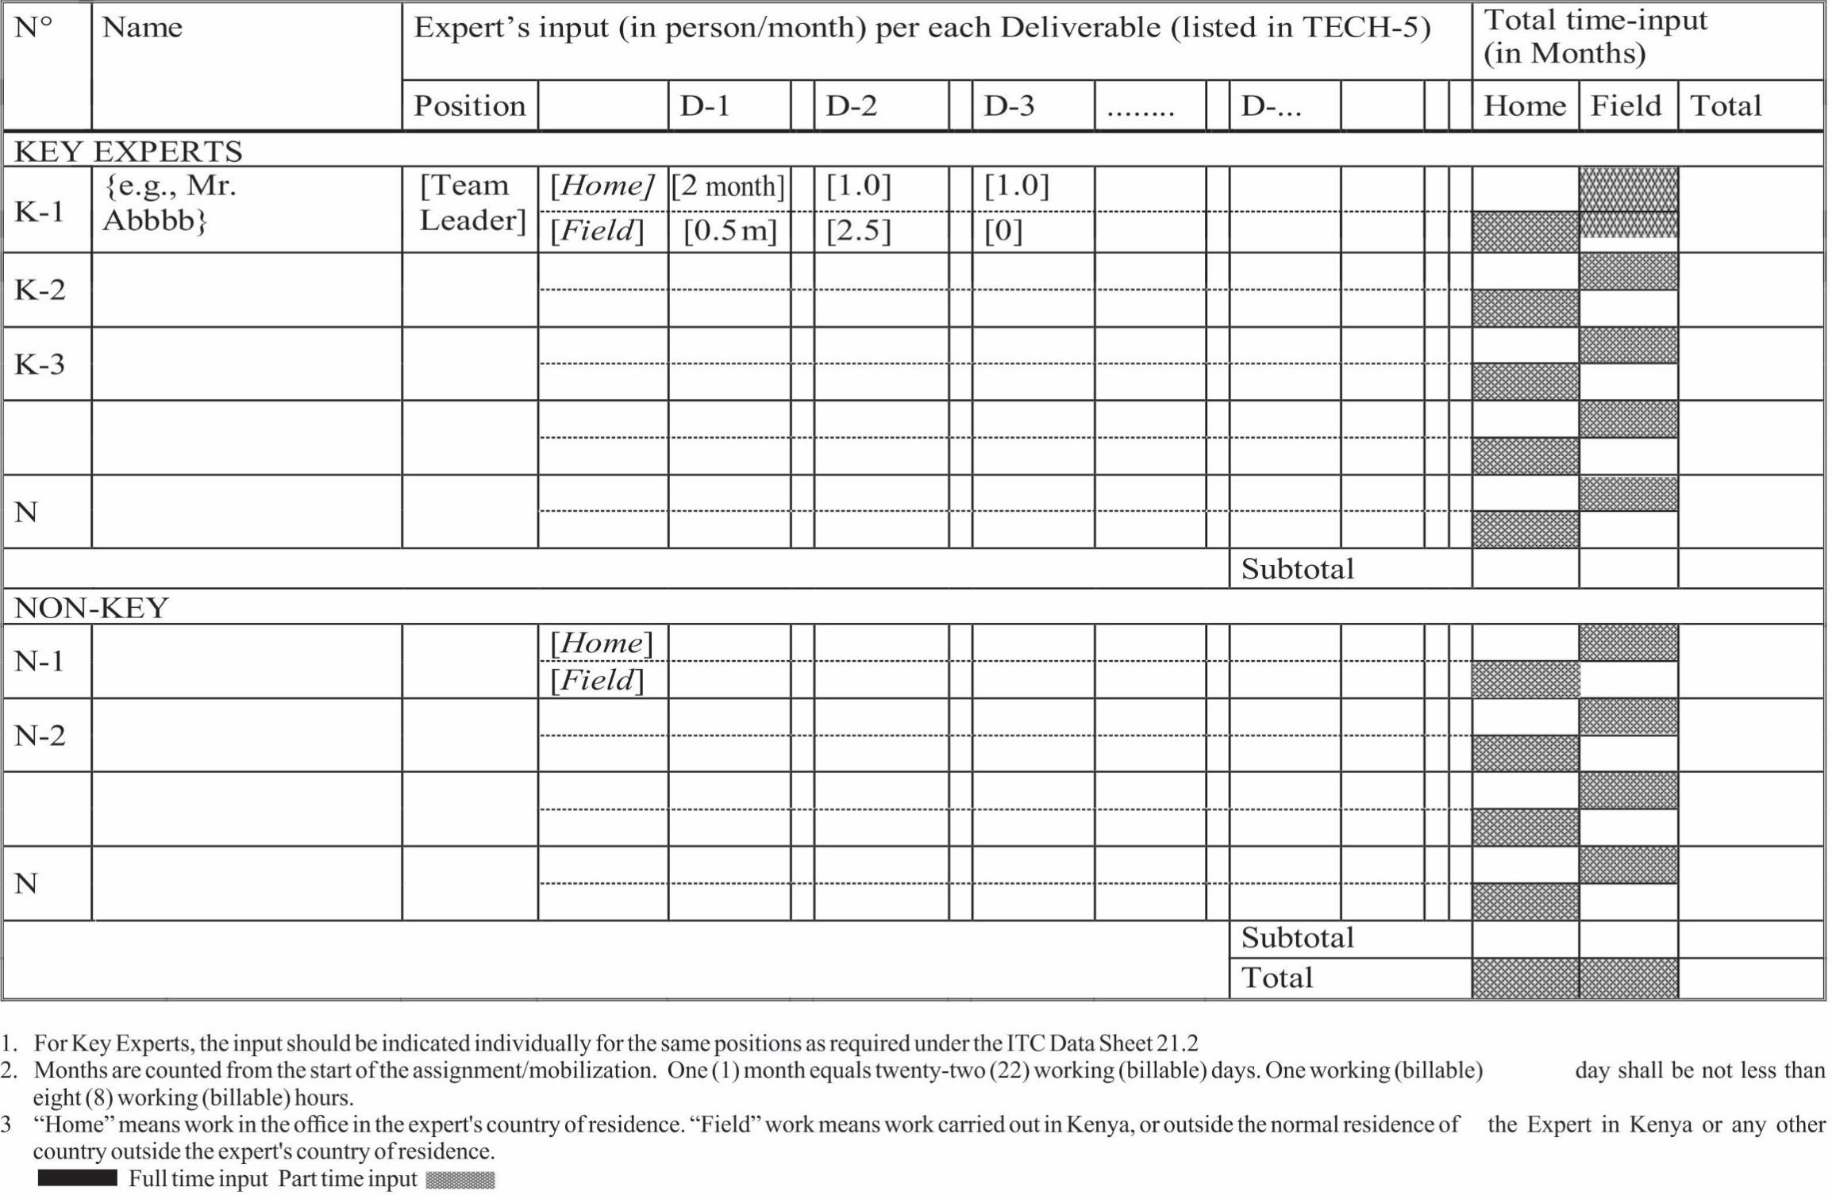
FORMT ECH- 6A: TEAM COMPOSITION, ASSIGNMENT, AND KEY EXPERTS' INPUTS

FORM TECH-6B: CURRICULUM VITAE (CV)

Education: {List college/university or other specialized education, giving names of educational institutions, dates attended, degree(s)/diploma(s) obtained}

Employment record relevant to the assignment: {Starting with present position, list in reverse order. Please provide dates, name of employing organization, titles of positions held, types of activities performed and location of the assignment, and contact information of previous Procuring Entity's and employing organization(s) who can be contacted for references. Past employment that is not relevant to the assignment does not need to be included.}

 |  |  | 
 | 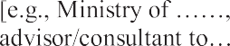  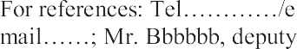

Membership in Professional Associations and Publications:
Language Skills (indicate only languages in which you can work):

Adequacy for the Assignment:




Expert's contact information :(e-mail……………..............................……. phone………....................................……) Certiﬁcation:
I, the undersigned, certify that to the best of my knowledge and belief, this CV correctly describes myself, my qualiﬁcations, and my experience, and I am available to undertake the assignment in case of an award. I understand that any misstatement or misrepresentation described herein may lead to my disqualiﬁcation or dismissal by the Procuring Entity, and/or sanctions by the PPRA.

{day / month/year}
Name of Expert Signature Date

{day / month/year}
Name of authorized Signature. Date
Representative of the Consultant (the same who signs the Proposal

FORMTECH-7: MANDATORY SUPPORT DOCUMENTS

[The Consultant shall use this form to submit all the required support documentary evidence as required in the RFP, especially the mandatory and eligibility criteria speciﬁed in the Data Sheet ITC 21.1]
- Certiﬁcate of Incorporation/Certiﬁcate of Registration
{Insert here a copy of certiﬁcate of incorporation or registration}
- Tax Compliance Certiﬁcate
{Consultant to insert a copy of the tax compliance certiﬁcate from Kenya Revenue Authority or similar body in the case of foreign consulting ﬁrms}
- Practice License or Certiﬁcate for the Firm
{If required, Consultant to insert a copy of the ﬁrm's practice license or registration certiﬁcate issued by the professional body speciﬁed under Data Sheet ITC 21.1}
- Similar Consulting Assignments Experience
{Consultant to insert here copies of the form of contract, purchase order, service order, and performance certiﬁcate or similar evidence of similar assignments carried out by the ﬁrm. The assignments shall be the same as those provided under FORM TECH 2B}
- Academic Certiﬁcates
{Consultant to insert copies of the required relevant academic certiﬁcates relevant to the assignment for all the key experts}
- Professional Certiﬁcates
{Consultant to insert copies of professional certiﬁcates and relevant short-term trainings to demonstrate professional qualiﬁcations for all the key experts}
- Professional Membership of Key Experts
{If applicable, Consultant to insert copies of professional membership certiﬁcate for its key experts}
- Certiﬁcate of Independent Proposal Determination
(The Form is available on Tech FORM TECH-1: TECHNICAL PROPOSAL SUBMISSION FORM).

FORM TECH - 8: SELF-DECLARATIONFORMS

FORM SD1
SELF DECLARATION THAT THE PERSON/TENDERER IS NOT DEBARRED IN THE MATTER OF THE PUBLIC PROCUREMENT AND ASSET DISPOSAL ACT 2015.

I, ……………………………………., of Post Ofﬁce Box …….………………………. being a resident of
………………………………….. in the Republic of ……………………………. do hereby make a statement as follows: -

- THAT I am the Company Secretary/Chief Executive/Managing Director/Principal Ofﬁcer/Director of
………....……………………………….. (Insert name of the Company) who is a Bidder in respect of Tender No.
…………………. for……………………. (Insert tender title/description) for……………………. (Insert name of the Procuring entity) and duly authorized and competent to make this statement.

- THAT the aforesaid Bidder, its Directors and subcontractors have not been debarred from participating in procurement proceeding under Part IV of the Act.

- THAT what is deponed to here in above is true to the best of my knowledge, information and belief.

…………………………………. ………………………………. ……………………… (Title) (Signature) (Date)

Bidder Ofﬁcial Stamp

FORM SD2

SELF DECLARATION THAT THE PERSON/TENDERER WILL NOT ENGAGE IN ANY CORRUPT OR FRAUDULENT PRACTICE.

I, .................................................................... of P. O. Box.....................................................being a resident of
………………………………….. in the Republic of ………………. do hereby make a statement as follows: -
- THAT I am the Chief Executive/Managing Director/Principal Ofﬁcer/Director of………....
………………………… (insert name of the Company) who is a Bidder in respect of Tender No.
……………….......................................................….. for ……………………. (insert tender title/description) for ……………......................................… (insert name of the Procuring entity) and duly authorized and competent to make this statement.

- THAT the aforesaid Bidder, its servants and/or agents /subcontractors will not engage in any corrupt or fraudulent practice and has not been requested to pay any inducement to any member of the Board, Management, Staff and/or employees and/ or agents of……………………. (insert name of the Procuring entity) which is the procuring entity.

- THAT the aforesaid Bidder, its servants and/or agents /subcontractors have not offered any inducement to any member of the Board, Management, Staff and/or employees and/or agents of……………………. (name of the procuring entity).

- THAT the aforesaid Bidder will not engage /has not engaged in any corrosive practice with other bidders participating in the subject tender.

- THAT what is deponed to herein above is true to the best of my knowledge information and belief.

………………………………… | …………………………… | ………………………
(Title)  Bidder's Ofﬁcial Stamp | (Signature) | (Date)

DECLARATION AND COMMITMENT TO THE CODE OF ETHICS

I …………………………....................................................................................………. (person) on behalf of (Name
of the Business/ Company/Firm) …………………………………………………. declare that I have read and fully understood the contents of the Public Procurement & Asset Disposal Act,2015, Regulations and the Code of Ethics for persons participating in Public Procurement and Asset Disposal Activities in Kenya and my responsibilities under the Code.
I do here by commit to abide by the provisions of the Code of Ethics for persons participating in Public Procurement and Asset Disposal.
Name of Authorized signatory......................................................................................................................
Sign…………….........................................................................................................................................

Position……………...................................................................................................................................

Ofﬁce address………………………………………………. Telephone…………………....……………. E-mail………………………………………………....................................................................................
Name of the Firm/Company……………………………..............................................................................
Date………………………………………………………............................................................................

(Company Seal/ Rubber Stamp where applicable)

Witness

Name ………………………………………………………........................................................................

Sign………………………………………………………...........................................................................

Date……………………………………………………

FORM TECH - 9: TENDER-SECURING DECLARATION FORM {r 46 and 155(2)}
[The Bidder shall complete this Form in accordance with the instructions indicated]

Date:...................................................................................[insert date (as day, month and year) of Tender Submission]
Tender No.:...................................................................................[insert number of tendering process]
To:...................................................................................[insert complete name of Purchaser]

I/We, the undersigned, declare that:

- I / We understand that, according to your conditions, bids must be supported by a Tender-Securing Declaration.

- I /We accept that I/we will automatically be suspended from being eligible for tendering in any contract with the Purchaser or the period of time of[insert number of months or years] starting on[insert date],if we are in breach of our obligation (s)under the bid conditions, because we–(a) have withdrawn our tender during the period of tender validity speciﬁed by us in the Tendering Data Sheet; or (b) having been notiﬁed of the acceptance of our Bid by the Purchaser during the period of bid validity,(i) fail or refuse to execute the Contract, if required, or (ii) fail or refuse to furnish the Performance Security, in accordance with the instructions to tenders.
- I / We understand that this Tender Securing Declaration shall expire if we are not the successful Tenderer (s), upon the earlier of:
  - Our receipt of a copy of your notiﬁcation of the name of the successful Tenderer; or
  - Thirty days after the expiration of our Tender.

- I/We understand that if I am /we are/in a Joint Venture, the Tender Securing Declaration must be in the name of the Joint Venture that submits the bid, and the Joint Venture has not been legally constituted at the time of bidding, the Tender Securing Declaration shall be in the names of all future partners as named in the letter of intent.
Signed: ………………………………………………………………….………. Capacity / title (director or partner or sole proprietor, etc.) ……….………………. Name: ………………………………………………………………………………….
Duly authorized to sign the bid for and on behalf of: ..................................[insert complete name of Tenderer] Dated on …………………. day of …………….……. [Insert date of signing]
Seal or stamp

SECTION 4. FINANCIALPROPOSAL - STANDARD FORMS
{Notes to Consultant shown in brackets {....} provide guidance to the Consultant to prepare the Financial Proposals; they should not appear on the Financial Proposals to be submitted.}
Financial Proposal Standard Forms shall be used for the preparation of the Financial Proposal according to the instructions provided in Section 2.
FIN-1 Financial Proposal Submission Form FIN-2 Summary of Costs
FIN-3 Breakdown of Remuneration FIN-4 Reimbursable expenses

FORM FIN-1: FINANCIAL PROPOSAL SUBMISSION FORM

...............................................................{Location, Date}
To: ........................................................[Name and address of Procuring Entity]

Dear Sirs:
We, the undersigned, offer to provide the consulting services for.......................................... [Insert title of assignment]
in accordance with your Request for Proposal dated................................ [Insert Date] and our Technical Proposal.
Our attached Financial Proposal is for the amount of.............................................{Indicate the corresponding to the amount currency} {Insert amounts in words and ﬁgures}, including of all taxes in accordance with ITC24.2 in the Data Sheet. The estimated amount of local taxes is..........................{Insert currency} {Insert amount in words and ﬁgures}.
{Please note that all amounts shall be the same as in Form FIN-2}.
Our Financial Proposal shall be valid and remain binding upon us, subject to the modiﬁcations resulting from Contract negotiations, for the period of time speciﬁed in the ITC12.1 Datasheet.
Commissions and gratuities paid or to be paid by us to an agent or any third party relating to preparation or submission of this Proposal and Contract execution, paid if we are awarded the Contract, are listed below:
Name and Address, Amount and Purpose of Commission of Agents, Currency or Gratuity
{If no payments are made or promised, add the following statement: “No commissions or gratuities have been or are to be paid by us to agents or any third party relating to this Proposal and Contract execution.”}

We understand you are not bound to accept any Proposal you receive. We remain,
Yours sincerely,

Signature................... (of Consultant's authorized representative) {In full and initials}: Full name: .................. {insert full name of authorized representative} Title: ..................{inserttitle/positionofauthorizedrepresentative}
Name of Consultant.................. (company's name or JV's name): Capacity: ..................{insert the person's capacity to sign for the Consultant} Physical Address: ..................{insert the authorized representative's address}
Phone: ..................{insert the authorized representative's phone and fax number, if applicable} Email: ..................{insert the authorized representative's email address}
{For a joint venture, either all members shall sign or only the lead member/consultant, in which case the power of attorney to sign on behalf of all members shall be attached}

FORM FIN-2: SUMMARY OF COSTS

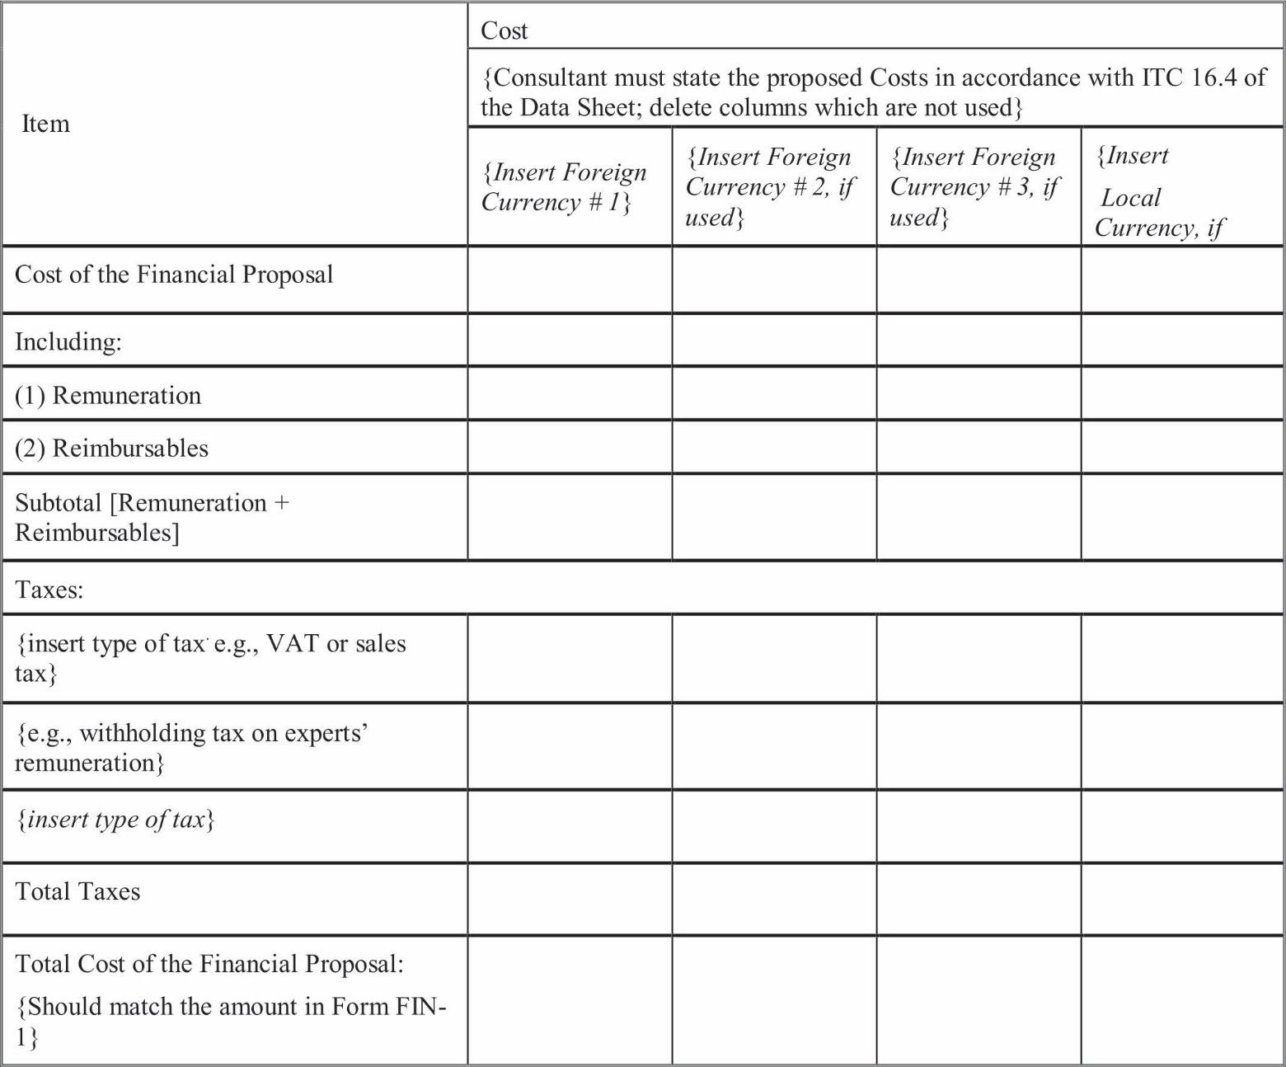

FORM FIN-3A: BREAKDOWN OF REMUNERATION
When used for Lump-Sum contract assignment, information to be provided in this Form shall only be used to demonstrate the basis for the calculation of the Contract's ceiling amount; to calculate applicable taxes at contract negotiations; and, if needed, to establish payments to the Consultant for possible additional services requested by the Procuring Entity. This Form shall not be used as a basis for payments under Lump-Sum contracts.

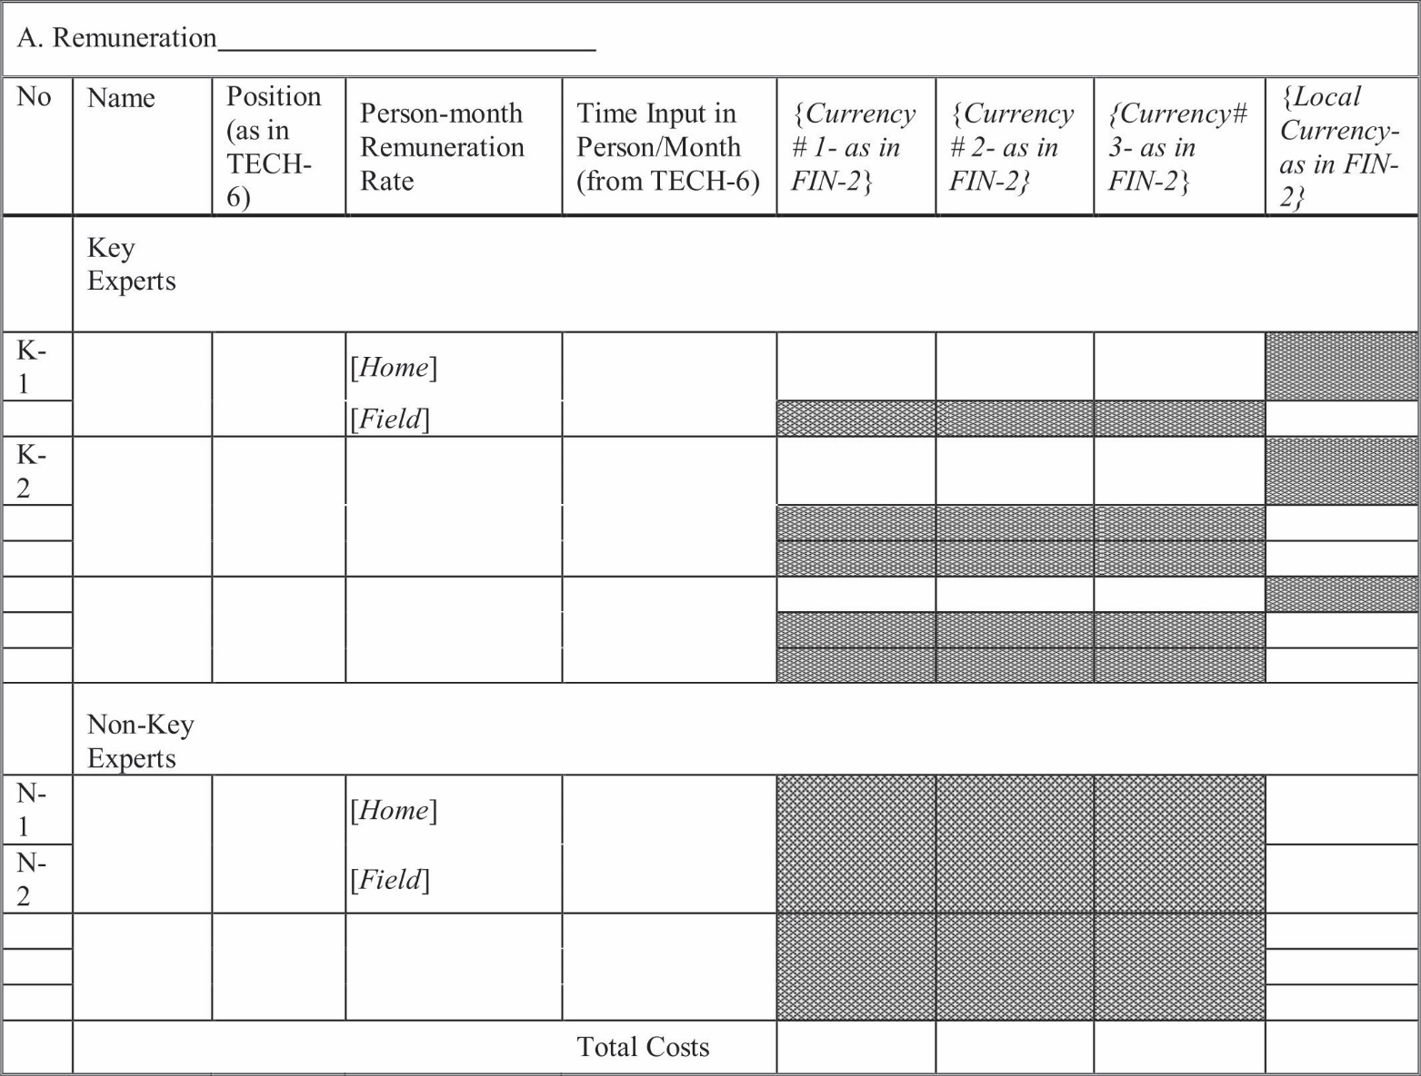

FORM FIN 3B: CONSULTANT'S REPRESENTATIONS REGARDING COSTS AND CHARGES
{This Form FIN 3B shall be used for Time-Based contracts only. If Lumpsum Contract is used, the Procuring Entity shall delete the FORMFIN-3B, FORM FIN-3C and FORM FIN-3D from the RFP before issuance to Consultants}
Consultant: ................................................................................Country:
Assignment: ................................................................................Date:
We hereby conﬁrm that:
- The basic fees indicated in the attached table are taken from the ﬁrm's pay roll records and reﬂect the current rates of the Experts listed which have not been raised other than within the normal annual pay increase policy as applied to all the Consultant's Experts;
- attached are true copies of the latest pay slips of the Experts listed;
- theaway-from-homeofﬁceallowancesindicatedbelowarethosethattheConsultanthasagreedtopayforthis assignment to the Experts listed;
- the factors listed in the attached table for social charges and overhead are based on the ﬁrm's average cost experiences for the latest three years as represented by the ﬁrm's ﬁnancial statements; and
- said factors for overhead and social charges do not include any bonuses or other means of proﬁt-sharing.

....................................................................................................................................[Name of Consultant]

Signature of Authorized Representative
Name: .............................................................................................................................................
Title: ..............................................................................................................................................
Date: ..............................................................................................................................................

42

FORM 3C: FORM FOR CONSULTANT'S REPRESENTATIONS REGARDING COSTS AND CHARGES
{This Form FIN 3C shall be used for Time-Based contracts only}
(Expressed in {insert name of currency*})

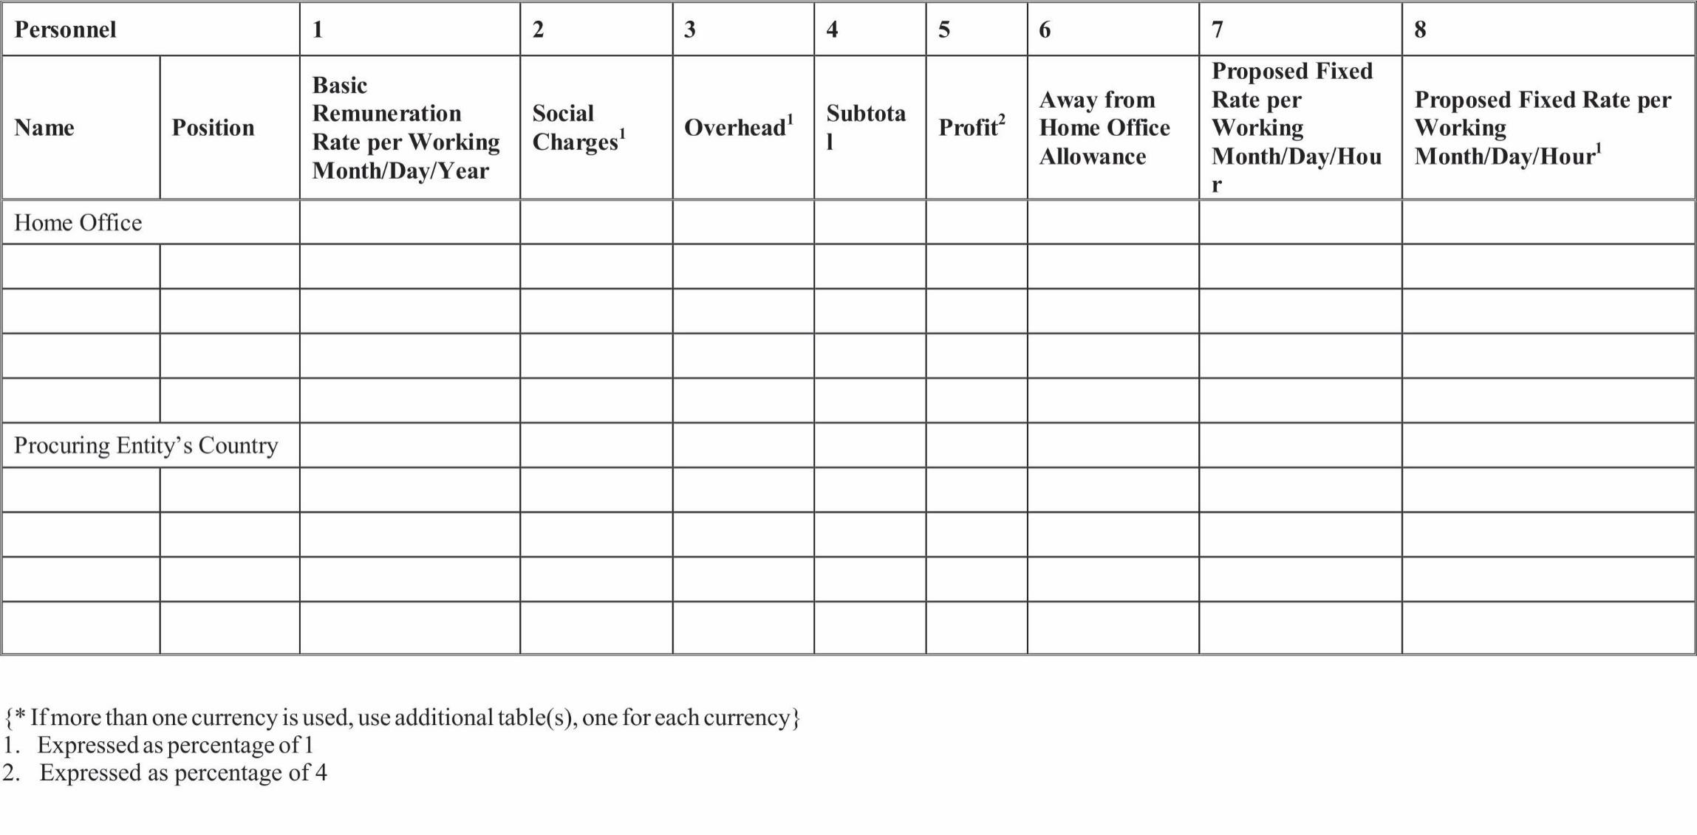

FORM FIN 3D: BREAKDOWN OF REMUNERATION RATES [FOR TIME BASED CONTRACTS ONLY]
- Review of Remuneration Rates
  - The remuneration rates are made up of salary or abase fee, social costs, overheads, proﬁt, and any premium or allowance that may be paid for assignments away from headquarters or a home ofﬁce. Form FIN3 C can be used to provide a breakdown of rates.
  - The Form FIN 3C shall be completed and attached to the Financial Form-3. As agreed at the negotiations, breakdown sheets shall form part of the negotiated Contract and included in its Appendix D or C.
  - At the negotiations the ﬁrm shall be prepared to disclose its audited ﬁnancial statements for the last three years, to substantiate its rates, and accept that its proposed rates and other ﬁnancial matters are subject to scrutiny. The Procuring Entity is charged with the custody of government funds and is expected to exercise prudence in the expenditure of these funds.

Rate details are discussed below:
- Salary is the gross regular cash salary or fee paid to the individual in the ﬁrm's home ofﬁce. It shall not contain any premium for work away from headquarters or bonus, except where these are included bylaw or government regulations.
- Bonuses are normally paid out of proﬁts. To avoid double counting, any bonuses shall not normally be included in the “Salary” and should be shown separately. Where the Consultant's accounting system is such that the percentages of social costs and overheads are based on total revenue, including bonuses, those percentages shall be adjusted downward accordingly. Where national policy requires that 13 months' pay be given for 12 months' work, the proﬁt element need not be adjusted downward. Any discussions on bonuses shall be supported by audited documentation, which shall be treated as conﬁdential.
- Social Charges are the costs of non-monetary beneﬁts and may include, inter alia, social security (including pension, medical, and life insurance costs) and the cost of a paid sick and/or annual leave. In this regard, a paid leave during public holidays or an annual leave taken during an assignment if no Expert's replacement has been provided is not considered social charges.
- Cost of Leave The principles of calculating the cost of total days leave per annum as a percentage of basic salary is normally calculated as follows:
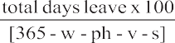
Leave cost as percentage of salary =
Where w = weekends, ph = public holidays, v = vacation, and s = sick leave.
Please note that leave can be considered as a social cost only if the Procuring Entity is not charged for the leave taken.
- Overheads are the Consultant's business costs that are not directly related to the execution of the assignment and shall not be reimbursed as separate items under the Contract. Typical items are home ofﬁce costs (non-billable time, time of senior Consultant's staff monitoring the project, rent of headquarters' ofﬁce, support staff, research, staff training, marketing, etc.), the cost of Consultant's personnel not currently employed on revenue-earning projects, taxes on business activities, and business promotion costs. During negotiations, audited ﬁnancial statements, certiﬁed as correct by an independent auditor and supporting the last three years' over heads, shall be available for discussion, together with detailed lists of items making up the overheads and the percentage by which each relates to basic salary. The Procuring Entity does not accept an add-on margin for social charges, overhead expenses, etc. for Experts who are not permanent employees of the Consultant. In such case, the Consultant shall be entitled only to administrative costs and a fee on the monthly payments charged for sub-contracted Experts.
- Proﬁt is normally based on the sum of the Salary, Social costs, and Overheads. If any bonuses paid on a regular basis are listed, a corresponding reduction shall be made in the proﬁt amount. Proﬁt shall not be allowed on travel or any other reimbursable expenses.
- Away from Home Ofﬁce Allowance or Premium or Subsistence Allowances Some Consultants pay allowances to Experts working away from headquarters or outside of the home ofﬁce. Such allowances are calculated as a percentage of salary (or a fee) and shall not draw over heads or proﬁt. Sometimes, by law, such allowances may draw social costs. In this case, the amount of this social cost shall still be shown under social costs, with the net allowance shown separately.

44

FORM FIN-4 BREAKDOWN OF REIMBURSABLE
When used for Lump-Sum contract assignment, information to be provided in this Form shall only be used to demonstrate the basis for calculation of the Contract ceiling amount, to calculate applicable taxes at contract negotiations and, if needed, to establish payments to the Consultant for possible additional services requested by the Procuring Entity. This form shall not be used as a basis for payments under Lump-Sum contracts. This form shall be ﬁlled for Time-Based Contracts to form the basis of contract negotiations.

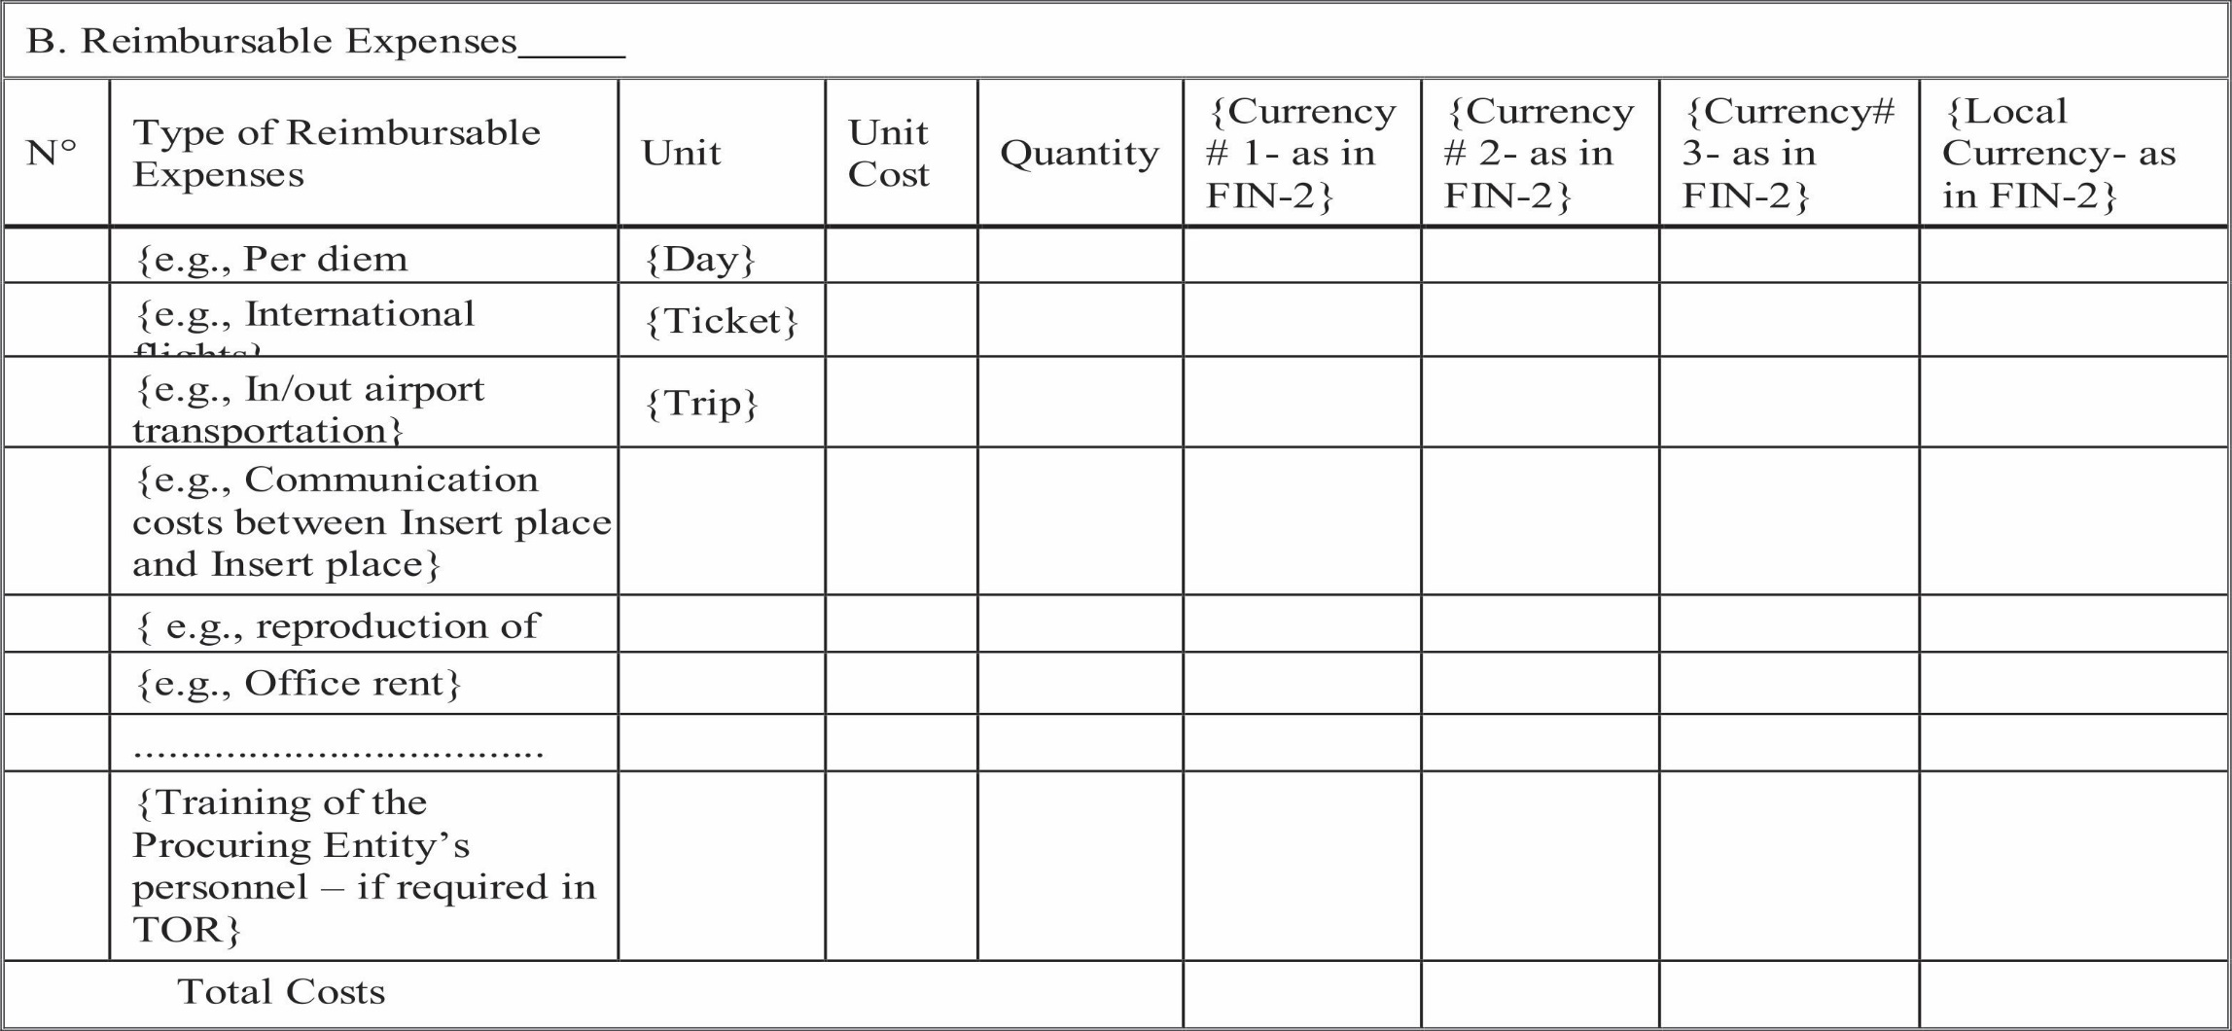

Legend:
“Per diem allowance” is paid for each night the expert is required by the Contract to be away from his/her usual place of residence. Procuring Entity can set up a ceiling.

SECTION 5. TERMS OF REFERENCE
[Sample outline:
- Background
- Objective(s) of the Assignment
- Scope of Services, Tasks (Components)and Expected Deliverables
Brief outline [indicate if downstream work is required]
[indicate if training is a speciﬁc component of the assignment] Etc.
- Team Composition & Qualiﬁcation Requirements for the Key Experts (and any other requirements which will be used for evaluating the Key Experts under Data Sheet 21.2 of the ITC). Please make sure that the speciﬁc key positions are clearly identiﬁed and the minimum academic education, professional qualiﬁcation, training, experience and professional memberships are articulated for each position.
PositionK-1: Team Leader/Lead Consultant: Position K-2: [Insert position title] Position K-3: [Insert position title] PositionK-4: [Insert position title], Etc.
- Reporting Requirements and Time Schedule for Deliverables
[At a minimum, list the following:
format, frequency, and contents of reports; number of copies, and requirements to electronic submission. Final reports shall be delivered in soft copy in addition to the speciﬁed number of hardcopies; dates of submission; persons (indicate names, titles, submission address) to receive them; etc.
- Procuring Entity's Input and Counterpart Personnel
- Services, facilities and property to be made available to the Consultant by the Procuring Entity:
[list / specify]
- Professional and support counterpart personnel to be assigned by the Procuring Entity to the Consultant's team: [list/specify]

SECTION 6. CONDITIONS OF CONTRACTAND CONTRACT FORMS

Preface
- This Section includes two types of standard contract forms for: A Lump-Sum Contract and a Time-Based Contract. Each type includes General Conditions of Contract (“GCC”) that shall not be modiﬁed, and Special Conditions of Contract (“SCC”). The SCC includes clauses speciﬁc to each contract to supplement, but not over- write or otherwise contradict, the General Conditions of Contract.
- Lump-Sum Contract. This type of contract is used mainly for assignments in which the scope and the duration of the Services and the required output of the Consultant are clearly deﬁned. Payments are linked to outputs (deliverables) such as draft or ﬁnal reports, drawings, bill of quantities, bidding documents, or software programs. Lump-sum contracts are easier to administer because they operate on the principle of a ﬁxed price for a ﬁxed scope, and payments are due on clearly speciﬁed out puts and milestones. Never the less, quality control of the Consultant's outputs by the Procuring Entity s paramount.
- Time-Based Contract. This type of contract is appropriate when it is difﬁcult to deﬁne or ﬁx the scope and the duration of the services, either because they are related to activities carried out by others for which the completion period may vary, or because the input of the consultants required for attaining the objectives of the assignment is difﬁcult to assess. In time-based contracts the Consultant provides services on a timed basis according to quality speciﬁcations, and Consultant's remuneration is determined on the basis of the time actually spent by the Consultant in carrying out the Services and is based on (i) agreed upon unit rates for the Consultant's experts multiplied by the actual time spent by the experts in executing the assignment, and (ii) reimbursable expenses using actual expenses and/or agreed unit prices. This type of contract requires the Procuring Entity to closely supervise the Consultant and to be involved in the daily execution of the assignment.
- The templates are designed for use in assignments with consulting ﬁrms and shall not be used for contracting of individual experts. In some consultancy assignments such as design and construction supervision, both Lump- Sum and Time-Based Contracts are used and signed with the Consultant. In that case, the Lump-Sum Contract would apply for the design part of the Services while the construction supervision part would be based on a Time- Based Contract. In such event, both types of contracts shall be signed at the same time.

CONTRACT FOR CONSULTANT'S SERVICES

Lump-Sum Contract Consulting Services for:
Contract No.:

Contract Description:

Between

[Name of the Procuring Entity]

and

[Name of the Consultant]

Date:

FORM OF CONTRACT - LUMP-SUM
(Text in brackets [ ] is optional; all notes should be deleted in the ﬁnal text)
This CONTRACT (herein after called the “Contract”) is made the [number] day of the month of [month], [year], between, on the one hand, [name of Procuring Entity] (herein after called the “Procuring Entity”) and, on the other hand, [name of Consultant] (herein after called the “Consultant”).
[If the Consultant consists of more than one entity, the above should be partially amended to read as follows: “… (hereinafter called the “Procuring Entity”) and, on the other hand, a Joint Venture (name of the JV) consisting of the following entities, each member of which will be jointly and severally liable to the Procuring Entity for all the Consultant's obligations under this Contract, namely, [name of member]and [name of member] (herein after called the “Consultant”).]
WHEREAS
- The Procuring Entity has requested the Consultant to provide certain consulting services as deﬁned in this Contract (herein after called the “Services”);
- the Consultant, having represented to the Procuring Entity that it has the required professional skills, expertise and technical resources, has agreed to provide the Services on the terms and conditions set forth in this Contract;
- the Procuring Entity has set aside a budget and funds toward the cost of the Services and intends to apply a portion of these funds towards payments under this Contract;
NOW THEREFORE the parties hereto hereby agree as follows:
- The following documents attached here to shall be deemed to form an integral part of this Contract:
  - The General Conditions of Contract;
  - The Special Conditions of Contract;
  - Appendices:
    - Appendix A: Terms of Reference
    - Appendix B: Key Experts
    - Appendix C: Breakdown of Contract Price
    - Appendix D: Form of Advance Payments Guarantee
In the event of any inconsistency between the documents, the following order of precedence shall prevail: The Special Conditions of Contract; the General Conditions of Contract; Appendix A; Appendix B; Appendix C; Appendix D. Any reference to this Contract shall include, where the context permits, a reference to its Appendices.
- The mutual rights and obligations of the Procuring Entity and the Consultant shall be asset for thin the Contract, in particular:
  - The Consultant shall carryout the Services in accordance with the provisions of the Contract; and
  - the Procuring Entity shall make payments to the Consultant in accordance with the provisions of the Contract.
IN WITNESS WHERE OF, the Parties here to have caused this Contract to be signed in their respective names as of the day and year ﬁrst above written.
For and on behalf of .............................................[Name of Procuring Entity] [Authorized Representative of the Procuring Entity–name, title and signature]
For and on behalf of............................................. [Name of Consultant or Name of a Joint Venture] [Authorized Representative of the Consultant–name and signature]
[Note: For a joint venture, either all members shall sign or only the lead member, in which case the power of attorney to sign on behalf of all members shall be attached.]
For and on behalf of each of the members of the Consultant.......................... [Insert the Name of the Joint Venture] [Name of the lead member]
[Authorized Representative on behalf of a Joint Venture] [Add signature blocks for each member if all are signing]

SECTION 7: GENERAL CONDITIONS OF CONTRACT

General Provisions
  - Deﬁnitions
      - Unless the context otherwise requires, the following terms whenever used in this Contract have the following meanings:
      - “Applicable Law” means the laws and any other instruments having he force of law in Kenya.
      - “Consultant” means a legally-established professional consulting ﬁrm or entity selected by the Procuring Entity to provide the Services under the signed Contract.
      - “Contract” means the legally binding written agreement signed between the Procuring Entity and the Consultant and which includes all the attached documents listed in its paragraph1of the Form of Contract (the General Conditions (GCC), the Special Conditions (SCC), and the Appendices).
      - “Procuring Entity” means the Procuring Entity that signs the Contract for the Services with the selected Consultant.
      - “Day” means a working day unless indicated otherwise.
      - “Effective Date” means the date on which this Contract comes into force and effect pursuant to Clause GCC 11.
      - “Experts” means, collectively, Key Experts, Non-Key Experts, or any other personnel of the Consultant, Sub-consultant or JV member(s) assigned by the Consultant to perform the Services or any part thereof under the Contract.
      - “Foreign Currency” means any currency other than the currency of Kenya.
      - “GCC” mean these General Conditions of Contract.
      - “Government” means the government of Kenya.
      - “Joint Venture (JV)” means an association with or without a legal personality distinct from that of its members, of more than one entity where one member has the authority to conduct all businesses for and on behalf of any and all the members of the JV, and where the members of the JV are jointly and severally liable to the Procuring Entity for the performance of the Contract.
      - “Key Expert(s)” means an individual professional whose skills, qualiﬁcations, knowledge and experience are critical to the performance of the Services under the Contract and whose Curricula Vitae (CV)was taken into account in the technical evaluation of the Consultant's proposal.
      - “Local Currency” means the Kenya Shillings, the currency of Kenya.
      - “Non-Key Expert(s)” means an individual professional provided by the Consultant or its Sub-consultant to perform the Services or any part here of under the Contract.
      - “Party” means the Procuring Entity or the Consultant, as the case may be, and “Parties” means both of them.
      - “SCC” means the Special Conditions of Contract by which the GCC may be amended or supplemented but not over-written.
      - “Services” means the work to be performed by the Consultant pursuant to this Contract, as described in Appendix A hereto.
      - “Sub-consultants” means an entity to whom/which the Consultant subcontracts any part of the Services while remaining solely liable for the execution of the Contract.

(t) “Third Party “means any person or entity other than the Government, the Procuring Entity, the Consultant or a Sub-consultant.

Relationship between the Parties
2.1 Nothing contained herein shall be construed as establishing a relationship of master and servant or of principal and agent as between the Procuring Entity and the Consultant. The Consultant, subject to this Contract, has complete charge of the Experts and Sub-consultants, if any, performing the Services and shall be fully responsible for the Services performed by them or on their behalf hereunder.

Law Governing Contract
  - This Contract, its meaning and interpretation, and the relation between the Parties shall be governed by the Laws of Kenya.

Language
  - This Contract has been executed in the English language, which shall be the binding and controlling language for all matters relating to the meaning or interpretation of this Contract.

Headings
  - The headings shall not limit, alter or affect the meaning of this Contract.

Communications
  - Any communication required or permitted to be given or made pursuant to this Contract shall be in writing in the English Language. Any such notice, request or consent shall be deemed to have been given or made when delivered in person to an authorized representative of the Party to whom the communication is addressed, or when sent to such Party at the address speciﬁed in the SCC.
  - A Party may change its address for notice here under by giving the other Party any communication of such change to the address speciﬁed in the SCC.

Location
  - The Services shall be performed at such locations as are speciﬁed in Appendix A hereto and, where the location of a particular task is not so speciﬁed, at such locations, whether in Kenya or elsewhere, as the Procuring Entity may approve.

Authority of Member in Charge
  - In case the Consultant is a Joint Venture, the members hereby authorize them ember speciﬁed in the SCC to act on their behalf in exercising all the Consultant's rights and obligations towards the Procuring Entity under this Contract, including without limitation the receiving of instructions and payments from the Procuring Entity.

Authorized Representatives
  - Any action required or permitted to be taken, and any document required or permitted to be executed under this Contract by the Procuring Entity or the Consultant may be taken or executed by the ofﬁcials speciﬁed in the SCC.

Corrupt and Fraudulent Practices
10.1 The government requires compliance with its policy regarding corrupt and fraudulent/prohibited practices as set forth in its laws and policies.
  - Commissions and Fees-The Procuring Entity requires the Consultant to disclose any commissions, gratuities or fees that may have been paid or are to be paid to a gents or any other party with respect to the selection process or execution of the Contract. The information disclosed must include at least the name and address of the agent or other party, the amount and currency, and the purpose of the commission, gratuity or fee. Failure to disclose such commissions, gratuities or fees may result in termination of the Contract by the Procuring Entity and/or sanctions by the PPRA.

B. Commencement, Completion, Modiﬁcation and Termination of Contract
- Effectiveness of Contract
  - This Contract shall come into force and effect on the date (the “Effective Date”) of the Procuring Entity's notice to the Consultant instructing the Consultant to begin carrying out the Services. This notice shall conﬁrm that the effectiveness conditions, if any, listed in the SCC have been met.
- Termination of Contract for Failure to Become Effective
  - If this Contract has not become effective within such time period after the date of Contract signature as speciﬁed in the SCC, either Party may, by not less than twenty-two (22) days written notice to the other Party, declare this Contract to be null and void, and in the event of such a declaration by either Party, neither Party shall have any claim against the other Party with respect there to.

Commencement of Services
  - The Consultant shall conﬁrm availability of Key Experts and begins carrying out the Services not later than the number of days after the Effective Date speciﬁed in the SCC.

Expiration of Contract
  - Unless terminated earlier pursuant to Clause GCC19hereof, this Contract shall expire at the end of such time period after the Effective Date as speciﬁed in the SCC.

Entire Agreement
  - This Contract contains all covenants, stipulations and provisions agreed by the Parties. No agent or representative of either Party has authority to make, and the Parties shall not be bound by or be liable for, any statement, representation, promise or agreement not set forth herein.

Modiﬁcations or Variations
  - Any modiﬁcation or variation of the terms and conditions of this Contract, including any modiﬁcation or variation of the scope of the Services, may only be made by written agreement between the Parties. However, each Party shall give due consideration to any proposals for modiﬁcation or variation made by the other Party.

Force Majeure
- Deﬁnition
  - For the purposes of this Contract,“ Force Majeure” means event which is beyond the reasonable control of a Party, is not foreseeable, is unavoidable, and makes a Party's performance of its obligations hereunder impossible or so impractical as reasonably to be considered impossible under the circumstances, and subject to those requirements, includes, but is not limited to, war, riots, civil disorder, earthquake, ﬁre, explosion, storm, ﬂood or other adverse weather conditions, strikes, lockouts or other industrial action conﬁscation or any other action by Government agencies.
  - Force Majeure shall not include (i) any event which his caused by the negligence or intentional action of a Party or such Party's Experts, Sub-consultants or agents or employees, nor (ii) any event which a diligent Party could reasonably have been expected to both take into account at the time of the conclusion of this Contract and avoid or over come in the carrying out of its obligations here under.
  - Force Majeure shall not include insufﬁciency of funds or failure to make any payment required here under.

No Breach of Contract
  - The failure of a Party to fulﬁll any of its obligations here under shall not be considered to be a breach of, or default under, this Contract in so far as such inability arises from an event of Force Majeure, provided that the Party affected by such an event has taken all reasonable precautions, due care and reasonable alternative measures, all with the objective of carrying out the terms and conditions of this Contract.

Measures to be taken
  - A party affected by an event of Force Majeure shall continue to perform its obligations under the Contract as far as is reasonably practical and shall take all reasonable measures to minimize the consequences of any event of Force Majeure.
  - A Party affected by an event of Force Majeure shall notify the other Party of such event as soon as possible, and in any case not later than fourteen (14) calendar days following the occurrence of such event, providing evidence of the nature and cause of such event, and shall similarly give written notice of the restoration of normal conditions as soon as possible.
    - Any period within which a Party shall, pursuant to this Contract, complete any action or task, shall be extended for a period equal to the time during which such Party was unable to perform such action as a result of Force Majeure.
    - During the period of their inability to perform the Services as a result of an event of Force Majeure, the Consultant, upon instructions by the Procuring Entity, shall either:
    - demobilize, in which case the Consultant shall be reimbursed for additional costs they reasonably and necessarily incurred, and, if required by the Procuring Entity, in reactivating the Services; or
    - Continue with the Services to the extent reasonably possible, in which case the Consultant shall continue to be paid under the terms of this Contract and be reimbursed or additional costs reasonably and necessarily incurred.
  - In the case of disagreement between the Parties as to the existence or extent of Force Majeure, the matter shall be settled according to Clauses GCC 44 & 45.

Suspension
  - The Procuring Entity may, by written notice of suspension to the Consultant, suspend all payments to the Consultant here under if the Consultant fails to perform any of its obligations under this Contract, including the carrying out of the Services, provided that such notice of suspension (i)shall specify the nature of the failure, and (ii) Shall request the Consultant to remedy such failure within a period not exceeding thirty (30) calendar days after receipt by the Consultant of such notice of suspension.

Termination
  - This Contract may be terminated by either Party as per provisions set up below:

a. By the Procuring Entity
    - The Procuring Entity may terminate this Contract in case of the occurrence of any of the events speciﬁed in paragraphs (a) through (f) of this Clause. In such an occurrence, the Procuring Entity shall give at least thirty (30) calendar days' written notice of termination to the Consultant in case of the events referred to in(a)through(d); at least sixty (60) calendar days' written notice in case of the event referred to in (e); and at least ﬁve (5) calendar days 'written notice in case of the event referred to in (f):
- If the Consultant fails to remedy a failure in the performance of its obligations here under, as speciﬁed in a notice of suspension pursuant to Clause GCC 18;
- If the Consultant becomes (or, if the Consultant consists of more than one entity, if any of its members becomes) insolvent or bankrupt or enter into any agreements with their creditors for relief of debt or take advantage of any law for the beneﬁt of debtors or go in to liquidation or receivership whether compulsory or voluntary;
- If the Consultant fails to comply with any ﬁnal decision reached as a result of arbitration proceedings pursuant to Clause GCC 45.1;
- If, as the result of Force Majeure, the Consultant is unable to perform a material portion of the Services for a period of not less than sixty (60) calendar days;
- If the Procuring Entity, in its sole discretion and for any reason whatsoever, decides to terminate this Contract;
- If the Consultant fails to conﬁrm availability of Key Experts as required in Clause GCC13.

    - Furthermore, if the Procuring Entity determines that the Consultant has engaged in corrupt, fraudulent, collusive, coercive [or obstructive] practices, in competing for or in executing the Contract, then the Procuring Entity may, after giving fourteen (14) calendar days written notice to the Consultant, terminate the Consultant's employment under the Contract.

By the Consultant
      - The Consultant may terminate this Contract, by not less than thirty (30) calendar days' written notice to the Procuring Entity, in case of the occurrence of any of the events speciﬁed in paragraphs(a)through(d)of this Clause.
      - If the Procuring Entity fails to pay any money due to the Consultant pursuant to this Contract and not subject to dispute pursuant to Clause GCC45.1withinforty-ﬁve (45) calendar days after receiving written notice from the Consultant that such payment is overdue.
      - If, as the result of Force Majeure, the Consultant is unable to perform a material portion of the Services for a period of not less than sixty (60) calendar days.
      - If the Procuring Entity fails to comply with any ﬁnal decision reached as a result of arbitration pursuant to Clause GCC45.1.
      - If the Procuring Entity is in material breach of its obligations pursuant to this Contract and has not remedied the same within forty-ﬁve (45) days (or such longer period as the Consultant may have subsequently approved in writing) following the receipt by the Procuring Entity of the Consultant's notice specifying such breach.

Cessation of Rights and Obligations
19.1.4 Upon termination of this Contract pursuant to Clauses GCC 12 or GCC 19 hereof, or upon expiration of this Contract pursuant to Clause GCC14, all rights and obligations of the Parties here under shall cease, except (i) such rights and obligations as may have accrued on the date of termination or expiration, (ii) the obligation of conﬁdentiality set forth in Clause GCC22, (iii) the Consultant's obligation to permit in section, copying and auditing of their accounts and records set forth in Clause GCC25, and (iv) any right which a Party may have under the Applicable Law.

Cessation of Services
19.1.5. Upon termination of this Contract by notice of either Party to the other pursuant to Clauses GCC 19a or GCC 19b, the Consultant shall immediately upon dispatch or receipt of such notice, take all necessary steps to bring the Services to a close in a prompt and orderly manner and shall make every reasonable effort to keep expenditures for this purpose to a minimum. With respect to documents prepared by the Consultant and equipment and materials furnished by the Procuring Entity, the Consultant shall proceed as provided, respectively, by Clauses GCC27or GCC28.
- Payment up on Termination
    - Up on termination of this Contract, the Procuring Entity shall make the following payments to the Consultant:
      - Payment or Services satisfactorily performed prior to the effective date of termination; and
      - In the case of termination pursuant to paragraphs (d) and (e) of Clause GCC 19.1.1, reimbursement of any reasonable cost incidental to the prompt and orderly termination of this Contract, including the cost of the return travel of the Experts.

C. Obligation s of the Consultant
- General
a. Standard of Performance
  - The Consultant shall perform the Services and carry out the Services with all due diligence, efﬁciency and economy, in accordance with generally accepted professional standards and practices, and shall observe sound management practices, and employ appropriate technology and safe and effective equipment, machinery, materials and methods. The Consultant shall always act, in respect of any matter relating to this Contract or to the Services, as a faithful adviser to the Procuring Entity, and shall at all times support and safeguard the Procuring Entity's legitimate interests in any dealings with the third parties.

  - The Consultant shall employandprovidesuchqualiﬁedandexperiencedExpertsandSub-consultants as are required to carry out the Services.
  - The Consultant may subcontract part of the Services to an extent and with such Key Experts and Sub- consultants as may be approved in advance by the Procuring Entity. Notwithstanding such approval, the Consultant shall retain full responsibility for the Services.

b. Law Applicable to Services
20.4. The Consultant shall perform the Services in accordance with the Contract and the Applicable Law and shall take all practicable steps to ensure that any of its Experts and Sub-consultants, comply with the Applicable Law.
  - Throughout the execution of the Contract, the Consultants hall comply with the import of goods and services prohibitions in Kenya when
- As a matter of law or ofﬁcial regulations, Kenya prohibits commercial relations with that country; or
- by an act of compliance with a decision of the United Nations Security Council taken under Chapter VII of the Charter of the United Nations, Kenya prohibits any import of goods from that country or any payments to any country, person, or entity in that country.
20.6. The Procuring Entity shall notify the Consultant in writing of relevant local customs, and the Consultant shall, after such notiﬁcation, respect such customs.

Conﬂict of Interests
21.1 The Consultant shall hold the Procuring Entity's interest paramount, without any consideration for future work, and strictly avoid conﬂict with other assignments or their own corporate interests.

Consultant Not to Beneﬁt from Commissions, Discounts, etc.
    - The payment of the Consultant pursuant to GCC F (Clauses GCC 38 through 42) shall constitute the Consultant's only payment in connection with this Contract and, subject to Clause GCC21.1.3,the Consultant shall not accept for its own beneﬁt any trade commission, discount or similar payment in connection with activities pursuant to this Contract or in the discharge of its obligations here under, and the Consultant shall use its best efforts to ensure that any Sub-consultants, as well as the Experts and agents of either of them, similarly shall not receive any such additional payment.
    - Furthermore, if the Consultant, as part of the Services, has the responsibility of advising the Procuring Entity on the procurement of goods, works or services, the Consultant shall at all times exercise such responsibility in the best interest of the Procuring Entity. Any discounts or commissions obtained by the Consultant in the exercise of such procurement responsibility shall be for the account of the Procuring Entity.

Consultant and Afﬁliates Not to Engage in Certain Activities
    - The Consultant agrees that, during the term of this Contract and after its termination, the Consultant and any entity afﬁliated with the Consultant, as well as any Sub-consultants and any entity afﬁliated with such Sub- consultants, shall be disqualiﬁed from providing goods, works or non-consulting services resulting from or directly related to the Consultant's Services for the preparation or implementation of the project.
    - Prohibition of Conﬂicting Activities
    - The Consultant shall not engage and shall cause its Experts as well as its Sub-consultants not to engage, either directly or indirectly, in any business or professional activities that would conﬂict with the activities assigned to them under this Contract.
    - Strict Duty to Disclose Conﬂicting Activities
    - The Consultant has an obligation and shall ensure that its Experts and Sub-consultants shall have an obligation to disclose any situation of actual or potential conﬂict that impacts their capacity to serve the best interest of their Procuring Entity, or that may reasonably be perceived as having this effect. Failure to disclose said situations may lead to the disqualiﬁcation of the Consultant or the termination of its Contract.

Conﬁdentiality
  - Except with the prior written consent of the Procuring Entity, the Consultant and the Experts shall not at any time communicate to any person or entity any conﬁdential information acquired in the course of the Services, nor shall the Consultant and the Experts make public the recommendations formulated in the course of, or because of, the Services.

Liability of the Consultant
  - Subject to additional provisions, if any, set for thin the SCC, the Consultant's liability under this Contract shall be as determined under the Applicable Law.

Insurance to be taken out by the Consultant
  - The Consultant (i) shall take out and maintain and shall cause any Sub-consultants to take out and maintain, at its (or the Sub-consultants', as the case may be) own cost but on terms and conditions approved by the Procuring Entity, insurance against the risks, and for the coverage speciﬁed in the SCC, and (ii) at the Procuring Entity's request, shall provide evidence to the Procuring Entity showing that such insurance has been taken out and maintained and that the current premiums therefore have been paid. The Consultant shall ensure that such insurance is in place prior to commencing the Services as stated in Clause GCC13.

Accounting, Inspection and Auditing
  - The Consultant shall keep and shall make all reasonable efforts to cause its Sub-consultants to keep, accurate and systematic accounts and records in respect of the Services and in such form and detail as will clearly identify relevant time changes and costs.
  - The Consultant shall permit and shall cause its Sub-consultants to permit, the PPRA and/ or persons appointed by the PPRA to inspect the Site and /or all accounts and records relating to the performance of the Contract and the submission of the Proposal to provide the Services, and to have such accounts and records audited by auditors appointed by the PPRA if requested by the PPRA. The Consultant's attention is drawn to Clause GCC10 which provides, interlaid, that acts intended to materially impede the exercise of the PPRA's inspection and audit rights provided for under this ClauseGCC25.2 constitute a prohibited practice subject to contract termination (as well as to a determination of in eligibility under the PPRA's prevailing sanctions procedures.)

Reporting Obligations
  - The Consultant shall submit to the Procuring Entity the reports and documents speciﬁed in Appendix A, in the form, in the numbers and within the time periods set forth in the said Appendix.

Proprietary Rights of the Procuring Entity in Reports and Records
  - Unless otherwise indicated in the SCC, all reports and relevant data and information such as maps, diagrams, plans, databases, other documents and software, supporting records or material compiled or prepared by the Consultant for the Procuring Entity in the course of the Services shall be conﬁdential and become and remain the absolute property of the Procuring Entity. The Consultant shall, not later than upon termination or expiration of this Contract, deliver all such documents to the Procuring Entity, together with a detailed inventory thereof. The Consultant may retain a copy of such documents, data and/or software but shall not use the same for purposes unrelated to this Contract without prior written approval of the Procuring Entity.
  - If license agreements are necessary or appropriate between the Consultant and third parties for purposes of development of the plans, drawings, speciﬁcations, designs, databases, other documents and software, the Consultant shall obtain the Procuring Entity's prior written approval to such agreements, and the Procuring Entity shall be entitled at its discretion to require recovering the expenses related to the development of the program(s) concerned. Other restrictions about the future use of these documents and software, if any, shall be speciﬁed in the SCC.

Equipment, Vehicles and Materials
  - Equipment, vehicles and materials made available to the Consultant by the Procuring Entity or purchased by the Consultant wholly or partly with funds provided by the Procuring Entity, shall be the property of the Procuring Entity and shall be marked accordingly. Upon termination or expiration of this Contract, the Consultant shall make available to the Procuring Entity an inventory of such equipment, vehicles and materials and shall dispose of such equipment, vehicles and materials in accordance with the Procuring Entity's instructions. While in possession of such equipment, vehicles and materials, the Consultant, unless otherwise instructed by the Procuring Entity in writing, shall insure them at the expense of the Procuring Entity in an amount equal to their full replacement value.
  - Any equipment or materials brought by the Consultant or its Experts into Kenya for the use either for the project or personal use shall remain the property of the Consultant or the Experts concerned, as applicable.

D. Consultant's Experts and Sub-consultants
- Description of Key Experts
  - The title, agreed job description, minimum qualiﬁcation and estimated period of engagement to carry out the Services of each of the Consultant's Key Experts are described in Appendix B.

Replacement of Key Experts
  - Except as the Procuring Entity may otherwise agree in writing, no changes shall be made in the Key Experts.
  - Notwithstanding the above, the substitution of Key Experts during Contract execution may be considered only based on the Consultant's written request and due to circumstances outside the reasonable control of the Consultant, including but not limited to death or medical in capacity. In such case, the Consultant shall forth with provide as a replacement, a person of equivalent or better qualiﬁcations and experience, and at the same rate of remuneration.

Removal of Experts or Sub-consultants
  - If the Procuring EntityﬁndsthatanyoftheExpertsorSub-consultanthascommittedseriousmisconductorhas been charged with having committed a criminal action, or shall the Procuring Entity determine that Consultant's Expert of Sub consultant have engaged in corrupt, fraudulent, collusive, coercive [or obstructive] practice while performing the Services, the Consultant shall, at the Procuring Entity's written request, provide a replacement.
  - In the event that any of Key Experts, Non-Key Experts or Sub-consultants is found by the Procuring Entity to be in competent or in capable in discharging assigned duties, the Procuring Entity, specifying the grounds therefore, may request the Consultant to provide a replacement.
  - Any replacement of the removed Experts or Sub consultants shall possess better qualiﬁcations and experience and shall be acceptable to the Procuring Entity.
  - The Consultant shall bear all costs arising out of or incidental to any removal and/or replacement of such Experts.

E. Obligations of the Procuring Entity
- Assistance and Exemptions
  - Unless otherwise speciﬁed in the SCC, the Procuring Entity shall use its best efforts to:
- Assist the Consultant with obtaining work permits and such other documents as shall be necessary to enable the Consultant to perform the Services.
- Assist the Consultant with promptly obtaining, for the Experts and, if appropriate, their eligible dependents, all necessary entry and exit visas, residence permits, exchange permits and any other documentsrequiredfortheirstayinKenyawhilecarryingouttheServicesundertheContract.
- FacilitatepromptclearancethroughcustomsofanypropertyrequiredfortheServicesandofthepersonal effects of the Expert sand their eligible dependents.
- Issue to ofﬁcials, agents and representatives of the Government all such instructions and information as may be necessary or appropriate for the prompt and effective implementation of the Services.
- Assist the Consultant and the Experts and any Sub-consultants employed by the Consultant for the Services with obtaining exemption from any requirement to register or obtain any permit to practice their profession or to establish themselves either individually or as a corporate entity in Kenya according to the applicable law in Kenya.

  - Assist the Consultant, any Sub-consultants and the Experts of either of them with obtaining the privilege, pursuant to the applicable law in Kenya, of bringing in to Kenya reasonable amounts of foreign currency for the purposes of the Services or for the personal use of the Experts and of withdrawing any such amounts as may be earned therein by the Experts in the execution of the Services.
  - Provide to the Consultant any such other assistance as may be speciﬁed in the SCC.

Access to Project Site
  - The Procuring Entity warrants that the Consultant shall have, free of charge, unimpeded access to the project site in respect of which access is required for the performance of the Services. The Procuring Entity will be responsible for any damage to the project site or any property thereon resulting from such access and will indemnify the Consultant and each of the experts in respect of liability for any such damage, unless such damage is caused by the willful default or negligence of the Consultant or any Sub-consultants or the Experts of either of them.

Change in the Applicable Law Related to Taxes and Duties
  - If, after the date of this Contract, there is any change in the applicable law in Kenya with respect to taxes and duties which increases or decreases the cost incurred by the Consultant in performing the Services, then the remuneration and reimbursable expenses otherwise payable to the Consultant under this Contract shall be increased or decreased accordingly by agreement between the Parties hereto, and corresponding adjustments shall be made to the Contract price amount speciﬁed in Clause GCC 39.1

Services, Facilities and Property of the Procuring Entity
  - The Procuring Entity shall make available to the Consultant and the Experts, for the purposes of the Services and free of any charge, the services, facilities and property described in the Terms of Reference (Appendix A) at the times and in the manner speciﬁed in said Appendix A.

Counterpart Personnel
  - The Procuring Entity shall make available to the Consultant free of charge such professional and support counterpart personnel, to be nominated by the Procuring Entity with the Consultant's advice, if speciﬁed in Appendix A.
  - Professional and support counterpart personnel, excluding Procuring Entity's liaison personnel, shall work under the exclusive direction of the Consultant. If any member of the counterpart personnel fails to perform adequately any work as signed to such member by the Consultant that is consistent with the position occupied by such member, the Consultant may request the replacement of such member, and the Procuring Entity shall not unreasonably refuse to act upon such request.

Payment Obligation
  - In consideration of the Services performed by the Consultant under this Contract, the Procuring Entity shall make such payments to the Consultant for the deliverables speciﬁed in Appendix A and in such manner as is provided by GCCF below.

F. Payments to the Consultant
- Contract Price
  - The Contract price is ﬁxed and is set forth in the SCC. The Contract price breakdown is provided in Appendix C.
  - Any change to the Contract price speciﬁed in Clause 38.1 can be made only if the Parties have agreed to the revised scope of Services pursuant to Clause GCC 16 and have amended in writing the Terms of Reference in Appendix A.

Taxes and Duties
  - The Consultant, Sub-consultants and Experts are responsible for meeting any and all tax liabilities arising out of the Contract unless it is stated otherwise in the SCC.

Currency of Payment
40.1 Any payment under this Contract shall be made in the currency (ies) of the Contract.

Mode of Billing and Payment
  - The total payments under this Contract shall not exceed the Contract price set forth in Clause GCC 38.1.
  - The payments under this Contract shall be made in lump-sum installments against deliverables speciﬁed in Appendix A. The payments will be made according to the payment schedule stated in the SCC.
    - Advance payment: Unless otherwise indicated in the SCC, an advance payment shall be made against an advance payment bank guarantee acceptable to the Procuring Entity in an amount (or amounts) and in a currency (or currencies) speciﬁed in the SCC. Such guarantee (I) is to remain effective until the advance payment has been fully set off, and (ii) is to be in the form set forth in Appendix D, or in such other form as the Procuring Entity shall have approved in writing. The advance payments will be set off by the Procuring Entity in equal portions against the lump-sum installments speciﬁed in the SCC until said advance payments have been fully set off.
    - The Lump-Sum Installment Payments. The Procuring Entity shall pay the Consultant within sixty (60) days after the receipt by the Procuring Entity of the deliverable(s) and the cover invoice for the related lump-sum installment payment. The payment can be withheld if the Procuring Entity does not approve the submitted deliverable(s) as satisfactory in which case the Procuring Entity shall provide comments to the Consultant within the same sixty (60) days period. The Consultant shall thereupon promptly make any necessary corrections, and there after the fore going process shall be repeated.
41.1.3 The Final Payment: The ﬁnal payment under this Clause shall be made only after the ﬁnal report has been submitted by the Consultant and approved as satisfactory by the Procuring Entity. The Services shall then be deemed completed and ﬁnally accepted by the Procuring Entity. The last lump-sum installment shall be deemed approved for payment by the Procuring Entity within ninety (90) calendar days after receipt of the ﬁnal report by the Procuring Entity unless the Procuring Entity, within such ninety (90) calendar day period, gives written notice to the Consultant specifying in detail deﬁciencies in the Services, the ﬁnal report. The Consultant shall thereupon promptly make any necessary corrections, and there after the fore going process shall be repeated.

41.1.4 All payments under this Contract shall be made to the accounts of the Consultant speciﬁed in the SCC.
41.1.5 With the exception of the ﬁnal payment under 41.2.3above, payments do not constitute acceptance of the whole Services nor relieve the Consultant of any obligations here under.

Interest on Delayed Payments
  - If the Procuring Entity had delayed payments beyond thirty (30) days after the due date stated in Clause GCC 41.2.2, interest shall be paid to the Consultant on any amount due by, not paid on, such due date for each day of delay at the annual rate stated in the SCC.

G. Fairness and Good Faith
- Good Faith
  - The Parties undertake to act in good faith with respect to each other's rights under this Contract and to adopt all reasonable measures to ensure the realization of the objectives of this Contract.

H. Settlement of Disputes
- Amicable Settlement
    - The Parties shall seek to resolve any dispute amicably by mutual consultation.
    - If either Party objects to any action or in action of the other Party, the objecting Party may ﬁle a written Notice of Dispute to the other Party providing in detail the basis of the dispute. The Party receiving the Notice of Dispute will consider it and respond in writing within fourteen (14) days after receipt. If that Party fails to respond within fourteen (14) days, or the dispute cannot be amicably settled within fourteen (14) days following the response of that Party, Clause GCC 45.1 shall apply.

Dispute Resolution
    - Any dispute between the Parties arising under or related to this Contract that cannot be settled amicably may be referred to by either Party to the adjudication/arbitration in accordance with the provisions speciﬁed in the SCC.

SECTION 8: SPECIAL CONDITIONS OF CONTRACT
[Notes in brackets are for guidance purposes only and should be deleted in the ﬁnal text of the signed contract]

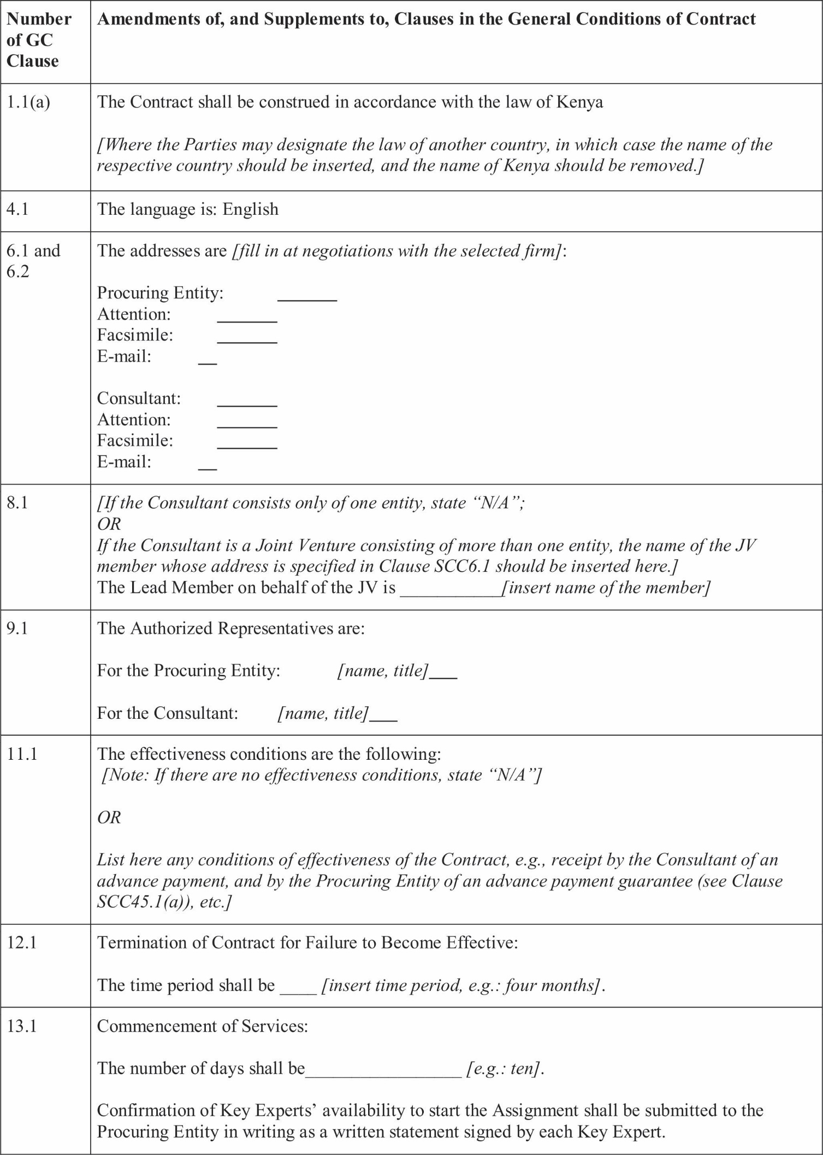

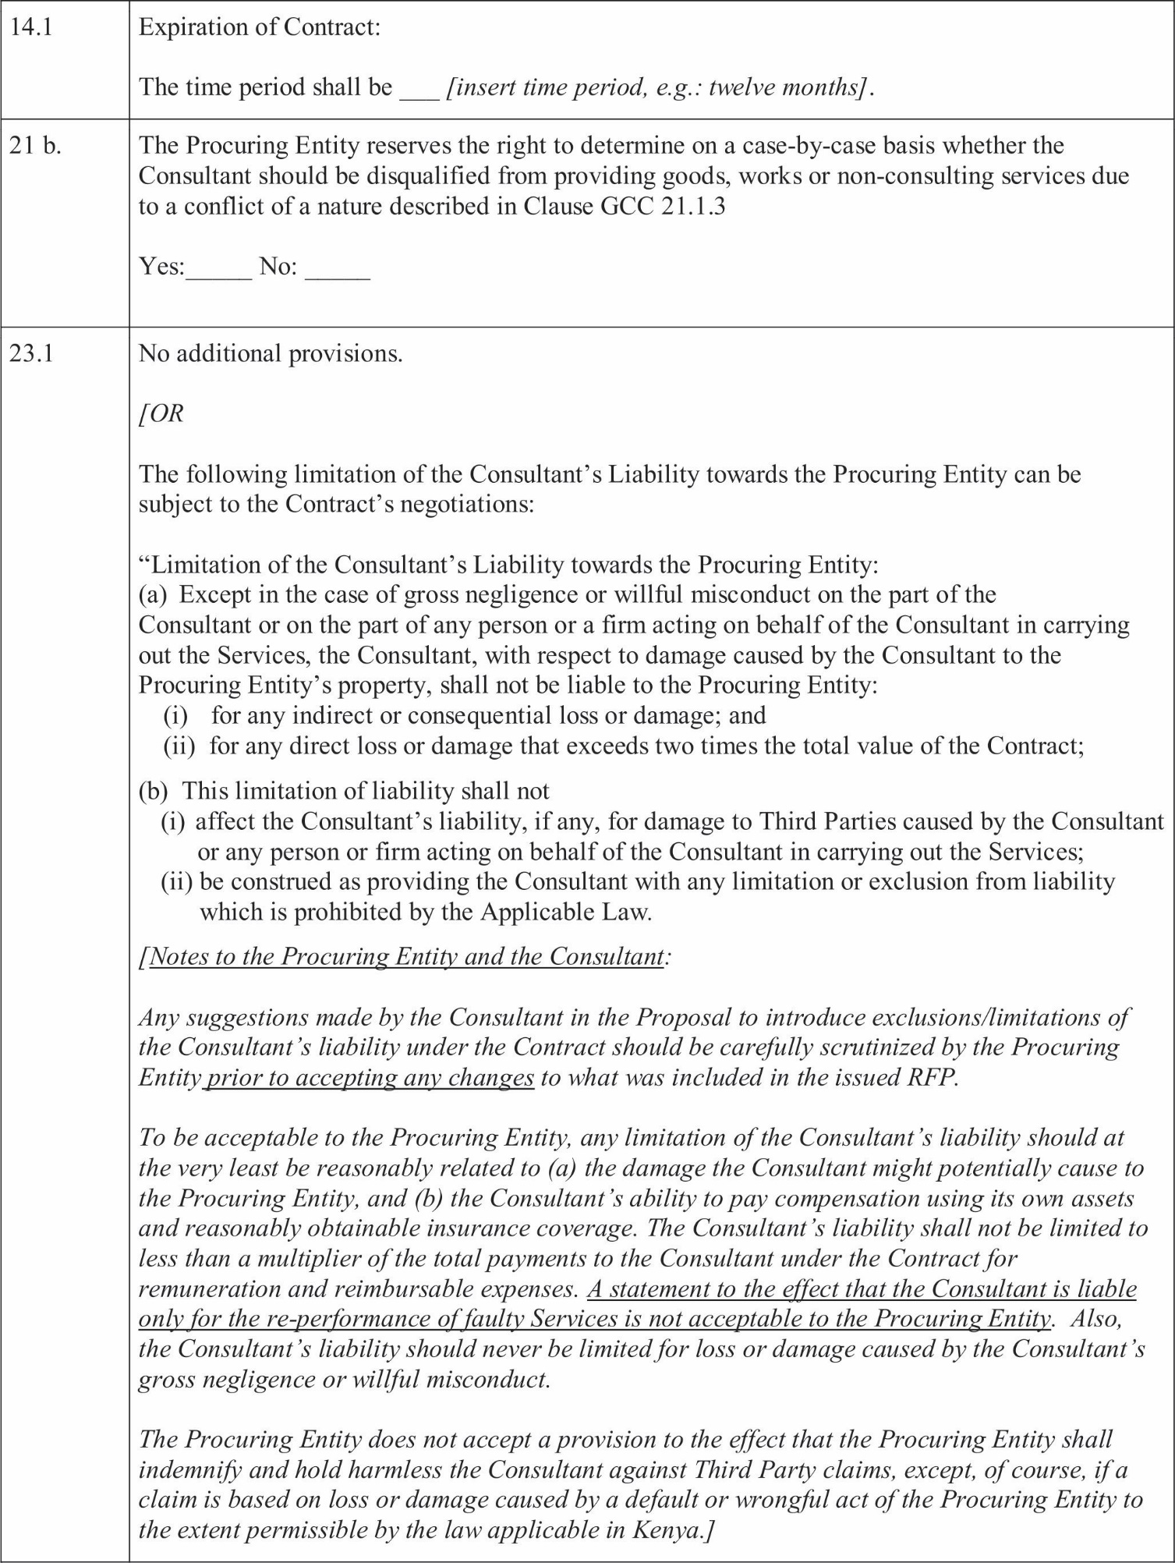
I I

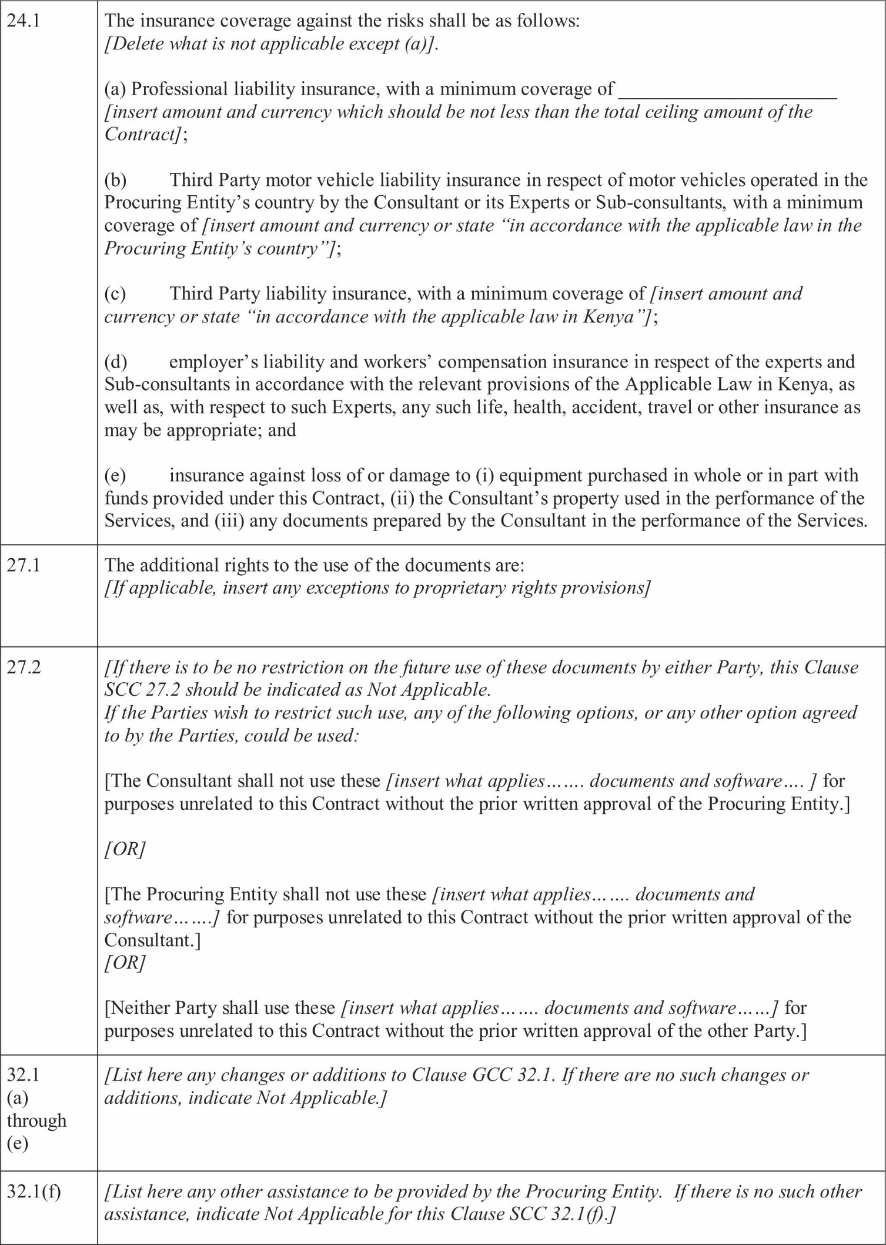



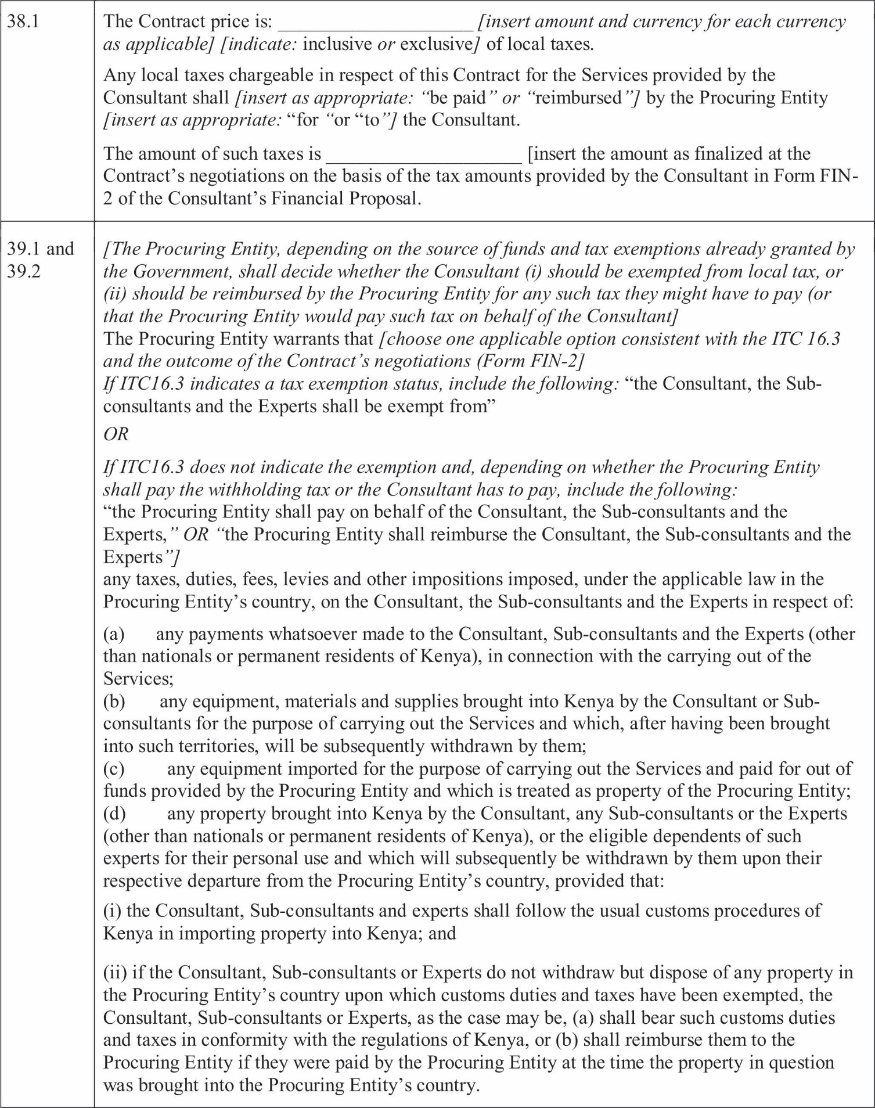

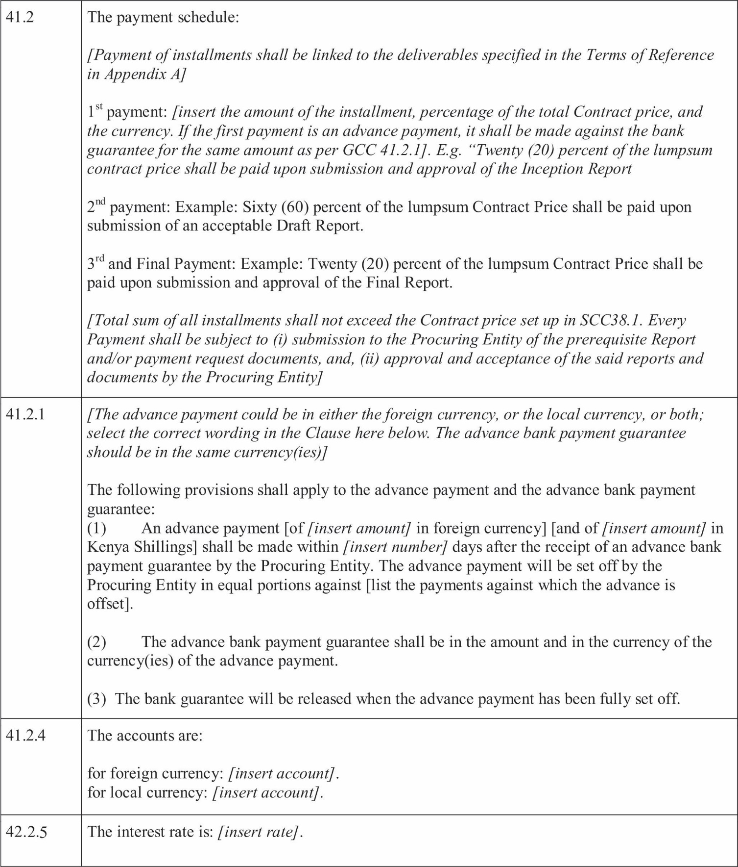

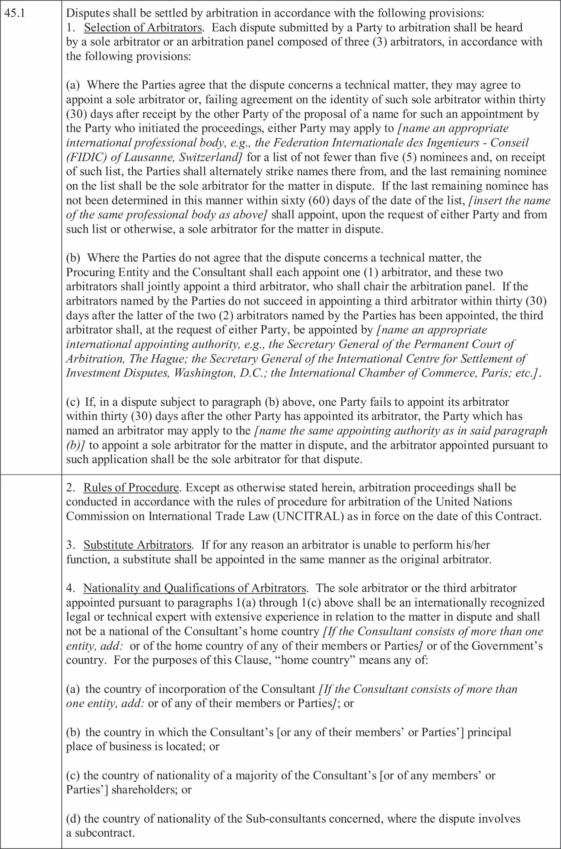
I I

SECTION 9: APPENDICES

Appendix A – Terms of Reference
[Note: This Appendix shall include the ﬁnal Terms of Reference (TORs) worked out by the Procuring Entity and the Consultantduringthenegotiations;datesforcompletionofvarioustasks;locationofperformancefordifferenttasks; detailed reporting requirements and list of deliverables against which the payments to the Consultant will be made; ProcuringEntity'sinput,includingcounterpartpersonnelassignedbytheProcuringEntitytoworkontheConsultant's team;speciﬁctasksoractionsthatrequirepriorapprovalbytheProcuringEntity.
Insert the text based on the Section 5 (Terms of Reference) of the ITC in the RFP and modiﬁed based on the Forms TECH-1 through TECH-5 of the Consultant's Proposal. Highlight the changes to Section 5 of the RFP]

……………………………………………………………………………………………….........................................
Appendix B - Key Experts
[Insert a table based on Form TECH-6 of the Consultant's Technical Proposal and ﬁnalized at the Contract's negotiations. Attach the CVs (updated and signed by the respective Key Experts) demonstrating the qualiﬁcations of Key Experts.]

………………………………………………………………………………………………......................................... Appendix C – Breakdown of Contract Price
{Insert the table with the unit rates to arrive at the breakdown of the lump-sum price. The table shall be based on [Form FIN-3andFIN-4] of the Consultant's Proposal and reﬂect any changes agreed at the Contract negotiations, if any. The footnote shall list such changes made to [FormFIN-3andFIN-4] at the negotiations or state that none has been made.}

Appendix D - Form of Advance Payment Guarantee
[Note: See Clause GCC 41.2.1 and SCC 41.2.1]
Bank Guarantee for Advance Payment [Bank's Name and Address of Issuing Branch or Ofﬁce] Beneﬁciary: [Name and Address of Procuring Entity]
Date:
ADVANCEPAYMENTGUARANTEE No.:
We have been informed that [name of Consultant or a name of the Joint Venture, same as appears on the signed Contract] (herein after called" the Consultant") has entered into Contract No. [reference number of the contract] dated with you, for the provision of [brief description of Services] (herein after called" the Contract").
Furthermore, we understand that, according to the conditions of the Contract, an advance payment in the sum of
[amount in ﬁgures] () [amount in words]is to be made against an advance payment guarantee.
At the request of the Consultant, we [name of bank] here by irrevocably undertake to pay you any sum or sums not exceeding in total an amount of [amount in ﬁgures] () [amount in words]1upon receipt by us of your ﬁrst demand in writing accompanied by a written statement stating that the Consultant are in b reach of their obligation under the Contract because the Consultant have used the advance payment for purposes other than toward providing the Services under the Contract.
It is a condition for any claim and payment under this guarantee to be made that the advance payment referred to above must have been received by the Consultant on their account number at [name and address of bank].
The maximum amount of this guarantee shall be progressively reduced by the amount of the advance payment repaid by the Consultant as indicated in copies of certiﬁed monthly statements which shall be presented to us. This guarantee shall expire, at the latest, upon our receipt of the monthly payment certiﬁcate indicating that the Consultant has made
Full repayment of the amount of the advance payment, or on the day of , 2 whichever is earlier.

Consequently, any demand for payment under this guarantee must be received by us at this ofﬁce on or before that date.

[Signature]
Note: All italicized text is for indicative purposes only to assist in preparing this form and shall be deleted from the ﬁnal product.

PREFACE
This Section includes a Time-Based Contract. It includes General Conditions of Contract (“GCC”) that shall not be modiﬁed, and Special Conditions of Contract (“SCC”). The SCC include clauses speciﬁc to each contract to supplement, but not over-write or otherwise contradict, the General Conditions of Contract.
Time-Based Contract. This type of contract is appropriate when it is difﬁcult to deﬁne or ﬁx the scope and the duration of the services, either because they are related to activities carried out by others for which the completion period may vary, or because the input of the consultants required for attaining the objectives of the assignment is difﬁcult to assess. In time-based contracts the Consultant provides services on a timed basis according to quality speciﬁcations, and Consultant's remuneration is determined on the basis of the time actually spent by the Consultant in carrying out the Services and is based on (i) agreed upon unit rates for the Consultant's experts multiplied by the actual time spent by the experts in executing the assignment, and (ii) reimbursable expenses using actual expenses and/or agreed unit prices. This type of contract requires the Procuring Entity to closely supervise the Consultant and to be involved in the daily execution of the assignment.
The template is designed for use in assignments with consulting ﬁrms and shall not be used for contracting of individual experts. In some consultancy assignments such as design and construction supervision, both Lump-Sum and Time- Based Contracts are used and signed with the Consultant. In that case, the Lump-Sum Contract would apply for the design part of the Services while the construction supervision part would be based on a Time-Based Contract. In such event; both types of contracts shall be signed at the same time.
In case a Time-Based Contract is not used, please delete the contract template for time-based contract before issuance of the RFP to Consultants.

1The Guarantor shall insert an amount representing the amount of the advance payment and denominated either in the currency (ies) of the advance payment as
Speciﬁed in the Contract, or in a freely convertible currency acceptable to the Procuring Entity.
2Inserttheexpectedexpirationdate.IntheeventofanextensionofthetimeforcompletionoftheContract the Procuring Entity would need to request an extension of
This guarantee from the Guarantor. Such request must be in writing and must be made prior to the expiration date established in the guarantee. In preparing this guarantee, the Procuring Entity might consider adding the following text to the form, at the end of the pen ultimate paragraph: “The Guarantor agrees to a one-time extension of this guarantee for a period not to exceed [six months] [one year], in response to the Procuring Entity's written request for such extension, such request to be presented to the Guarantor before the expiry of the guarantee.”

CONTRACT FOR CONSULTANT'S SERVICES

TIME-BASED CONTRACT

Consulting Services for:

Contract No.:

Contract Description:

between [Name of the Procuring Entity] and
[Name of the Consultant]

Date:

II: FORMOFCONTRACT-TIME-BASED
(Text in brackets [ ] is optional; all notes should be deleted in the ﬁnal text)
This CONTRACT (hereinafter called the “Contract”) is made the [number] day of the month of [month], [year], between, on the one hand, [name of Procuring Entity] (herein after called the “Procuring Entity”) and, on the other hand, [name of Consultant] (hereinafter called the “Consultant”).
[Note: If the Consultant consist of more than one entity, the above should be partially amended to read as follows: “… (herein after called the “Procuring Entity”) and, on the other hand, a Joint Venture (name of the JV) consisting of the following entities, each member of which will be jointly and severally liable to the Procuring Entity for all the Consultant's obligations under this Contract, namely, [name of member] and [name of member] (hereinafter called the “Consultant”).]
WHEREAS
- the Procuring Entity has requested the Consultant to provide certain consulting services as deﬁned in this Contract (hereinafter called the “Services”);
- the Consultant, having represented to the Procuring Entity that it has the required professional skills, expertise and technical resources, has agreed to provide the Services on the terms and conditions set forth in this Contract;
- The Procuring Entity has set aside a budget and funds towards the cost of the services and intends to apply a portion of the funds to eligible payments under the Contract.
NOW THEREFORE the parties hereto hereby agree as follows:
- The following documents attached here to shall be deemed to form an integral part of this Contract:
  - The General Conditions of Contract;
  - The Special Conditions of Contract;
  - Appendices:
Appendix A: Terms of Reference
Appendix B: Key Experts
Appendix C: Remuneration Cost Estimates
Appendix D: Reimbursable Cost Estimates
Appendix E: Form of Advance Payments Guarantee
In the event of any in consistency between the documents, the following order of precedence shall prevail: The Special Conditions of Contract; the General Conditions of Contract; Appendix A; Appendix B; Appendix C and Appendix D; Appendix E. Any reference to this Contract shall include, where the context permits, a reference to its Appendices.
- ThemutualrightsandobligationsoftheProcuringEntityandtheConsultantshallbeassetforthintheContract, in particular:
  - The Consultant shall carryout the Services in accordance with the provisions of the Contract; and
  - The Procuring Entity shall make payments to the Consultant in accordance with the provisions of the Contract.
IN WITNESS WHERE OF, the Parties here to have caused this Contract to be signed in their respective names as of the day and year ﬁrst above written.
For and on behalf of [Name of Procuring Entity] [Authorized Representative of the Procuring Entity–name title and signature]
For and on behalf of [Name of Consultant or Name of a Joint Venture] [Authorized Representative of the Consultant–name and signature]
[Note: For a joint venture, either all members shall sign or only the lead member, in which case the power of attorney to sign on behalf of all members shall be attached.]
For and on behalf of each of the members of the Consultant............. [insert the name of the Joint Venture] [Name of the lead member]
[Authorized Representative on behalf of a Joint Venture] [add signature blocks for each member if all are signing]

Section 8: General Conditions of Contract

GENERAL PROVISIONS
  - Deﬁnitions
  - Unless the context otherwise requires, the following terms whenever used in this Contract have the following meanings:
      - “Applicable Law” means the laws and any other instruments having the force of law in Kenya.
      - “Procuring Entity” means the Procuring Entity that signs the Contract for the Services with the Selected Consultant.
      - “Consultant” means a legally - established professional consulting ﬁrm or entity selected by the Procuring Entity to provide the Services under the signed Contract.
      - “Contract” means the legally binding written agreement signed between the Procuring Entity and the Consultant and which includes all the attached documents listed in its paragraph 1 of the Form of Contract (the General Conditions (GCC), the Special Conditions (SCC), and the Appendices).
      - “Day” means a working day unless indicated otherwise.
      - “Effective Date” means the date on which this Contract comes into force and effect pursuant to Clause GCC11.
      - “Experts” means, collectively, Key Experts, Non-Key Experts, or any other personnel of the Consultant, Sub-consultant or JV member(s) assigned by the Consultant to perform the Services or any part thereof under the Contract.
      - “Foreign Currency” means any currency other than the Kenya Shilling.
      - “GCC” means these General Conditions of Contract.
      - “Government” means the government of Kenya.
      - “Joint Venture (JV)” means an association with or without a legal personality distinct from that of its members, of more than one entity where one member has the authority to conduct all businesses for and on behalf of any and all the members of the JV, and where the members of the JV are jointly and severally liable to the Procuring Entity for the performance of the Contract.
      - “Key Expert(s)” means an individual professional whose skills, qualiﬁcations, knowledge and experience are critical to the performance of the Services under the Contract and whose Curricula Vitae (CV) was taken in to account in the technical evaluation of the Consultant's proposal.
      - “Local Currency” means the Kenya Shilling.
      - “Non-Key Expert(s)” means an individual professional provided by the Consultant or its Sub-consultant to perform the Services or any part thereof under the Contract.
      - “Party” means the Procuring Entity or the Consultant, as the case may be, and “Parties” means both.
      - “SCC” means the Special Conditions of Contract by which the GCC may be amended or supplemented but not over-written.
      - “Services” means the work to be performed by the Consultant pursuant to this Contract, as described in Appendix A hereto.
      - “Sub-consultants” means an entity to whom/which the Consultant subcontracts any part of the Services while remaining solely liable for the execution of the Contract.
      - “Third Party” means any person or entity other than the Government, the Procuring Entity, the Consultant or a Sub-consultant.

Relationship between the Parties
  - Nothing contained here in shall be construed as establishing a relationship of master and servant or of principal and agent as between the Procuring Entity and the Consultant. The Consultant, subject to this Contract, has complete charge of the Experts and Sub-consultants, if any, performing the Services and shall be fully responsible for the Services performed by the moron their behalf here under.

Law Governing Contract
  - This Contract, its meaning and interpretation, and the relation between the Parties shall be governed by the Applicable Law.

Language
  - This Contract has been executed in the language speciﬁed in the SCC, which shall be the binding and controlling language for all matters relating to the meaning or interpretation of this Contract.

Headings
  - The headings shall not limit, alter or affect the meaning of this Contract.

Communications
  - Any communication required or permitted to be given or made pursuant to this Contract shall be in writing in the language speciﬁed in Clause GCC4. Any such notice, request or consent shall be deemed to have been give nor made when delivered in person to an authorized representative of the Party to whom the communication is addressed, or when sent to such Party at the address speciﬁed in the SCC.
  - A party may change its address for notice here under by giving the other Party any communication of such change to the address speciﬁed in the SCC.

Location
7.1. The Services shall be performed at such locations as are speciﬁed in Appendix A here to and, where the location of a particular task is not so speciﬁed, at such locations, whether in Kenya or elsewhere, as the Procuring Entity may approve.

Authority of Member in Charge
  - In case the Consultant is a Joint Venture, the members hereby authorize the member speciﬁed in the SCC to act on their behalf in exercising all the Consultant's rights and obligations towards the Procuring Entity under this Contract, including without limitation the receiving of instructions and payments from the Procuring Entity.

9. Authorized Representatives
  - Any action required or permitted to be taken, and any document required or permitted to be executed under this Contract by the Procuring Entity or the Consultant may be taken or executed by the ofﬁcials speciﬁed in the SCC.

Corrupt and Fraudulent Practices
  - The Governmentrequirescompliancewithitspolicyandlawsinregardtocorruptandfraudulentorprohibited practices as set forth in its laws and policies.

a. Commissions and Fees
  - The Procuring Entity requires the Consultant to disclose any commissions, gratuities or fees that may have been paid or are to be paid to agents or any other party with respect to the selection process or execution of the Contract. The information disclosed must include at least the name and address of the agent or the other party, the amount and currency, and the purpose of the commission, gratuity or fee. Failure to disclose such commissions, gratuities or fees may result in termination of the Contract by the Procuring Entity and/or sanctions by the PPRA.
Commencement, Completion, Modiﬁcation and Termination of Contract.

Effectiveness of Contract
  - This Contract shall come into force and effect on the date (the “Effective Date”) of the Procuring Entity's notice to the Consultant instructing the Consultant to begin carrying out the Services. This notice shall conﬁrm that the effectiveness conditions, if any, listed in the SCC have been met.
- Termination of Contract for Failure to Become Effective
  - If this Contract has not become effective within such time period after the date of Contract signature as speciﬁed in the SCC, either Party may, by not less than twenty-two (22) days written notice to the other Party, declare this contract to be null and void, and in the event of such a declaration by either Party, neither Party shall have any claim against the other Party with respect hereto.

Commencement of Services
  - The Consultant shall conﬁrm availability of Key Experts and begin carrying out the Services not later than the number of days after the Effective Date speciﬁed in the SCC.

Expiration of Contract
  - Unless terminated earlier pursuant to Clause GCC 19 hereof, this Contract shall expire at the end of such time period after the Effective Date as speciﬁed in the SCC.

Entire Agreement
  - This Contract contains all covenants, stipulations and provisions agreed by the Parties. No agent or representative of either Party has authority to make, and the Parties shall not be bound by or be liable for, any statement, representation, promise or agreement not set forth herein.

Modiﬁcations or Variations
  - Any modiﬁcation or variation of the terms and conditions of this Contract, including any modiﬁcation or variation of the scope of the Services, may only be made by written agreement between the Parties. However, each Party shall give due consideration to any proposals for modiﬁcation or variation made by the other Party.

In cases of substantial modiﬁcations or variations.
- Force Majeure
- Deﬁnition
  - For the purposes of this Contract, “Force Majeure” means an event which is beyond the reasonable control of a Party, is not foreseeable, is unavoidable, and makes a Party's performance of its obligations here under impossible or so impractical as reasonably to be considered impossible under the circumstances, and subject to those requirements, includes, but is not limited to, war, riots, civil disorder, earthquake, ﬁre, explosion, storm, ﬂood or other adverse weather conditions, strikes, lockouts or other industrial action conﬁscation or any other action by Government agencies.
  - Force Majeure shall not include (i) any event which is caused by then negligence or intentional action of a Party or such Party's Experts, Sub-consultants or agents or employees, nor (ii) any event which a diligent Party could reasonably have been expected to both take into account at the time of the conclusion of this Contract and avoid or overcome in the carrying out of its obligations here under.
  - Force Majeure shall not include in sufﬁciency of funds or failure to make any payment required here under.

No Breach of Contract
  - The failure of a Party to fulﬁll any of its obligations here under shall not be considered to be a breach of, or default under, this Contract in so far as such inability arises from an event of Force Majeure, provided that the Party affected by such an event has taken all reasonable precautions, due care and reasonable alternative measures, all with the objective of carrying out the terms and conditions of this Contract.

Measures to be taken
  - A party affected by an event of Force Majeure shall continue to perform its obligations under the Contract as far as is reasonably practical and shall take all reasonable measures to minimize the consequences of any event of Force Majeure.
  - A Party affected by an event of Force Majeure shall notify the other Party of such event as soon as possible, and in any case not later than fourteen (14) calendar days following the occurrence of such event, providing evidence of the nature and cause of such event, and shall similarly give written notice of the restoration of normal conditions as soon as possible.

  - Any period within which a Party shall, pursuant to this Contract, complete any action or task, shall be extended for a period equal to the time during which such Party was unable to perform such action as a result of Force Majeure.
  - During the period of their inability to perform the Services as a result of an event of Force Majeure, the Consultant, upon instructions by the Procuring Entity, shall either:
- demobilize, in which case the Consultant shall be reimbursed for additional costs they reasonably and necessarily incurred, and, if required by the Procuring Entity, in reactivating the Services; or
- Continue with the Services to the extent reasonably possible, in which case the Consultant shall continue to be paid under the terms of this Contract and be reimbursed for additional costs reasonably and necessarily incurred.
  - In the case of disagreement between the Parties as to the existence or extent of Force Majeure, the matter shall be settled according to Clauses GCC 47 & 48.

Suspension
  - The Procuring Entity may, by written notice of suspension to the Consultant, suspend all payments to the Consultant here under if the Consultant fails to per for many of its obligations under this Contract, including the carrying out of the Services, provided that such notice of suspension (i) shall specify the nature of the failure, and (ii) shall request the Consultant to remedy such failure within a period not exceeding thirty (30) calendar days after receipt by the Consultant of such notice of suspension.

Termination
  - ThisContractmaybeterminatedbyeitherPartyasperprovisionssetupbelow:

By the Procuring Entity
    - The Procuring Entity may terminate this Contract in case of the occurrence of any of the events speciﬁed in paragraphs (a) through (f) of this Clause. In such an occurrence, the Procuring Entity shall give at least thirty (30) calendar days' written notice of termination to the Consultant in case of the events referred to in (a) through (d); at least sixty (60) calendar days' written notice in case of the event referred to in (e); and at least ﬁve (5) calendar days' written notice in case of the event referred to in (f):
- If the Consultant fails to remedy a failure in the performance of its obligations here under, as speciﬁed in a notice of suspension pursuant to Clause GCC 18;
- If the Consultant becomes (or, if the Consultant consists of more than one entity, if any of its members becomes) insolvent or bankrupt or enter into any agreements with their creditors for relief of debt or take advantage of any law for the beneﬁt of debtors or go into liquidation or receivership whether compulsory or voluntary;
- If the Consultant fails to comply with any ﬁnal decision reached as a result of arbitration proceedings pursuant to Clause GCC 48.1;
- If, as the result of Force Majeure, the Consultant is unable to perform a material portion of the Services for a period of not less than sixty (60) calendar days;
- If the Procuring Entity, in its sole discretion and for any reason whatsoever, decides to terminate this Contract;
- If the Consultant fails to conﬁrm availability of Key Experts as required in Clause GCC 13.
    - Furthermore, if the Procuring Entity determines that the Consultant has engaged in corrupt, fraudulent, collusive, coercive [or obstructive] practices, in competing for or in executing the Contract, then the Procuring Entity may, after giving fourteen (14) calendar days written notice to the Consultant, terminate the Consultant's employment under the Contract.

By the Consultant
    - The Consultant may terminate this Contract, by not less than thirty (30) calendar days' written notice to the Procuring Entity, in case of the occurrence of any of the events speciﬁed in paragraphs (a) through (d) of this Clause.

- If the Procuring Entity fails to pay any money due to the Consultant pursuant to this Contract and not subject to dispute pursuant to Clauses GCC 48.1 within forty-ﬁve (45) calendar days after receiving written notice from the Consultant that such payment is overdue.
- If, as the result of Force Majeure, the Consultant is unable to perform a material portion of the Services for a period of not less than sixty (60) calendar days.
- If the Procuring Entity fails to comply with any ﬁnal decision reached as a result of arbitration pursuant to Clause GCC 48.1.
- If the Procuring Entity is in material breach of its obligations pursuant to this Contract and has not remedied the same within forty-ﬁve (45) days (or such longer period as the Consultant may have subsequently approved in writing) following the receipt by the Procuring Entity of the Consultant's notice specifying such breach.

Cessation of Rights and Obligations
    - Upon termination of this Contract pursuant to Clauses GCC 12 or GCC 19 hereof, or upon expiration of this Contract pursuant to Clause GCC 14, all rights and obligations of the Parties here under shall cease, except (i) such rights and obligations as may have accrued on the date of termination or expiration, (ii) the obligation of conﬁdentiality set forth in Clause GCC 22, (iii) the Consultant's obligation to permit inspection, copying and auditing of their accounts and records set forth in Clause GCC 25, and (iv) any right which a Party may have under the Applicable Law.

Cessation of Services
    - Upon termination of this Contract by notice of either Party to the other pursuant to Clauses GCC 19a or GCC 19b, the Consultant shall, immediately upon dispatch or receipt of such notice, take all necessary steps to bring the Services to a close in a prompt and orderly manner and shall make every reasonable effort to keep expenditures for this purpose to a minimum. With respect to documents prepared by the Consultant and equipment and materials furnished by the Procuring Entity, the Consultant shall proceed as provided, respectively, by Clauses GCC 27 or GCC 28.

Payment upon Termination
    - Upon termination of this Contract, the Procuring Entity shall make the following payments to the Consultant:
- remuneration for Services satisfactorily performed prior to the effective date of termination, and reimbursable expenditures for expenditures actually incurred prior to the effective date of termination; and pursuant to Clause 42;
- In the case of termination pursuant to paragraphs (d)and(e) of Clause GCC 19.1.1, reimbursement of any reasonable cost incidental to the prompt and orderly termination of this Contract, including the cost of the return travel of the Experts.

C. OBLIGATIONS OF THE CONSULTANT
- General
a. Standard of Performance
  - The Consultant shall perform the Services and carry out the Services with all due diligence, efﬁciency and economy, in accordance with generally accepted professional standards and practices, and shall observe sound management practices, and employ appropriate technology and safe and effective equipment, machinery, materials and methods. The Consultant shall always act, in respect of any matter relating to this Contract or to the Services, as a faithful adviser to the Procuring Entity, and shall at all times support and safeguard the Procuring Entity's legitimate interests in any dealings with the third parties.
  - The Consultant shall employ and provide such qualiﬁed and experienced Experts and Sub-consultants as are required to carry out the Services.
  - The Consultant may subcontract part of the Services to an extent and with such Key Experts and Sub- consultants as may be approved in advance by the Procuring Entity. Notwithstanding such approval, the Consultant shall retain full responsibility for the Services.

b. Law Applicable to Services
  - The Consultant shall perform the Services in accordance with the Contract and the Applicable Law and shall take all practicable steps to ensure that any of its Experts and Sub-consultants, comply with the Applicable Law.
  - Throughout the execution of the Contract, the Consultant shall comply with the import of goods and services prohibitions in Kenya when
- As a matter of law or ofﬁcial regulations, Kenya prohibits commercial relations with that country; or
- by an act of compliance with a decision of the United Nations Security Council taken under Chapter VII of the Charter of the United Nations,
  - The Procuring Entity shall notify the Consultant in writing of relevant local customs, and the Consultant shall, after such notiﬁcation, respect such customs.

Conﬂict of Interests
  - The Consultant shall hold the Procuring Entity's interests paramount, without any consideration for future work, and strictly avoid conﬂict with other assignments or their own corporate interests.

Consultant Not to Beneﬁt from Commissions, Discounts, etc.
    - The payment of the Consultant pursuant to GCC F (Clauses GCC 41 through 46) shall constitute the Consultant's only payment in connection with this Contract and, subject to Clause GCC 21.1.3, the Consultant shall not accept for its own beneﬁt any trade commission, discount or similar payment in connection with activities pursuant to this Contract or in the discharge of its obligations here under, and the Consultant shall use its best efforts to ensure that any Sub-consultants, as well as the Experts and agents of either of them, similarly shall not receive any such additional payment.
    - Furthermore, if the Consultant, as part of the Services, has the responsibility of advising the Procuring Entity on the procurement of goods, works or services, shall at all times exercise such responsibility in the best interest of the Procuring Entity. Any discounts or commissions obtained by the Consultant in the exercise of such procurementresponsibilityshallbefortheaccountoftheProcuringEntity.

Consultant and Afﬁliates Not to Engage in Certain Activities
    - The Consultant agrees that, during the term of this Contract and after its termination, the Consultant and any entity afﬁliated with the Consultant, as well as any Sub-consultants and any entity afﬁliated with such Sub- consultants, shall be disqualiﬁed from providing goods, works or non-consulting services resulting from or directlyrelatedtotheConsultant'sServicesforthepreparationorimplementationoftheproject.

Prohibition of Conﬂicting Activities
    - The Consultant shall not engage and shall cause its Experts as well as its Sub-consultants not to engage, either directly or indirectly, in any business or professional activities that would conﬂict with the activities assigned to them under this Contract.

Strict Duty to Disclose Conﬂicting Activities
    - The Consultant has an obligation and shall ensure that its Experts and Sub-consultants shall have an obligation to disclose any situation of actual or potential conﬂict that impacts their capacity to serve the best interest of their Procuring Entity, or that may reasonably be perceived as having this effect. Failure to disclose said situations may lead to the disqualiﬁcation of the Consultant or the termination of its Contract.

Conﬁdentiality
  - Except with the prior written consent of the Procuring Entity, the Consultant and the Experts shall not at any timecommunicatetoanypersonorentityanyconﬁdentialinformationacquiredinthecourseoftheServices, nor shall the Consultant and the Experts make public the recommendations formulated in the course of, or because of, the Services.

Liability of the Consultant
  - Subject to additional provisions, if any, set forth in the SCC, the Consultant's liability under this Contract shall be as determined under the Applicable Law.

Insurance to be taken out by the Consultant
  - The Consultant (I) shall takeout and maintain and shall cause any Sub-consultants to takeout and maintain, at its (or the Sub-consultants', as the case may be) own cost but on terms and conditions approved by the Procuring Entity, insurance against the risks, and for the coverage speciﬁed in the SCC, and (ii) at the Procuring Entity's request, shall provide evidence to the Procuring Entity showing that such insurance has been taken out and maintained and that the current premiums therefore have been paid. The Consultant shall ensure that such insurance is in place prior to commencing the Services as stated in ClauseGCC13.

Accounting, Inspection and Auditing
  - The ConsultantshallkeepandshallmakeallreasonableeffortstocauseitsSub-consultantstokeep, accurate and systematic accounts and records in respect of the Services and in such form and detail as will clearly identify relevant time changes and costs.
25.2. The Consultant shall permit and shall cause its Sub-consultants to permit, the PPRA and/or persons appointed by the PPRA to inspect the Site and /or all accounts and records relating to the performance of the Contract and the submission of the Proposal to provide the Services, and to have such accounts and records audited by auditors appointed by the PPRA if requested by the PPRA. The Consultant's attention is drawn to Clause GCC10which provides, interlaid, that acts intended to materially impede the exercise of the PPRA's inspection and audit rights provided for under this Clause GCC25.2 constitute a prohibited practice subject to contract termination (as well as to a determination of in eligibility under the PPRA's prevailing sanctions procedures.)

Reporting Obligations
  - The ConsultantshallsubmittotheProcuringEntitythereportsanddocumentsspeciﬁedinAppendixA, in the form, in the numbers and within the time periods set forth in the said Appendix.

Proprietary Rights of the Procuring Entity in Reports and Records
  - Unless otherwise indicated in the SCC, all reports and relevant data and information such as maps, diagrams, plans, databases, other documents and software, supporting records or material compiled or prepared by the Consultant for the Procuring Entity in the course of the Services shall be conﬁdential and become and remain the absolute property of the Procuring Entity. The Consultant shall, not later than upon termination or expiration of this Contract, deliver all such documents to the Procuring Entity, together with a detailed inventory thereof. The Consultant may retain a copy of such documents, data and/or software but shall not use the same for purposes unrelated to this Contract without prior written approval of the Procuring Entity.
  - If license agreements are necessary or appropriate between the Consultant and third parties for purposes of development of the plans, drawings, speciﬁcations, designs, databases, other documents and software, the Consultant shall obtain the Procuring Entity's prior written approval to such agreements, and the Procuring Entity shall be entitled at its discretion to require recovering the expenses related to the development of the program(s) concerned. Other restrictions about the future use of these documents and software, if any, shall be speciﬁed in the SCC.

Equipment, Vehicles and Materials
  - Equipment, vehicles and materials made available to the Consultant by the Procuring Entity, or purchased by the Consultant wholly or partly with funds provided by the Procuring Entity, shall be the property of the Procuring Entity and shall be marked accordingly. Upon termination or expiration of this Contract, the Consultant shall make available to the Procuring Entity an inventory of such equipment, vehicles and materials and shall dispose of such equipment, vehicles and materials in accordance with the Procuring Entity's instructions. While in possession of such equipment, vehicles and materials, the Consultant, unless otherwise instructed by the Procuring Entity in writing, shall insure the mat the expense of the Procuring Entity in an amount equal to their full replacement value.

  - Any equipment or materials brought by the Consultant or its Experts into, as applicable.

D. CONSULTANT'S EXPERTS AND SUB-CONSULTANTS
- Description of Key Experts
  - The title, agreed job description, minimum qualiﬁcation and time-input estimates to carry out the Services of each of the Consultant's Key Experts are described in Appendix B.
  - If required to comply with the provisions of Clause GCC 20 a, adjustments with respect to the estimated time- input of Key Experts set forth in Appendix B may be made by the Consultant by a written notice to the Procuring Entity, provided (i) that such adjustments shall not alter the original time-input estimates for any individual by more than 10% or one week, whichever is larger; and (ii)that the aggregate of such adjustments shall not cause payments under this Contract to exceed the ceilings set forth in ClauseGCC41.2.
  - If additional work is required beyond the scope of the Services speciﬁed in Appendix A, the estimated time-input for the Key Experts may be increased by agreement in writing between the Procuring Entity and the Consultant. In case where payments under this Contract exceed the ceilings set forth in Clause GCC41.1, the Parties shall sign a Contract amendment.

Replacement of Key Experts
  - Except as the Procuring Entity may otherwise agree in writing, no changes shall be made in the Key Experts.
  - Notwithstanding the above, the substitution of Key Experts during Contract execution may be considered only based on the Consultant's written request and due to circumstances outside the reasonable control of the Consultant, including but not limited to death or medical in capacity. In such case, the Consultant shall forth with provide as are placement, a person of equivalent or better qualiﬁcations and experience, and at the same rate of remuneration.

Approval of Additional Key Experts
  - If during execution of the Contract, additional Key Experts are required to carry out the Services, the Consultant shall submit to the Procuring Entity for review and approval a copy of their Curricula Vitae (CVs). If the Procuring Entity does not object in writing (stating the reasons for the objection) within twenty-two (22) days from the date of receipt of such CVs, such additional Key Experts shall be deemed to have been approved by the Procuring Entity.

Removal of Experts or Sub-consultants
  - If the Procuring Entity ﬁnds that any of the Experts or Sub-consultant has committed serious misconduct or has been charged with having committed a criminal action, or shall the Procuring Entity determine that Consultant's Expert or Sub-consultant has engaged in corrupt, fraudulent, collusive, coercive, or obstructive practice while performing the Services, the Consultant shall, at the Procuring Entity's written request, provide a replacement.
  - In the event that any of Key Experts, Non-Key Experts or Sub-consultants is found by the Procuring Entity to be in competent or in capable in discharging assigned duties, the Procuring Entity, specifying the grounds therefore, may request the Consultant to provide a replacement.
  - Any replacement of the removed Experts or Sub-consultants shall possess better qualiﬁcations and experience and shall be acceptable to the Procuring Entity.

Replacement/ Removal of Experts–Impact on Payments
  - Except as the Procuring Entity may otherwise agree, (i)the Consultant shall bear all additional travel and other costs arising out of or incidental to any removal and/or replacement, and (ii) the remuneration to be paid for any of the Experts provided as a replacement shall not exceed the remuneration which would have been payable to the Experts replaced or removed.

Working Hours, Overtime, Leave, etc.
  - Working hours and holidays for Experts a reset forth in Appendix B. To account for travel time to/from Kenya, experts carrying out Services inside Kenya shall be deemed to have commenced or ﬁnished work in respect of the Services such number of days before their arrival in, or after their departure from, Kenya as is speciﬁed in Appendix B.
  - The Experts shall not be entitled to be paid for overtime nor to take paid sick leave or vacation leave except as speciﬁed in Appendix B, and the Consultant's remuneration shall be deemed to cover these items.
  - Any taking of leave by Key Experts shall be subject to the prior approval by the Consultant who shall ensure that absence for leave purposes will not delay the progress and or impact adequate supervision of the Services.

E. Obligations of the Procuring Entity
- Assistance and Exemptions
  - Unless otherwise speciﬁed in the SCC, the Procuring Entity shall use its best efforts to:
- Assist the Consultant with obtaining work permits and such other documents as shall be necessary to enable the Consultant to perform the Services.
- Assist the Consultant with promptly obtaining, for the Experts and, if appropriate, their eligible dependents, all necessary entry and exit visas, residence permits, exchange permits and any other documents required for their stay in Kenya while carrying out the Services under the Contract.
- Facilitate prompt clearance through customs of any property required for the Services and of the personal effects of the Experts and their eligible dependents.
- Issue to ofﬁcials, agents and representatives of the Government all such instructions and information as may be necessary or appropriate for the prompt and effective implementation of the Services.
- Assist the Consultant and the Experts and any Sub-consultants employed by the Consultant for the Services with obtaining exemption from any requirement to register or obtain any permit to practice their profession or to establish themselves either individually or as a corporate entity in Kenya according to the applicable law in Kenya.
- Assist the Consultant, any Sub-consultantsandtheExpertsofeitherofthemwithobtainingtheprivilege, pursuant to the applicable law in Kenya, of bringing into Kenya reasonable amounts of foreign currency for the purposes of the services or for the personal use of the Experts and of withdrawing any such amounts as may be earned there in by the Experts in the execution of the Services.
- Provide to the Consultant any such other assistance as may be speciﬁed in the SCC.

Access to Project Site
  - The Procuring Entity warrants that the Consultant shall have, free of charge, unimpeded access to the project site in respect of which access is required for the performance of the Services. The Procuring Entity will be responsible for any damage to the project site or any property thereon resulting from such access and will indemnify the Consultant and each of the experts in respect of liability for any such damage, unless such damage iscausedbythewillfuldefaultornegligenceoftheConsultantoranySub-consultantsortheExpertsofeitherof them.

Change in the Applicable Law Related to Taxes and Duties
  - If, after the date of this Contract, there is any change in the applicable law in Kenya with respect to taxes and duties which increases or decreases the cost incurred by the Consultant in performing the Services, then the remuneration and reimbursable expenses otherwise payable to the Consultant under this Contract shall be increased or decreased accordingly by agreement between the Parties hereto, and corresponding adjustments shall be made to the ceiling amounts speciﬁed in Clause GCC41.1

Services, Facilities and Property of the Procuring Entity
  - The Procuring Entity shall make available to the Consultant and the Experts, for the purposes of the Services and free of any charge, the services, facilities and property described in the Terms of Reference (Appendix A) at the times and in the manner speciﬁed in said Appendix A.

  - In case that such services, facilities and property shall not be made available to the Consultant as and when speciﬁed in Appendix A, the Parties shall agree on (i) any time extension that it may be appropriate to grant to the Consultant for the performance of the Services,(ii) the manner in which the Consultant shall procure any such services, facilities and property from other sources, and (iii) the additional payments, if any, to be made to the Consultant as a result there of pursuant to Clause GCC 41.3.

Counterpart Personnel
  - The Procuring Entity shall make available to the Consultant free of charge such professional and support counterpart personnel, to be nominated by the Procuring Entity with the Consultant's advice, if speciﬁed in Appendix A.
  - If counterpart personnel are not provided by the Procuring Entity to the Consultant as and when speciﬁed in Appendix A, the Procuring Entity and the Consultants hall agree on (i) how the affected part of the Services shall be carried out, and (ii) the additional payments, if any, to be made by the Procuring Entity to the Consultant as a result there of pursuant to Clause GCC 41.3.
  - Professional and support counterpart personnel, excluding Procuring Entity's liaison personnel, shall work under the exclusive direction of the Consultant. If any member of the counterpart personnel fails to perform adequately any work assigned to such member by the Consultant that is consistent with the position occupied by such member, the Consultant may request the replacement of such member, and the Procuring Entity shall not unreasonably refuse to act upon such request.

Payment Obligation
  - In consideration of the Services performed by the Consultant under this Contract, the Procuring Entity shall make such payments to the Consultant and in such manner as is provided by GCCF below.

PAYMENTS TO THE CONSULTANT

Ceiling Amount

An estimate of the cost of the Services is set forth in Appendix C (Remuneration) and Appendix D ([Reimbursable expenses]).

PaymentsunderthisContractshallnotexceedtheceilingsinforeigncurrencyandinlocalcurrencyspeciﬁedin the SCC.

For any payments in excess of the ceilings speciﬁed in GCC 41.2, an amendment to the Contract shall be signed by the Parties referring to the provision of this Contract that evokes such amendment.

41. Remuneration and Reimbursable Expenses

41.1 The Procuring Entity shall pay to the Consultant (i) remuneration that shall be determined on the basis of time actually spent by each Expert in the performance of the Services after the date of commencing of Services or such other date as the Parties shall agree in writing; and (ii) reimbursable expenses that are actually and reasonably incurred by the Consultant in the performance of the Services.

41.2 All payments shall be at the rates set forth in Appendix C and Appendix D.

41.3 Unless the SCC provides for the price adjustment of the remuneration rates, said remuneration shall be ﬁxed for the duration of the Contract.

41.4 The remuneration rates shall cover:(i) such salaries and allowances as the Consultant shall have agreed to pay to the Experts as well as factors for social charges and overheads (bonuses or other means of proﬁt-sharing shall not be allowed as an element of overheads), (ii) the cost of backstopping by home ofﬁce staff not included in the Experts ‘list in Appendix B, (iii) the Consultant's proﬁt, and (iv) any other items as speciﬁed n the S CC.

41.5 Any rates speciﬁed for Experts not yet appointed shall be provisional and shall be subject to revision, with the written approval of the Procuring Entity, once the applicable remuneration rates and allowances are known.

Taxes and Duties

42.1 The Consultant, Sub-consultantsandExpertsareresponsibleformeetinganyandalltaxliabilitiesarisingoutof the Contract unless it is stated otherwise in the SCC.

Currency of Payment
  - Any payment under this Contract shall be made in the currency or currencies speciﬁed in the SCC.

Mode of Billing and Payment
  - Billing and payments in respect of the Services shall be made as follows:
- Advance payment. Within the number of days after the Effective Date, the Procuring Entity shall pay to the Consultant an advance payment as speciﬁed in the SCC. Unless otherwise indicated in the SCC, an advance payment shall be made against an advance payment bank guarantee acceptable to the Procuring Entity in an amount (or amounts) and in a currency (or currencies) speciﬁed in the SCC. Such guarantee (i) is to remain effective until the advance payment has been fully set off, and (ii) is to be in the form set forth in Appendix E. The advance payments will be set off by the Procuring Entity in equal installments against the statements for the number of months of the Services speciﬁed in the SCC until said advance payments have been fully setoff.
- The Itemized Invoices. As soon as practicable and not later than ﬁfteen (15) days after the end of each calendar month during the period of the Services, or after the end of each time interval otherwise indicated in the SCC, the Consultant shall submit to the Procuring Entity, in duplicate, itemized invoices, accompanied by the receipts or other appropriate supporting documents, of the amounts payable pursuant to Clauses GCC 44 and GCC 45 for such interval, or any other period indicated in the SCC. Separate invoices hall be submitted for expenses incurred in foreign currency and in local currency. Each invoice shall show remuneration and reimbursable expenses separately.
- The Procuring Entity shall pay the Consultant's invoices within sixty (60) days after the receipt by the Procuring Entity of such itemized invoices with supporting documents. Only such portion of an invoice that is not satisfactorily supported may be withheld from payment. Should any discrepancy be found to exist between actual payment and costs authorized to be incurred by the Consultant, the Procuring Entity may add or subtract he difference from any subsequent payments.
- The Final Payment: The ﬁnal payment under this Clause shall be made only after the ﬁnal report and a ﬁnal invoice, identiﬁed as such, shall have been submitted by the Consultant and approved as satisfactory by the Procuring Entity. The Services shall be deemed completed and ﬁnally accepted by the Procuring Entity and the ﬁnal report and ﬁnal invoice shall be deemed approved by the Procuring Entity as satisfactory ninety (90) calendar days after receipt of the ﬁnal report and ﬁnal invoice by the Procuring Entity unless the Procuring Entity, within such ninety (90) calendar day period, gives written notice to the Consultant specifying in detail deﬁciencies in the Services, the ﬁnal report or ﬁnal invoice. The Consultant shall thereupon promptly make any necessary corrections, and thereafter the foregoing process shall be repeated. Any amount that the Procuring Entity has paid or has caused to be paid in accordance with this Clause in excess of the amounts payable in accordance with the provisions of this Contract shall be reimbursed by the Consultant to the Procuring Entity within thirty (30) days after receipt by the Consultant of notice thereof. Any such claim by the Procuring Entity for reimbursement must be made within twelve (12) Calendar month s after receipt t by the Procuring Entity of a ﬁnal report and a ﬁnal invoice approved by the Procuring Entity in accordance with the above.
- All payments under this Contract shall be made to the accounts of the Consultant speciﬁed in the SCC.
- With the exception of the ﬁnal payment under (d) above, payments do not constitute acceptance of the Services nor relieve the Consultant of any obligations here under.

Interest on Delayed Payments
  - If the Procuring Entity had delayed payments beyond thirty (30) days after the due date stated in Clause GCC 45.1(c), interest shall be paid to the Consultant on any amount due by, not paid on, such due date for each day of delay at the annual rate stated in the SCC.

G. Fairness and Good Faith
- Good Faith
  - The Parties undertake to act in good faith with respect to each other's rights under this Contract and to adopt all reasonable measures to ensure the realization of the objectives of this Contract.

H. Settlement of Disputes
- Amicable Settlement
  - ThePartiesshallseektoresolveanydisputeamicablybymutualconsultation.
  - If either Party objects to any action or inaction of the other Party, the objecting Party may ﬁle a written Notice of Dispute to the other Party providing in detail the basis of the dispute. The Party receiving the Notice of Dispute will considerate and responds in writing within fourteen (14) days after receipt. If that Party fails to respond within fourteen (14) days, or the dispute cannot be amicably settled within fourteen (14) days following the response of that Party, Clause GCC 49.1 shall apply.

Dispute Resolution
  - Any dispute between the Parties arising under or related to this Contract that cannot be settled amicably may be referredtobyeitherPartytotheadjudication/arbitrationinaccordancewiththeprovisionsinthe SCC.

SECTION 8: SPECIAL CONDITIONS OF CONTRACT
[Notes in brackets are for guidance purposes only and should be deleted in the ﬁnal text of the signed contract]

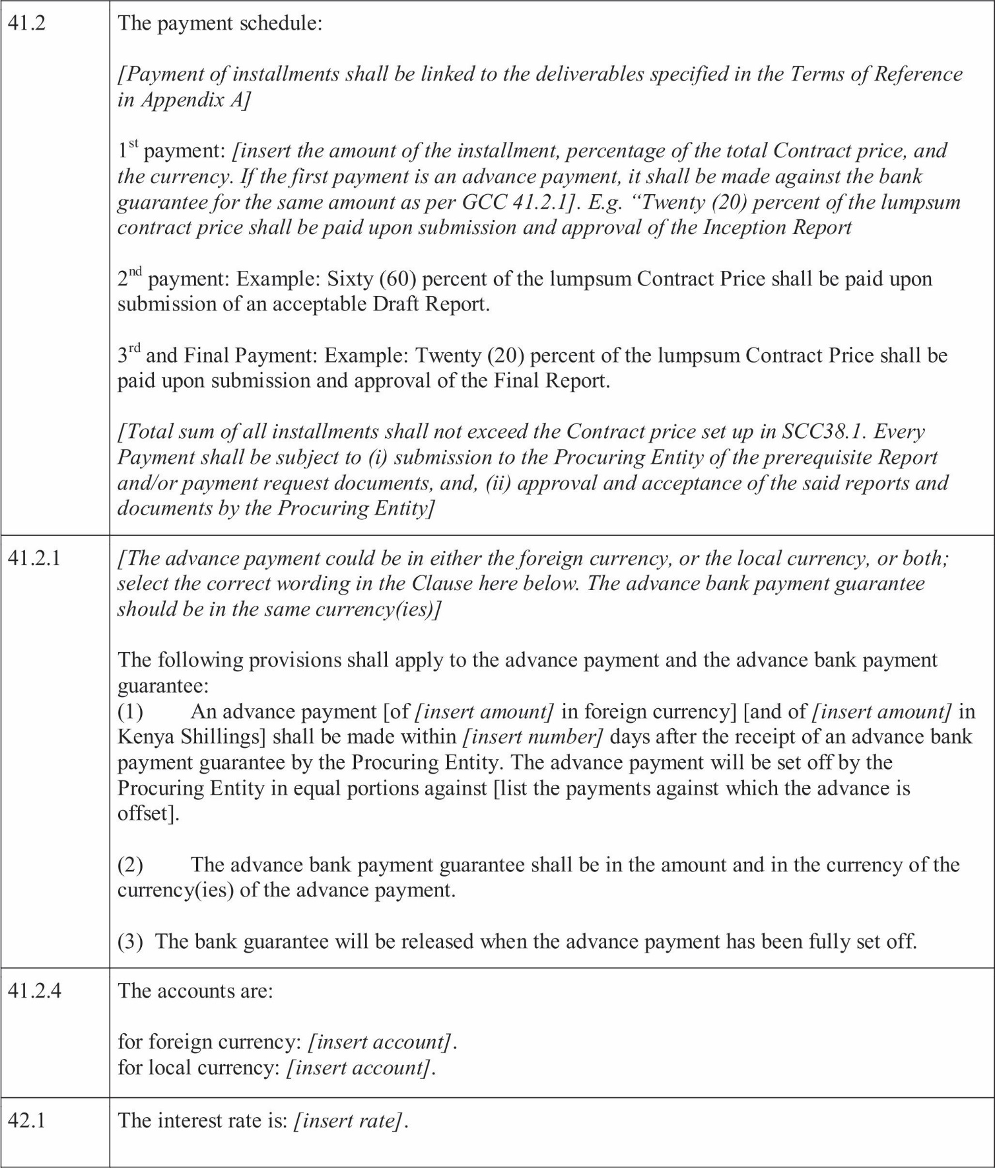

SECTION 9: APPENDICES

Appendix A – Terms of Reference
[This Appendix shall include the ﬁnal Terms of Reference (TORs) worked out by the Procuring Entity and the Consultant during the negotiations; dates for completion of various tasks; location of performance for different tasks; detailed reporting requirements; Procuring Entity's input, including counterpart personnel assigned by the Procuring Entity to work on the Consultant' steam; speciﬁc tasks that require prior approval by the Procuring Entity.
Insert the text based on the Section 5 (Terms of Reference) of the ITC in the RFP and modiﬁed based on the Forms TECH-1 through TECH-5 in the Consultant's Proposal. Highlight the changes to Section 5 of the RFP]
If the Services consist of or include the supervision of civil works, the following action that require prior approval of the Procuring Entity shall be added to the Reporting Requirements” section of the TORs: Taking any action under a civil works contract designating the Consultant as Engineer”, for which action, pursuant to such civil works contract, the written approval of the Procuring Entity is required.

Appendix B - Key Experts
[Insert a table based on Form TECH-6 of the Consultant's Technical Proposal and ﬁnalized at the Contract's negotiations. Attach the CVs (updated and signed by the respective Key Experts) demonstrating the qualiﬁcations of Key Experts.]
[Specify Hours of Work for Key Experts: List here the hours of work for Key Experts; travel time to/ from Kenya; entitlement, if any, to leave pay; public holidays in Kenya that may affect Consultant's work; etc. Make sure there is consistencywithFormTECH-6. In particular: one month equals twenty-two (22) working (billable) days. One working (billable) day shall be not less than eight (8) working (billable) hours.]

Appendix C – Remuneration Cost Estimates
- Monthly rates for the Experts:
[Insert the table with the remuneration rates. The table shall be based on [Form FIN-3] of the Consultant's Proposal and reﬂect any changes agreed at the Contract negotiations, if any. The footnote shall list such changes made to [Form FIN-3] at the negotiations or state that none has been made.]
- [When the Consultant has been selected under Quality-Based Selection method, or the Procuring Entity has requested the Consultant to clarify the breakdown of very high remuneration rates at the Contract's negotiations also add the following:
“The agreed remuneration rates shall be stated in the attached Form: Breakdown of Agreed Fixed Rates in Consultant's Contract. This form shall be prepared on the basis of Appendix A to Form FIN-3 of the RFP “Consultants' Representations regarding Costs and Charges” submitted by the Consultant to the Procuring Entity prior to the Contract's negotiations.
Should these representations be found by the Procuring Entity (either through inspections or audits pursuant to Clause GCC 25.2 or through other means) to be materially in complete or in accurate, the Procuring Entity shall be entitled to introduce appropriate modiﬁcations in the remuneration rates affected by such materially in complete or inaccurate representations. Any such modiﬁcation shall have retroactive effect and, in case remuneration has already been paid by the Procuring Entity before any such modiﬁcation,(i) the Procuring Entity shall been titled to offset any excess payment against the next monthly payment to the Consultants, or (ii) if there are no further payments to be made by the Procuring Entity to the Consultants, the Consultants shall reimburse to the Procuring Entity any excess payment with in thirty (30)days of receipt of a written claim of the Procuring Entity. Any such claim by the Procuring Entity for reimbursement must be made within twelve (12) calendar months after receipt by the Procuring Entity of a ﬁnal report and a ﬁnal statement approved by the Procuring Entity in accordance with Clause GCC45. 1(d) of this Contract.”

87

BREAKDOWN OFAGREED FIXED RATES IN CONSULTANT'S CONTRACT
We hereby conﬁrm that we have agreed to pay to the Experts listed, who will be involved in performing the Services, the basic fees and away from the home ofﬁce allowances (if applicable) indicated below:
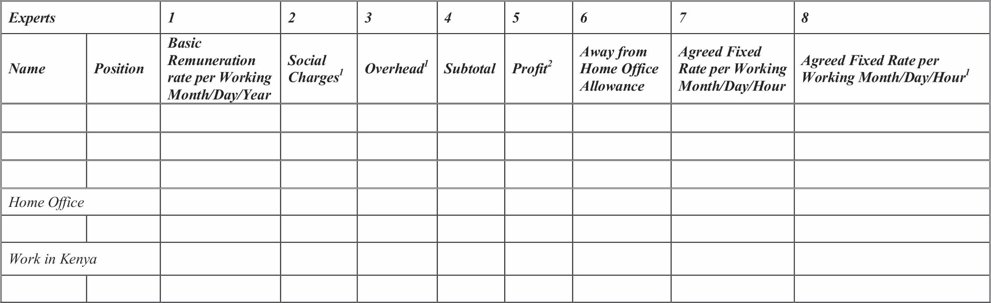
(Expressed in [insert name of currency]) *
Expressedaspercentageof1
  - Expressedaspercentageof4
* If more than one currency, add a table
Signature Date Name and Title:

APPENDIX D: REIMBURSABLE EXPENSES COST ESTIMATES
- {Insert the table with the Reimbursable Expenses rates. The table shall be based on [Form FIN-4] of the Consultant's Proposal and reﬂect any changes agreed at the Contract negotiations, if any. The foot note shall list such changes made to [FormFIN-4] at the negotiations or state that none has been made.]
- All reimbursable expenses shall be reimbursed at actual cost, unless otherwise explicitly provided in this Appendix, and in no event shall reimbursement be made in excess of the Contract amount.

Notiﬁcation of Intention to Award and Beneﬁcial Ownership Forms

APPENDIX E: FORM OFADVANCE PAYMENTS GUARANTEE
[Note: See Clause GCC 41.2 and SCC41.2] Bank Guarantee for Advance Payment
[Bank's Name and Address of Issuing Branch or Ofﬁce]
Beneﬁciary: [Name and Address of Procuring Entity] Date:
ADVANCE PAYMENT GUARANTEE No.
We have been informed that [name of Consultant or a name of the Joint Venture, same as appears on the signed Contract] (herein after called" the Consultant") has entered into Contract No. [Reference number of the contract] dated with you, for the provision of [brief description of Services] (hereinafter called" the Contract").
Furthermore, we understand that, according to the conditions of the Contract, an advance payment in the sum of
[Amount in ﬁgures] () [amount in words] is to be made against an advance payment guarantee.
At the request of the Consultant, we [name of bank] hereby irrevocably undertake to pay you any sum or sums not exceeding in total an amount of [amount in ﬁgures] () [amount in words]1upon receipt by us of your ﬁrst demand in writing accompanied by a written statement stating that the Consultant are in breach of their obligation under the Contract because the Consultant have used the advance payment for purposes other than toward providing the Services under the Contract.
Itisaconditionforanyclaimandpaymentunderthisguaranteetobemadethattheadvancepaymentreferredto above must have been received by the Consultant on their account number at [name and address of bank].
The maximum amount of this guarantee shall be progressively reduced by the amount of the advance payment repaid by the Consultant as indicated in copies of certiﬁed monthly statements which shall be presented to us. This guarantee shall expire, at the latest, upon our receipt of the monthly payment certiﬁcate indicating that the Consultant has made
full repayment of the amount of the advance payment, or on the day of , 2 ,2 whichever is earlier.
Consequently, any demand for payment under this guarantee must be received by us at this ofﬁce o n or before that date. This guarantee is subject to the Uniform Rules for Demand Guarantees, ICC Publication No.758.

[signature (s)]
Note: All italicized text is for indicative purposes only to assist in preparing this form and shall be deleted from the ﬁnal product.

1The Guarantor shall insert an amount representing the amount of the advance payment and denominated either in the currency (ies) of the advance payment as
Speciﬁed in the Contract, or in a freely convertible currency acceptable to the Procuring Entity.
2Insert the expected expiration dates. In the event of an extension of the time for completion of the Contract, the Procuring Entity would need to request an extension of this guarantee from the Guarantor. Such request must be in writing and must be made prior to the expiration date established in the guarantee. In preparing this guarantee, the procuring Entity might consider adding the following text to the form, at the end of the penultimate paragraph: “The Guarantor agrees to a one-time extension of this guarantee for a period not to exceed [six months] [one year], in response to the Procuring Entity's written request for such extension, such request to be presented to the Guarantor before the expiry of the guarantee.”

SECTION 10. NOTIFICATION FORMS

NOTIFICATIONOFINTENTIONTOAWARD
Procuring Entity: [insert the name of the Entity] Contract title: [insert the name of the contract] RFP No: [insert RF Preference number]
This Notiﬁcation of Intention to Award (Notiﬁcation) notiﬁes you of our decision to award the above contract. The transmission of this Notiﬁcation begins the Standstill Period. During the Standstill Period you may:
- Request a debrieﬁng in relation to the evaluation of your Proposal, and/or
- Submit a Procurement-relatedComplaintinrelationtothedecisiontoawardthecontract.
The successful Consultant




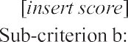
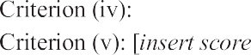
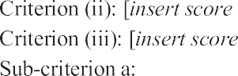
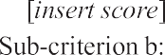
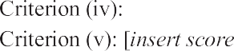
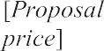
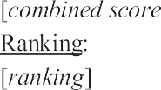

i) Short listed Consultants
[INSTRUCTIONS: insert names of allshort-listedConsultantsandindicatewhichConsultantssubmittedProposals. Where the selection method requires it, state the price offered by each Consultant as readout, and as evaluated. Include overalltechnicalscoresandscoresassignedforeachcriterionandsub-criterion.]
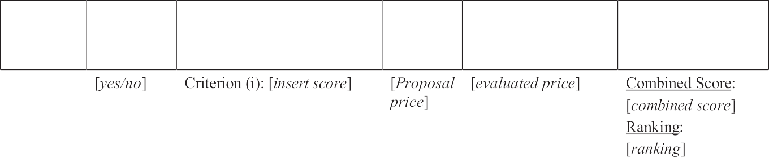
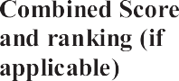




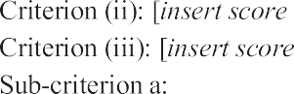

 |  |  |  |  | 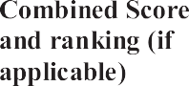
 |  | 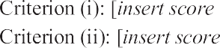  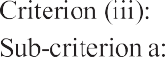  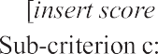  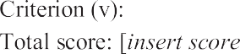 | 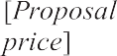 |  | 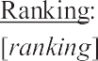

- Reason/s why your Proposal was unsuccessful [Delete if the combined score already reveals the reason].

- How to request a debrieﬁng [This applies only if your proposal was unsuccessful as stated under point (3) above].
DEADLINE: The deadline to request a debrieﬁng expires at midnight on [insert date] (local time).
You may request a debrieﬁng in relation to the results of the evaluation of your Proposal. If you decide to request a debrieﬁng your written request must be made within ﬁve (5) Business Days of receipt of this Notiﬁcation of Intention to Award.
Provide the contract name, reference number, name of the Consultant, contact details; and address the request for debrieﬁng as follows:
Attention: [insert full name of person if applicable] Title/position: [insert title/position]
Agency: [insert name of Procuring Entity] Email address: [insert email address] Fax number: [insert fax number] delete if not used
If your request for a debrieﬁng is received within the 5 Business Days deadline, we will provide the debrieﬁng within ﬁve (5) Business Days of receipt of your request. If we are unable to provide the debrieﬁng within this period, the Standstill Period shall be extended by ﬁve (5) Business Days after the date that the debrieﬁng is provided. If this happens, we will notify you and conﬁrm the date that the extended Standstill Periodwillend.

The debrieﬁng may be in writing, by phone, video conference call or in person. We shall promptly advise you in writing how the de brieﬁng will take place and conﬁrm the date and time.

If the deadline to request a debrieﬁng has expired, you may still request a debrieﬁng. In this case, we will provide the debrieﬁng as soon as practicable, as and normally no later than fourteen (14) Business Days from the date of publication of the Contract Award Notice.

How to Make a Complaint
DEADLINE: The deadline for submitting a Procurement-related Complaint challenging the decision to award the contract expires on midnight, [insert date] (local time).
Provide the contract name, reference number, name of the Consultant, contact details; and address the Procurement-related Complaint as follows:
Attention: [insert full name of person, if applicable] Title/position: [insert title/position]
Agency: [insert name of Procuring Entity] Email address: [insert email address]
Fax number: [insert fax number] delete not used
[At this point in the procurement process] [Upon receipt of this notiﬁcation] you may submit a Procurement- related Complaint challenging the decision to award the contract. You do not need to have requested, or received, a debrieﬁng before making this complaint. Your complaint must be submitted within the Standstill Period and received by us before the Standstill Period ends.
In summary, there are four essential requirements:
  - You must be an 'interested party'. In this case, that means a Consultant who has submitted a Proposal in this selection process and is the recipient of a Notiﬁcation of Intention to Award.
  - The complaint can only challenge the decision to award the contract.
  - You must submit the complaint within the deadline stated above.
  - You must include, in your complaint all of the information required by the Procuring Entity.

Stand still Period
DEADLINE: The Standstill Period is due to end at midnight on [insert date] (local time). The Standstill Period lasts (specify the number of business days as per Data Sheet 30.1)
BusinessDaysasspeciﬁedintheDataSheetafterthedateoftransmissionofthisNotiﬁcationofIntentionto Award.
The Standstill Period may be extended. This may happen where we are unable to provide a debrieﬁng within the ﬁve (5) Business Day deadline. If this happens, we will notify you of the extension.

If you have any questions regarding this Notiﬁcation, please do not hesitate to contact us.
On behalf of [insert the name of the Procuring Entity]: Signature: Name: Title/position: Telephone: Email:

- NOTIFICATION OF AWARD
[use letterhead paper of the Procuring Entity] [date]______To: ________ [name and address of the winning Consultant] Subject: Notiﬁcation of Award Contract No...........
This is to notify you that your Proposal dated [insert date] for consulting services for [name of the assignment] as negotiated with you on for the contract amount of
[Insert amount in numbers and words and name of currency] is here by accepted by our agency.

You are requested to:(i) sign and return the draft negotiated Contract attached here with within eight (8) Business Days from the date of receipt of this notiﬁcation; and (ii) furnish the additional information on beneﬁcial ownership in accordance with the Data Sheet of ITC 32.1 within eight (8) days using the Beneﬁcial Ownership Disclosure Form, included in Section 7 of the Request of Proposals.

Authorized Signature: Name and Title of Signatory: Name of Agency:

Attachment: Draft Negotiated Contract

BENEFICIAL OWNERSHIP DISCLOSURE FORM
INSTRUCTIONS TO CONSULTANTS: DELETE THIS BOX ONCE YOU HAVE COMPLETEDTHE FORM
This Beneﬁcial Ownership Disclosure Form (“Form”) is to be completed by the successful Consultant. In case of joint venture, the Consultant must submit a separate Form for each member. The beneﬁcial ownership information to be submitted in this Form shall be current as of the date of its submission.
For the purposes of this Form, a Beneﬁcial Owner of a Consultant is any natural person who ultimately owns or controls the Consultant by meeting one or more of the following conditions:
- Directly or indirectly holding 25% or more of the shares.
- Directly or in directly holding 25% or more of the voting rights.
- Directly or indirectly having the right to appoint a majority of the board of directors or equivalent governing body of the Consultant.

Request for Proposal Reference No.: [insert identiﬁcation no] Name of the Assignment: [insert name of the assignment] to: [insert complete name of Procuring Entity]
In response to your notiﬁcation of award dated [insert date of notiﬁcation of award] to furnish additional information on beneﬁcial ownership: [select one option as applicable and delete the options that are not applicable]
- We here by provide the following beneﬁcial ownership information.

Details of beneﬁcial ownership

 |  | 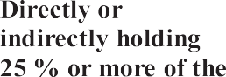 | 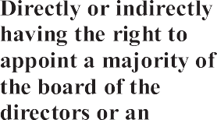  
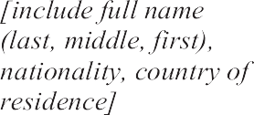

OR
- We declare that there is no Beneﬁcial Owner meeting one or more of the following conditions: directly or indirectly holding 25% or more of the shares. Directly or indirectly holding 25% or more of the voting rights. Directly or indirectly having the right to appoint a majority of the board of directors or equivalent governing body of the Consultant.

OR
- We declare that we are unable to identify any Beneﬁcial Owner meeting one or more of the following conditions. [If this option is selected, the Consultant shall provide explanation on why it is unable to identify any Beneﬁcial Owner]

Directly or indirectly holding 25% or more of the shares. Directly or indirectly holding25% or more of the voting rights.
Directly or indirectly having the right to appoint a majority of the board of directors or equivalent governing body of the Consultant]”
Name of the Consultant: .......................*[insert complete name of the Consultant]
NameofthepersondulyauthorizedtosigntheProposalonbehalfoftheConsultant: ** [insert complete name of person duly authorized to sign the Proposal]
Title of the person signing the Proposal: .......................[insert complete title of the person signing the Proposal]
Signature of the person named above: ....................... [insert signature of person whose name and capacity are shown above]
Date signed .......................[insert date of signing] day of....................... [Insert month], [insert year]

*In the case of the Proposal submitted by a Joint Venture specify the name of the Joint Venture as Consultant. In the event that the Consultant is a
Joint venture, each reference to “Consultant” in the Beneﬁcial Ownership Disclosure Form (including this Introduction there to) shall be read to refer to the joint venture member.
**PersonsigningtheProposalshallhavethepowerofattorneygivenbytheConsultant.ThepowerofattorneyshallbeattachedwiththeProposal
Schedules.



Public Procurement Regulatory Authority (PPRA)
National Bank Building, 11th Floor, Harambee Avenue
P.O Box 58535- 00200, Nairobi Kenya Telephone: +254 020 3244000, 2213106/7
Email: info@ppra.go.ke Website: www.ppra.go.ke

